“…We can learn from history how past generations thought and acted, how they responded to the demands of their time and how they solved their problems. We can learn by analogy, not by example, for our circumstances will always be different than theirs were…” Gerda Lerner

As Knights Templar, we need to be knowledgeable on our Order, its culture and history. The more knowledge we acquire as Knights Templar, the better prepared we will be to speak about any topic regarding our Order. Improving ourselves in knowledge reflects the pride we have as Knights Templar and this magnanimous Order. This is a journey that begins with the first step: commitment. Let us begin this journey in building this foundation of knowledge with the following 13 questions. God bless until our next newsletter.

Note: To the Sir Knight responsible for Masonic Education, please ask the questions and let the Sir Knights answer. After which, you will give the correct answer.

Question #1: What is a group of individuals ranked according to their authority or function called? Answer: HIERARCHY
Question #2: What is the first half of the Order of Malta called? Answer: THE ORDER OF ST. PAUL
Question #3: What was the original name of medieval Knights Templar? Answer: THE POOR FELLOW SOLDIERS OF CHRIST
Question #4: Describe the jewel of the Warder? Answer: TWO CROSSED SWORDS AND A TRUMPET IN A SQUARE.
Question #5: Who was the king of Babylon known for the destruction of the first Holy Temple? Answer: NEBUCHADNEZZAR
Question #6: In what year was the Temple of Solomon destroyed by Nebuchadnezzar? Answer: 586 B.C.
Question #7: What Pope issued a Papal Bull which suppressed the original Knights Templar? Answer: POPE CLEMENT THE 5TH
Question #8: What was the first identifiable body of Knights Templar in America? Answer: THE MOST HOLY AND INVINCIBLE ORDER OF KNIGHTS TEMPLAR, ST. ANDREWS LODGE, IN CHARLSTON, SC
Question #9: What is conferred annually to a Commandery in Florida that shows the highest level of proficiency in the conferral of the 9-Man Opening? Answer: THE RICHARD CARR TROPHY

Question #10: What year did the Beauceants Award first appear in Florida and which Grand Commander instituted it? Answer: 1977, S.K. HARRY ROSENTHAL JR.

Question #11: What is the ornamented belt worn over the shoulder that the Sir Knight is invested with in the Order of the Temple? Answer: THE BALDRIC

Question #12: What is an apartment in which the Knights of Malta ceremonial takes place called? Answer: THE CHAPEL

Question #13: What is the inscription on the Banner of the Illustrious Order of the Red Cross (meaning “Great is Truth and it will prevail”)? Answer: MAGNA EST VERITAS, ET PRAEVALEBIT

If your Commandery has any ideas or topics they would like to be included in future monthly newsletters, please contact one of the members of the Knights Templar Education and Leadership Committee:
S. K. David A. Aponte, E.G.G. – daponte1@tampabay.rr.com (352-503-3030)
S. K. Charles “Chic” Cicero, V. E. Deputy G.C. - Ciceros@tampabay.rr.com (727) 372 1320
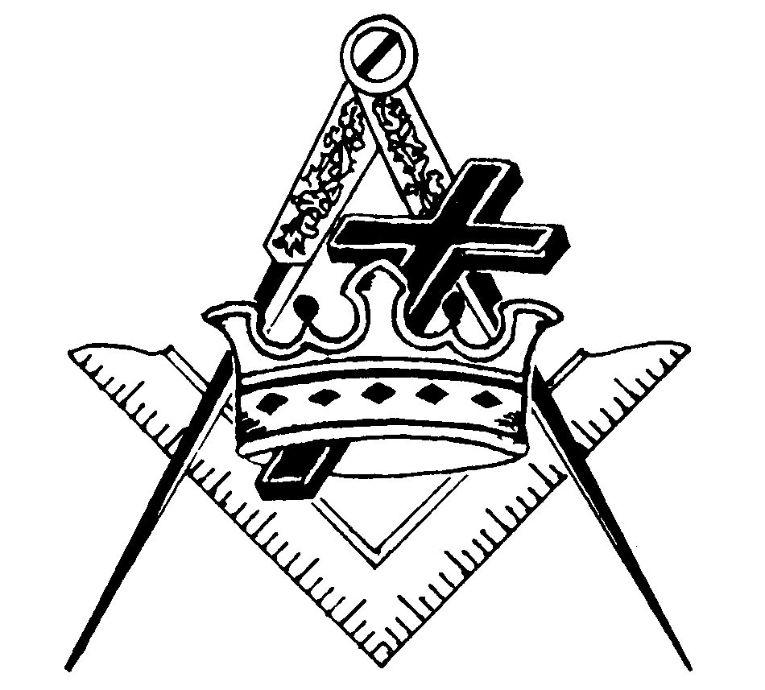
S. K. Charles “Bob” Cooper, D.I. - cooperhouse1@yahoo.com (904) 743-6922

