In this issue, we bring you an interesting article from the Sovereign Great Priory of Canada website. Always remember that every Christian Master Mason should be a Knight Templar.
This Is My Cross And This Is My Sword!
by R.E. Sir Knight W. Bruce Miller
Past Chairman of Knight Templar Advancement - Sovereign Great Priory of Canada, Knights Templar

A Masonic Knight Templar holding a golden sword aloft by its glittering silver blade, his white mantle swirling gently around him, a red cross pattée rippling against the stark white of the mantle, with his head covered by a red pillbox hat, proclaims, “This is my cross and this is my sword!”

This symbolism really condenses the reason for being of the Knights Templar of old and the Masonic Knights Templar. “In hoc signo vinces.” In this sign thou shalt conquer - from the vision given to Constantine. We are Christians militant. Believers in Christ as our Captain, our Priest and our King.

The ancient Knights Templar, founded in 1118 following the First Crusade, were warrior monks founded to protect the Christians who journeyed to the holy lands. They protected and defended Christian pilgrims traveling to Jerusalem and took vows of poverty, chastity and obedience. In the process they were originally stationed in Jerusalem, quartered in the stables of Solomon’s Temple; hence their name as Knights of the Temple or Knights Templar.
We do know that they quarried underground for a number of years. What they found there no one knows, but the original group of five knights lead by Hugh de Payens (a relative of the much later Henry Sinclair (Saint Clair), the builder of Rosslyn Chapel, and the hereditary Grand Master of the Templars in Scotland) suddenly grew in numbers receiving the approbation of the church and freeing them from all obligations to civil authority wherever they functioned.
They were the developers of the modern banking system, in addition to possessing a fleet of ships to transport pilgrims. By this means they not only carried pilgrims to the Holy Land but returned with goods such as muslin (from Mosul in modern Iraq), kandiq (candy made from sugar cane), and learning, particularly in medicine and mathematics

The Hospitallers (bearing the famed Maltese cross) lead the formation of the modern St. John’s ambulance. The techniques they learned for treating wounds led the way for advances in medical practices in the West.

The Knights Templar practiced many knightly virtues that we emulate. I shall name only three: the defense of religion and the church; the protection of widows, orphans and all who were powerless, or suffering under injustice and oppression; Patriotism

While the ancient Knights Templar had many faults, they also had many virtues. As Masonic Knights Templar choose to emulate the best in spiritual practices, and try to express them in our lives and in the world around us. We all, as Masonic Knights Templars, also wear the red cross pattée upon our white mantles that distinguished the Templars from other knightly groups upon many a hard fought field of battle. The red cross not only commemorates the sacrifice of Christ upon the cross but reminds us, by its four sections, of “fish tails” – the Fishers of Men – Mathew, Mark, Luke and John; while its points remind us of the eight Beatitudes of our Lord in the sermon on the Mount. The top of the mantle has the monk’s coif attached to it as a reminder that we are “Poor Soldiers of Christ”.

The Masonic Knights Templar have no real historical connection with the ancient Knights Templar that can be proven. When the Knights Templar grew too powerful and too arrogant, their arrest on Friday, October 13, 1307 was ordered by Philip the Fair of France and Pope Clement. (Friday the 13th has ever since been considered unlucky for that reason.) However, their treasure had disappeared and their fleet had sailed from La Rochelle. Shortly thereafter, the skull and crossbones on a black flag (the personal device of the Templar, Jolly Rodger of Sicily) began to appear in raids against French shipping. Many Knights Templar fled to other countries, thus setting the stage for much speculation, such as, the DaVinci Code which speculates as to were they went and what happened to the treasure – indeed, what was the treasure, beyond gold?

It is interesting to note that the battle flag of the Knights Templar was the red cross on a white field. The Red Cross of the Order symbolizes the spread of the gospel to the four quarters of the globe. It appears in many guises, not only as the emblem of the Red Cross organization, but in many variations: Switzerland – a white cross on a red background; Scotland – a white cross on a blue background – running from corner to corner emblematical of the cross on which St. Andrew was crucified: in England composed of the three crosses including that of St. George – the red cross; and many other examples.
There seems to be much evidence to support the concept of the Knights Templars being the progenitors of modern Masonry. Two simple examples the so-called “mosaic pavement” (the Beauséant repeated endlessly) and a Tyler who stands outside the door of the lodge with a drawn sword – a necessary thing if you were subject to arrest and death if found to be a Knights Templar! Evidence of connections might also be said to be found in the degrees of the Craft Lodge, particularly in the Third Degree, if one were to compare the preparation of the candidate in the floor work with the tombs of Templars, sometimes referred to as broken or crooked legged Knights from their burial effigies, and lastly, to the reference to the B.M.S. Further examples would require another paper devoted exclusively to symbolism.

As modern Masonic Knights Templar we practice the virtues of: Faith, Courage, Temperance, Prudence, Generosity and Courtesy. The Order of Masonic Knights Templar embraces those ideals, which have made human liberty the watchword of the ages. It impresses upon every Knight his responsibility, not only as a man and Mason, but also as a citizen and member of society.

If your Commandery has any ideas or topics they would like to be included in future monthly newsletters, please contact one of the members of the Knights Templar Education and Leadership Committee:
S. K. David A. Aponte, Eminent Grand Generalissimo – daponte1@tampabay.rr.com
S. K. Charles “Chic” Cicero, V. E. Deputy Grand Commander - Ciceros@tampabay.rr.com
S. K. Charles “Bob” Cooper, D.I. - cooperhouse1@yahoo.com
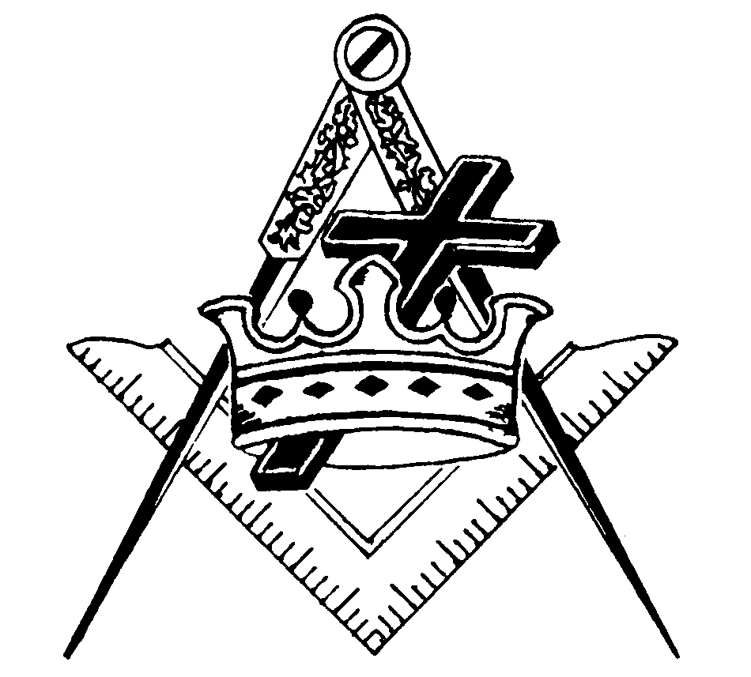
EVERY CHRISTIAN MASTER MASON SHOULD BE A KNIGHT TEMPLAR.

