Dear Friends, April 6, 2014
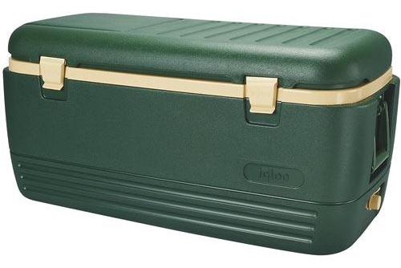

As the Charities Director this year, we have been asked to put together a basket to be auctioned at the Charities extravaganza in June. I am would like to get all the chapters in our district to participate in making a: Summer Fun Day “Basket”. I am going to have a cooler that I would like to fill with items that you would use to have a fun day in the sun. I would like each chapter to come up with something fun and interesting to add to the cooler. Just to give you some ideas to run with: Picnic items (reusable plates, cups, utensils…), outdoor games (badminton, balls, ring toss…), folding chairs, bug repellant, sun screen… I hope that you will use your imagination to find something fun to represent our district.
I realize that time is short; however I really need to have your chapter’s donation by April 24th (Ida’s Inspection). I am supposed to turn in our basket on April 26th at the WGM and WGP Reception, and I will need a day to put everything together. I will be attending Cardinal’s Country Breakfast on Saturday April 12th, if you have your items ready early and would like to bring them to me there.
Please feel free to contact me with any questions or to let me know what you might be adding to the cooler. Thank you, in advance, for helping me with this project!
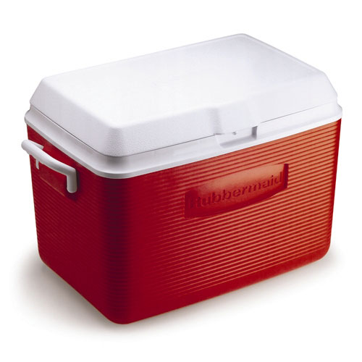
Star Love,

Rachel Schroer
490-1593
emeraldanne@hotmail.com

