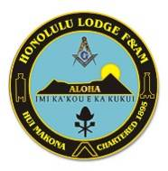

Honolulu Lodge F&AM
Trestle Board
December 2006
Welcome to Honolulu Lodge’s New Trestle Board
By Frank M. Condello II
Aloha brethren! I am very honored to be serving Honolulu Lodge as Master in 2007. I can assure you that we will be very busy in the new year. We have many candidates waiting in the wings for their degree work and at every Stated meeting, we have been blessed with new applicants for degree work. I want to first thank the dedicated officers who will be backing me up throughout the year. Their service to the lodge is what keeps us so strong. I also want to invite brethren who have not been that active in the past but want to come back. We love to see brethren return and we will assist in any way we can to make you feel more comfortable.
Some of you may not have heard yet, but Honolulu Lodge at the December Stated meeting voted to become a part owner of the lot next door to our current temple property. This issue has been debated for many years and has now been finally put
to rest. All four lodges are now owners of the property and it is anticipated that in the future, plans for renovations and additions will be made. This is truly an historic accomplishment for our lodge. Please be assured that our lodge will act responsibly with the money we have been entrusted with. We have very dedicated trustees who have been doing a great job over the past year or so in watching our funds grow and keeping the brethren apprised.
As I promised at the Installation of officers, I will be sending a trestle board to all of you monthly during my year as Master. This first one is somewhat abbreviated due to the lack of meetings in December, but I still wanted to pass along greetings and good wishes prior to our January Stated Meeting. I have also included my speech at the Installation of officers in case you were not able to attend. There are also pictures of the event. Thank you for you continued support of the lodge and please join us on Tuesday nights. We really love seeing you all there.
Fraternally,

Frank M. Condello II
Worshipful Master
Worshipful Master Frank M. Condell’s Installation Address
Aloha and good evening brethren and guests. It is truly a wonderful experience to be standing before all of you tonight. I want to dedicate tonight to Worshipful Warren Stremming who was a great mentor to me and a great friend. We lost him in February of this year.
This is not my first time as Worshipful Master of Honolulu Lodge, but it is in no way less special because it is my second time. Some of you may recall that I was Master in 2001. It was truly an honor to have served as Master during that period, and I believe a lot was accomplished for the lodge. I never actually expected to be standing before you again in this position. I was content with being a Past Master and assisting the younger Masons in moving up the officer line and giving good counsel when needed. Well, as life would have it, unforeseen circumstances have occurred that made it necessary for me to step up to the plate and serve again. I want all of you to know that Honolulu Lodge is a strong and vibrant lodge with very dedicated officers. Our lodge also performs some of the best ritual degree work in the jurisdiction. I fully expect the officer line to be strong after my year as Master and hopefully we will not need to ask a Past Master to serve again.
I want you to know that I expect to be an active and involved Master. I plan to treat this year as though it was my first time in the East. Although I have to admit that it is not as intimidating the second time around. I know what to expect and I know what it takes to continue the lodge on a positive note and direction. Of course, I cannot accomplish anything without the support of my brethren in the lodge. I am only as good as my officer corps and need their support to have a successful year. To that end, I plan to have monthly officer meetings. I want all of you to know what is happening on a monthly basis and not be in the dark with respect to what is happening in the lodge. I want the officers to feel as though they are part of a cohesive team that is making a difference and accomplishing something. I also plan to reinstate the Trestle board newsletter on a monthly basis. It will take some dedication but having a monthly trestle board allows all of the brethren in the lodge to know what has happened and what to expect the following month. It also showcases the great degree work and events the lodge has with pictures. Masonic education can also be provided to all members and all brethren are welcome to contribute their articles. We will also go high tech in this respect and will send the trestle board via e-mail to as many brethren as possible to cut down on printing and mailing expenses.
Although raising brethren to the sublime degree of Master Mason is our primary goal, I also believe that being active in the community paints a positive picture of Freemasonry and helps to strengthen us. I also know that many of our younger brethren enjoy community projects. I plan to rededicate the Dr. Jose Rizal statue in Chinatown in June 2007. During my first time as Master, the lodge placed several plaques at the statue commemorating Dr. Hizal as a Mason and hero of the Philippines. The plaques and statue need some upkeep and we will have both a work party and formal event at the statue along with the Knights of Rizal. I plan to have dinners throughout the year in order to foster friendship and allow the families of the brethren to participate and see how much fun we have together. Many of you know about our annual Boston Tea Party in September. Honolulu Lodge has been recreating the Boston Tea Party at the Falls of Clyde for the past 6 years. This could not happen without the continued dedication of Worshipful George Theofanis, Past Master of this lodge. I am very happy that this event will continue to be a lodge event and I will fully support it during my year. I would like to see if our scholarship program can be joined with this wonderful public event in order to have greater publicity for Freemasonry and show that we support public schools and Constitutional Observance. I would also like the lodge to offer their support to brethren and widows who need our assistance. We have done this in the past and I will be soliciting the brethren in the trestle board to ask for our assistance if it is needed.
I want the officers to provide their input as well. I know my year will be more successful if the officers feel that their ideas will be heard and considered. Many minds working together is better than one trying to do everything by themselves. At the same time, I am not afraid to make command decisions as the Master and will lead the lodge to the best of my ability.
Every year since 2000 our lodge has continued to grow and prosper. From what I can tell, our lodge performs more degree work and raises more brethren than any other lodge in the state. We can be very proud of this accomplishment. We are obviously doing something right if good men in the community want to join our lodge. It also means that we are supportive of our brethren. Although we may have disagreements at times, we treat each other with respect. The worst thing that can happen to our fraternity is to allow for dissention and internal bickering to be the norm. We are an ancient and honorable fraternity and we are better than this. I give this as a warning to the brethren that I will expect all brethren of this lodge to act honorably and by the teaching that are taught in our beautiful degree work. I also hold myself to this high standard. Freemasonry will continue to grow and make a difference in the community if it is allowed to be as it was in ancient times. We are not just a club of men that have dinners and secret passwords. Freemasonry is so much more and truly does make good men better men. We lead by example and we truly believe that we are making a difference no matter how small it may seem to others. We do this for the betterment of all and not for the public accolades or awards.
We also need to thank our families for being supportive of our Masonic activities. If we didn't have the support of our wives or girlfriends we wouldn't be able to attend lodge on a weekly basis. I am blessed with a wonderful and supportive wife and son and I thank you Leah for understanding how much Freemasonry means to me.
In closing, I want to thank everyone for coming tonight and being a part of this wonderful event. Happy holidays and may the Great Architect of the Universe be with you all and grant you peace and prosperity in the New Year.

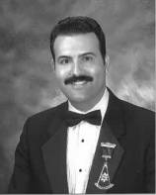

continued on page 2

Inside This Issue
1 | Master’s Welcome to the New Trestle Board
1 | Master’s Installation Address
3 | Secretary’s Corner
4 | Calendar of Events
4 | Pictures from the Installation of 2007 Officers
continued on page 2

continued from Trestle Board on page 1

continued from Installation Address on page 1

Secretary’s Corner
By Monty J. Glover PM

Aloha and Happy New Year Brethren. I hope that this issue of Honolulu Lodge’s New Trestle Board finds you and yours happy, safe and in good health.
This being the first issue I would like to take this opportunity to stress the importance of communication. Not only the communication between the Lodge and its Brothers but also between the Brothers and the Lodge.
Each year we struggle to locate Brothers who have moved and have failed to pass along their new addresses to the secretary so that our records remain up-to-date. This results in delayed notices and invitations, returned mail, and unfortunately suspensions of Brothers for non-payment of dues. Please make sure that if you move or you have a change in your phone numbers or e-mail address please take a moment and send me an e-mail at HonoluluLodge@hawaii.rr.com or call me at 808-695-5518 and I’ll make sure I get our records updated. That way you stay abreast of all the great happenings going on at Honolulu Lodge.
Also make sure you check out the Lodge Website for the latest information and if you are one of our sojourning Brothers out of State and you visit another Lodge or participate in a Masonic event please make sure you take some pictures, with you in them, and e-mail them tome and I’ll make sure they get posted on our web site. We want to let the world know what the Brothers of Honolulu Lodge are doing wherever they go in the world. The Web site address is: www.honolulufreemasons.
Worshipful Frank and I will be trying to produce this Trestle Board each and every month. In order to keep postage costs down we will be e-mailing copies to all Brothers who we have e-mail addresses for. We will mail hard copies to all those who we do not have e-mail addresses for. So please help us keep our expenses down and send me your e-mail address.
Fraternally yours,
Monty J. Glover PM
Secretary – Honolulu Lodge F&AM
continued from Installation Address on page 2

Calendar of Events
Stated Meeting January 2nd 2007
Makiki Temple
6:30 pm Dinner
Degrees/Practices
January 9th
January 16th
January 23rd
January 30th
Martin Luther King Parade
January 15th
All Brothers are encouraged to participate in the parade and march with our Prince Hall Brethren.

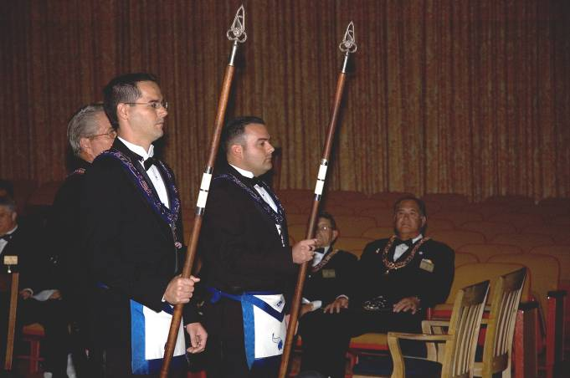

Sr. Steward James Coleman and Jr. Steward Kenneth Dymond

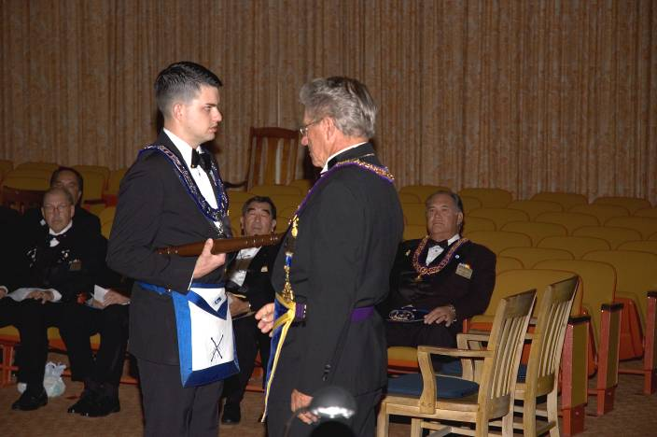

Marshal Br. Joshua Clark

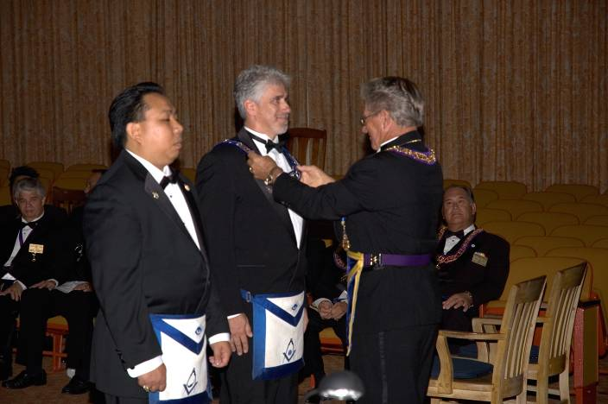

Jr. Deacon Dexter Carrasco and Sr. Deacon Br. Garry Graham
Pictures from the Installation of Officers
Scottish Rite Cathedral
December 2nd, 2006

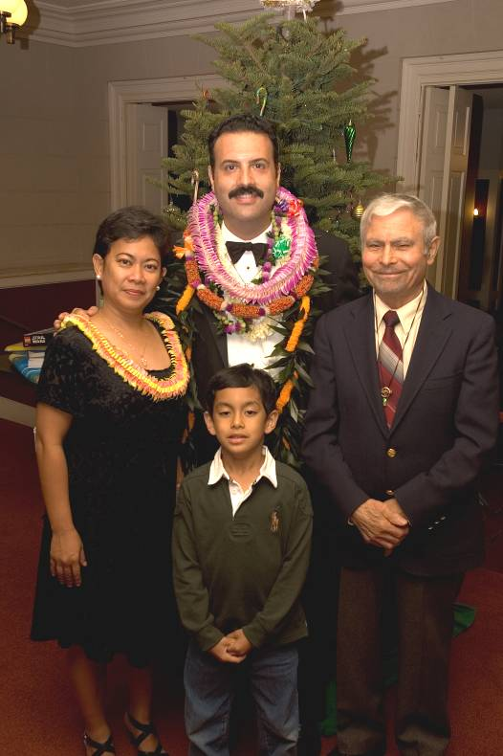

Worshipful Frank M. Condello and family

