Bring a Friend TO
FOREST LAKE LODGE
INFORMATION Night
THURSDAY, MAY 14, 2009
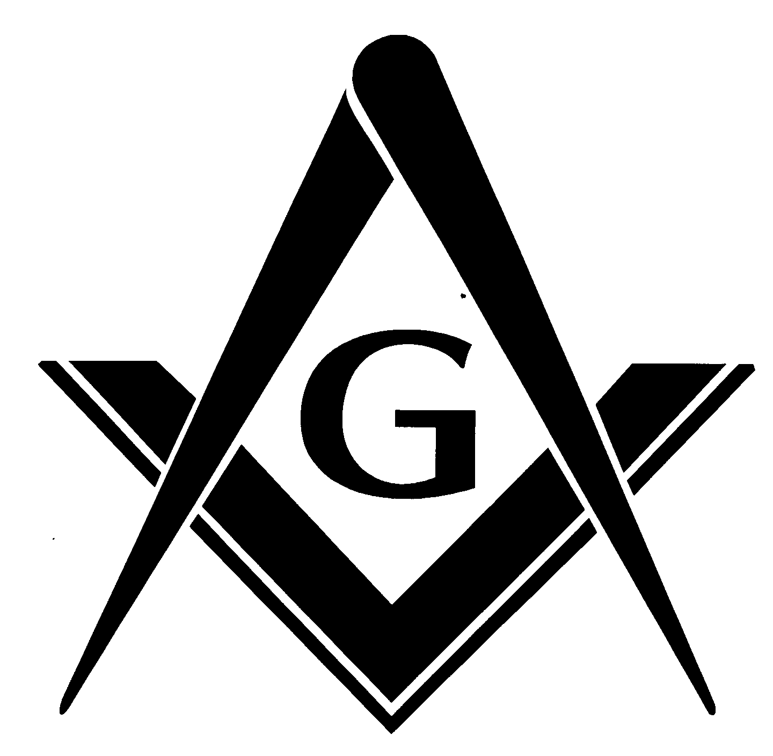

Program begins with Dinner at 6:30 p.m.
Informational meeting in the Lodge to follow

Please call in the names and addresses of guests to Mike Schultz
at (651) 210-6584 no later than 05/08/09

All sponsors and guests meals are compliments of the Lodge

Share the LIGHT of Freemasonry!

