From Darkness to Light

March 2009, Volume 1, Issue 9 Newsletter of Fairfield Lodge # 206
Trestle Board
March 2009
2 5:00 pm Clean Up
2 6:30 pm Supper Club
2 7:30 pm Stated Meeting
4 6:00 pm Wayne County Shrine Club
7 6:00 am Breakfast Fundraiser
9 5:00 pm Practice Night
14 11:00 am $5 Spaghetti Dinner at Iuka
16 6:30 pm Steering Committee Meeting
16 7:30 pm Stated Meeting
21 3:00 pm Spaghetti Dinner at Mt. Vernon
30 6:30 pm District Meeting at Newton

April 2009
1 6:00 pm Wayne County Shrine Club
3 4:00 pm Spring Reunion at Valley of Danville
4 8:00 am Spring Reunion at Valley of Danville
6 5:00 pm Clean Up
6 6:30 pm Supper Club
6 7:30 pm Stated Meeting
11 Consignment Auction on the Street at Iuka
13 5:00 pm Practice Night
20 6:30 pm Steering Committee Meeting
20 7:30 pm Stated Meeting
NOTES OF INTEREST
** Wives are welcome to attend Supper Club
** www.mastermason.com/fairfield/index.html The official website of Fairfield Lodge # 206
** Deadline for April Newsletter Submissions: March 25
SICKNESS OR DISTRESS
Fortunately, there is no new sickness or distress that we are aware of.

DID YOU KNOW?

Form of the Lodge: The terms “Ample” and “Due” Form appear to have been introduced by Anderson in the 1738 ed. of the Constitutions (p. 110). The form of a Mason’s Lodge is said to be an oblong square, having its greatest length from east to west, and its greatest breadth from north to south. This oblong form of the Lodge has, I think, a symbolic allusion that has not been adverted to by any other writer.

Excerpt from
An Encyclopedia of Freemasonry
By Albert G. Mackey, M. D. 33°
POINT OF INTEREST

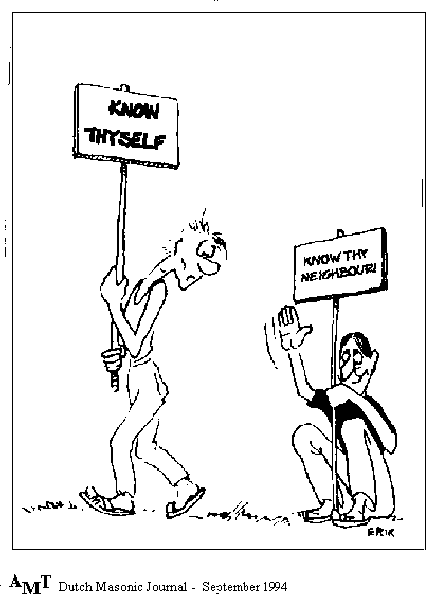

FROM THE SOUTH

Greetings from the South,
I would like to congratulate Brother Jerome Eckleberry on being raised to the sublime degree of Master Mason. Also, remember to bring your lady with you to Supper Club on March the 2nd.

Fraternally Yours,
Dean Linder
Junior Warden

FROM THE EAST

Greetings Brethren,
Monday the 16th Jerome Eckleberry finished his third degree. First he did the long form and Joe Pearce examined him. The long form is very cool to see and not very many do it anymore (I'm very proud of both of them). Next came the degree. Tom Wickham asked for the pass and Jerome didn't give it. Well I think you know what happened next (wamo now you’re a master mason). Thank you all that showed up and helped. We had a great crowd. 27 masons showed up to help out. What a great lodge we have. Worshipful Brother Floyd Harris presented Jerome a bible singed by all that were there. Don't forget about this upcoming supper club. Jeff puts on a great one.
Fraternally Yours,
Shawn Wells
Worshipful Master

FROM THE WEST

Greetings from the West,
I would like to congratulate new brother Jerome Eckleberry on the completion of his 3rd degree and welcome him to the fraternity. Jerome did the long form beautifully. He was coached by Brother Joe Pearce and they both deserve a pat on the back. We had a nice crowd for his 3rd degree and it was appreciated. If you were unable to attend, don't worry. Fairfield lodge 206 has another 3rd degree long form candidate in waiting.
Ainad shrine temple is having their spring ceremonial in Effingham, IL on Saturday May 16th. Potentate Steve Kibler has dedicated this ceremonial to Past Grand Masters and masons of Southern Illinois and invited us to attend and enter a parade float. If you are interested, or would like more information, please contact me. The spring ceremonial would also be a good time for any mason who would like to become a Shriner to do so.

Fraternally Yours,
Sheldon Bunting,
Senior Warden

SECRETARY’S REPORT

Another month has gone by, and the officers of your lodge are as busy as ever. We have three candidates in waiting and I am sure they will be ready soon.
By the way, we had an excellent 3rd degree the evening of the 16th. With good help from Cisne, Flora, and McLeansboro we were pleased to say that our candidate, Brother Jerome Eckleberry, is now a Master Mason.
Remember the regular meeting, and Supper Club, on March 2nd. We have been having excellent attendance at these functions and I would like to see it continue. On Saturday the 7th of March will be our pancake, sausage, biscuit and gravy breakfast. Then, on March 16th we will have our annual inspection by the Grand Lodge. Come in and help us kick off another successful Lodge Year. I hope to see you at one of these functions.
Fraternally,
Delman Bradshaw
Secretary

FUNDRAISER COMMITTEE & SUPPER CLUB

Greetings Brethren,
Hello again from your fundraiser committee chairman, Brother Joe Pearce. I'm looking forward to a big turnout on March 2 for Worshipful Brother Jeff Zurliene's sausage supper. You won't want to miss this one, bring your guest.
Also a reminder, our pancake and sausage breakfast is Saturday March 7th from 6 to 9:30. We can always use help in the kitchen, but mostly bring your friends and family and enjoy a great breakfast. See you at the lodge.
Fraternally Yours,
Worshipful Brother
Joe Pearce

NEWSLETTER SUPPORTERS
Dan Kinsolving Jason Kinsolving Jonah Kinsolving Jake Kinsolving Brad Koehler Floyd Harris
Supper Club Joe’s Body Shop Stephen Cox
Al Reid Chad Reid Jerry & Sue Withrow
Ron Heflin

FROM THE EDITOR

Greetings Fellow Brethren,
Once again February has come and gone by the time you read this. It seems like it went by fast. You would think February would be a slow month but it has not been. With the newsletter, Supper Club and degree work, the Lodge has stayed busy. While I am on that subject, don’t forget Supper Club which is the first Monday of the month and ladies are welcome. I would like to mention an oversight and thank Tim McBride for all his help and support on last month’s Supper Club. Don’t forget our spring Pancake and Sausage Breakfast is coming up in March.
Thus far it has been a fairly expensive month with the utilities. We have done certain things to help with that but any suggestions would be welcome. If any of the brothers have any ideas for fund raisers and helping at the Lodge, we have a lot of fine young members. Just approach one of them and let them know. One of our best tools for bouncing ideas off of one another is the Supper Club, so please support our Supper Club. It is one of the best places I have found to get feedback of information to put in the newsletter and the newsletter is one of the main vehicles of communication between the brethren.
We have a big spring and summer planned and I hope to see you at some of these events.

Fraternally Yours,
Dan Kinsolving, Editor

WE ARE STILL IN NEED OF FINANCIAL SUPPORTERS FOR THIS NEWSLETTER.
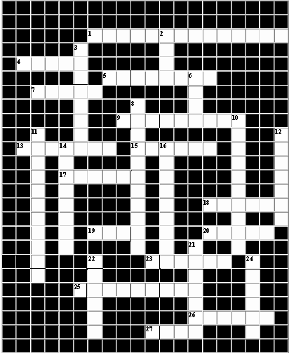
Down
2. A heavy hammer.
3. One of the 12 tribes of Israel: Hiram Abif’s tribe.
6. A famous maritime city of ancient Phoenicia.
8. A tropical fruit known for the abundance of its seeds.
10. A portable sanctuary: a temporary place of worship. A model
for King Solomon’s Temple.
11. A craftsman: a hewer in the mountains.
12. The strength and support of all institutions.
14. A Greek or Roman sacrifice consisting of 100 oxen or cattle.
16. What the plumb teaches. Strict observance of standards of
integrity and honesty: adherence to a high moral code.
21. The officer of the lodge who forms and conducts processions.
22. An open excavation usually for obtaining building stone.
24. Of or relating to the Cycladic island of Paros, noted for its
beautiful marble extensively used for sculptures in ancient times.
Across
1. The 2nd truly Masonic virtue. The quality or state of being
prudent and discreet.
4. A seaport where much of the material for King Solomon’s
Temple was landed.
5. A word meaning the quality or state of being faithful or loyal.
7. The hand which is the seat of fidelity.
9. The junction of darkness and light: the corner where the first
stone of a building is usually laid.
13. An emblem of industry.
15. A Grecian word signifying “I have found it.”
17. A vessel for burning incense: emblematical of a pure heart.
18. A word meaning made of brass.
19. The weaker part of man.
20. The officer of the lodge who guards against cowans.
23. The order of fiery six-winged angels who guard God’s throne.
25. A custom and rule which is unchanging and unchangeable.
26. The first 2 movable jewels. Freestone as it comes out of
the quarry.
27. Represented by clay. Impassioned eagerness especially in
favor of a person or cause.

“Our differences are politics. Our agreements are principles.” – Brother William McKinley
Contact Information
Shawn Wells: (618) 599-2060
Sheldon Bunting: (618) 839-7041
Dean Linder: (618) 516-1746
Delman Bradshaw: (618) 516-1779
Joe Pearce: (618) 231-5323
Dan Kinsolving: (618) 842-2675 or
(618) 919-0477
Billy Simpson: (618) 599-6214
Don Walker: (618) 599-1616
Ron Walker: (618) 599-1609
Doug Bone: (618) 599-1407
Freddie Vaughan Jr.: (618) 842-9609
John Dilges: (618) 599-5849
Jason Barnhart: (618) 599-6436

