From Darkness to Light

August 2008, Volume 1, Issue 2 Newsletter of Fairfield Lodge # 206

Trestle Board

August 2008
4 7:30 pm Stated Meeting
11 6:00 pm 2nd Degree at Wayne City
12 7:00 pm 2nd Degree at Sumner
15 6:30 pm Quarterly District Officers’
Meeting at Newton (3,4,8,9 S)
18 6:30 pm Steering Committee Meeting
18 7:30 pm Stated Meeting
22 6:00 pm 3rd Degree at Dieterich
23 8:00 am 1st Degree at Palestine
23 6:00 pm Book Signing and Dinner with
Masonic Author Todd Creason at
Callahan’s Restaurant in Lawrenceville
28 6:00 pm 3rd Degree at Flora
September 2008
1 Labor Day (No Lodge)
8 5:00 pm Practice Night
10 9:30 pm Setup For Fall Fun Fest Fundraiser
11 4:00 pmFall Fun Fest Fundraiser
12 4:00 pmFall Fun Fest Fundraiser
13 10:00 amFall Fun Fest Fundraiser
13 9:300 pm Tear Down For Fall Fun Fest
Fundraiser
15 6:30 pm Steering Committee Meeting
15 7:30 pm Stated Meeting
20 9:00 am GM Golf Tournament Benefit for Masonic
Children’s Home at Murphysboro
NOTES OF INTEREST
** Kady Bowman has been discharged from the Illinois Masonic Children’s Home in Murphysboro to reunite with her family. Your Lodge wishes you good luck Kady.
** www.mastermason.com/fairfield/index.html The official website of Fairfield Lodge # 206
** Deadline for September Newsletter Submissions: August 25
SICKNESS OR DISTRESS
Fortunately, there is no new sickness or distress that we are aware of. However, please continue to keep Worshipful Brothers Max Gray and Wayne Maddox in your thoughts and prayers. Brothers Claud Lamb, Terry Angle, and Worshipful Brother Melvin Maricle have all recently passed on to the Grand Lodge Above. Please remember their families in your thoughts and prayers as well.

DID YOU KNOW?

Low Twelve: In Masonic language midnight is so called. The reference is to the sun, which is then below the earth. Low Twelve in Masonic symbolism is an unpropitious hour.

Excerpt from
An Encyclopedia of Freemasonry
By Albert G. Mackey, M. D. 33rd Degree
POINT OF INTEREST

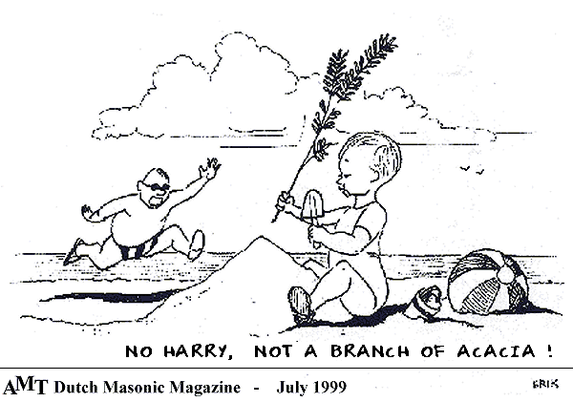

FROM THE EAST
Greetings Brethren, and welcome to the August edition of our newsletter. So far, this newsletter seems to have met with the approval of everyone. This is great news, for this newsletter has the potential to be one of the greatest platforms and tools of communication that we have ever had. As such, I would like to personally thank Brother Dan Kinsolving for his diligence and tireless efforts in getting this project off the ground, also for the alacrity and professionalism with which he has handled this project.
There are three things I would like to touch on briefly this month. First of all, we have been contacted about running a bingo at the Fall Fun Fest. While this would undoubtedly be a very successful fundraiser for us, there are two problems. First, we already have two projects going on at this time. So, unless enough interested brethren come forward to conduct it, we would not have the man power to adequately do the job. Second, there is an issue of legality. Code 211 of the Constitution and By-Laws of the Grand Lodge of Illinois could very well be interpreted to forbid just such an enterprise. However, in all fairness, I have referred this question to our By-Law and Jurisprudence Committee, who will give us a report at our next stated meeting, at which time we could discuss this proposal, if any of the brethren so choose.
Secondly, an apparent need has arisen for a Contact and Network Subcommittee to be attached to the Membership Committee. Since the Membership Committee will be occupied with other duties, it would be the duty of this subcommittee to periodically contact and check on shut-in or inactive members, and to notify the membership of all emergency situations and special meetings. If any brother is interested in performing this vital and important duty for the Lodge, please contact either me or our Senior Warden.
Finally, the webmaster of our website, Worshipful Brother Floyd Harris, has requested someone to assist him in updating and maintaining our website. Any brother who is interested should contact either him or me.

Fraternally Yours,
Jason Kinsolving
Worshipful Master

FROM THE WEST
Greetings Brethren, I don’t have much to report on this month. However, I would like to touch on the subject of the Membership Information Surveys. By now, you all should have received one. Brethren, it is very important that you fill these out and send them in. The information gathered in these surveys is the best way we have of determining how your lodge can best serve your needs.

Fraternally Yours,
Shawn Wells
Senior Warden

FROM THE SOUTH
Greetings Brethren, I don’t have much to report on in this our second newsletter. I would like to thank Brothers Dan Kinsolving, Joe Pearce, and John Dilges for preparing the food for Brother Chad Reid’s 2nd and 3rd degrees. The Fall Fun Fest is coming up soon. Anyone who is able to work at the lodge’s booth should contact an officer or Brother Joe Pearce to put their name on the sign up sheet. Membership is always important. Do you know someone who would make a good Mason?
Fraternally Yours,
Sheldon Bunting
Junior Warden

SECRETARY’S REPORT
Your lodge, along with the assistance of the Wayne County Sheriff’s Department and the City of Fairfield Police Department, is offering the ILCHIP program.
It is called the Illinois Child Identification Program (ILCHIP) and it is being sponsored by the Freemasons of Illinois. This vital information program provides everything you need to assist the authorities in finding a lost child.
Masons are funding the entire cost of this program and put together everything parents need to help the authorities find their lost child. It is the most comprehensive program of its kind.
Best of all it takes only ten minutes and supplies parents with a complete child identification package that can be taken home or carried with the family on vacation. The information (most of which is contained on a CD) is compact, and totally private. The ILCHIP program keeps only the parental consent form. And remember, IT IS FREE OF CHARGE TO PARENTS!
Here is what you get: a color photo showing the child’s height, DNA sample, finger prints, and a recorded interview. Be looking for the time and place for the event. Use it yourself, or tell any neighbor of this program for them and their children.

Fraternally,
Delman Bradshaw
Secretary

ILCHIP COMMITTEE
The sign-up for the IL CHIP program was a great success. We had over 90 kids sign up to receive a package. The children that have enrolled will be processed at the Wayne County Sheriff’s Department the week of August 24-30. Parents can still sign up for the service by calling the Wayne County Sheriff’s Department and asking for Linda. We are planning a second event during the Fall Fun Fest.
Jason M. Barnhart

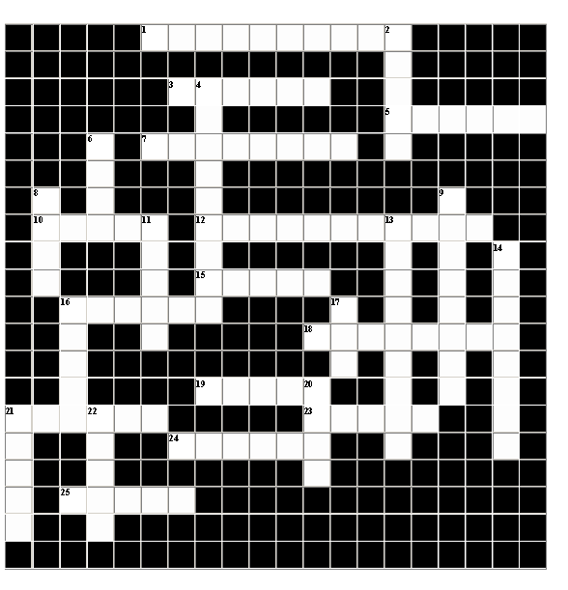
FUNRAISER COMMITTEE
Brethren, we will be selling brats, curly fries (with or without cheese), and bottled water at the Fall Fun Fest. This is our biggest fundraiser of the year, and we need your help to pull it off; especially for set up and tear down. If you would like to sign up for a shift give me a call at (618) 231-5323. One thing however, if you sign up for a shift, but are unable to make it, please find someone to take your place, so that we don’t end up shorthanded. If you can’t work, at least come eat and support your lodge. Also, we will have a small amount of Italian Beef on hand for those who would rather not have a brat. So, if anyone would be interested in donating some Italian Beef please let me know.
Worshipful Brother
Joe Pearce

“It is amazing what you can accomplish if you do not care who gets the credit.” – Harry S Truman, MWPGM of MO
Down
2. A place of darkness.
4. The fifth order of architecture: invented by the Romans
6. One of the wages of a fellowcraft, denoting plenty.
8. One of the wages of a fellowcraft, denoting health.
9. The fifth science, which forms the basis of Freemasonry.
11. An unskilled workman, or pretender.
13. A useful and valuable instrument which teaches friendship, morality, and brotherly love.
14. An emblem of fervency.
16. Right angles, horizontals, and perpendiculars.
17. One of the wages of a fellowcraft, denoting peace.
20. An emblem of zeal.
21. A divine attribute, and the foundation of every virtue.
22. An emblem of freedom.
Across
1. The fourth order of architecture: invented by the Greeks.
3. An emblem of time.
5. The special working tool of a master mason.
7. An emblem of innocence, and the badge of a mason.
10. The third order of architecture: invented by the Greeks.
12. A figure of two dimensions.
15. A certain friendly and brotherly grip, whereby one mason may know another in the dark as well as the light.
16. An angle of 90 degrees, or the fourth part of a circle.
18. An upright architectural member which projects from the wall of a building.
19. The second order of architecture: invented by the Greeks.
21. The first order of architecture: invented by the Romans.
23. An emblem of equality. Worn by the SW.
24. A thorny evergreen symbolizing the immortality of the soul.
25. An emblem for rectitude of life. Worn by the JW.
FROM THE EDITOR
Greetings Fellow Brethren,
From all indications, the newsletter seems to have been well received by all the members, thus far. Once again, I would like to thank all the officers for their cooperation, especially the WM who always has times and dates ready for me. I would like to briefly touch on two or three subjects. First of all, any time you have a project of such magnitude as this newsletter, you have to have the support of everyone. As such, we are in need of your support in this endeavor. Those who contribute any amount toward this newsletter will have their name published every month in a “Newsletter Supporters” section. Second, our annual fundraiser at the Fall Fun Fest is fast approaching. Brethren, this is our biggest fundraiser of the year. So, if you are unable to help work, for whatever reason, at least stop by our stand and show your support for your Lodge. Third, I am looking forward to the start of the Supper Club season, as I am sure many of you are. We all need to show our support of this wonderful program. With that in mind, we will be promoting a Supper Club incentive program next month. Finally, I would like to congratulate the York Rite Bodies of Bridgeport on all of their awards and success at their Grand Sessions in Peoria, particularly for winning the state championship in the Keystone Quest. It is nice to see brethren from the southern part of the state finally get recognized for all the hard work they do to promote Freemasonry in general.

Fraternally Yours,
Dan Kinsolving
Editor

NEWSLETTER SUPPORTERS

Dan Kinsolving Jason Kinsolving
Jonah Kinsolving Jake Kinsolving

