September 2006
Sunday | Monday | Tuesday | Wednesday | Thursday | Friday | Saturday
 |  |  |  |  | 1 | 2
3 | 4 | 5 | 6 Stated Meeting  Welcome Back Night  Refreshments: Treas. | 7 | 8 | 9
10 | 11 | 12   Shawnee | 13 | 14 | 15 | 16  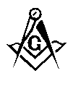 SW's Meeting  9:00 a.m. Wayne
17 | 18 | 19  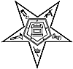 Hawthorne | 20 Stated Meeting  Refreshments: Sec. | 21  Sidney | 22  10th District  7:00 p.m. Latham | 23
24 | 25 | 26  Shawnee  Ivanhoe | 27  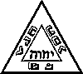 St. Marys Chapter & Council | 28 | 29 | 30

