October 2006
Sunday | Monday | Tuesday | Wednesday | Thursday | Friday | Saturday
1 | 2 | 3 | 4 Stated Meeting  Refreshments: S.D. | 5 | 6 | 7
8 | 9 | 10  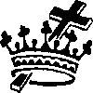 Shawnee | 11 | 12 | 13 | 14
15 | 16 | 17  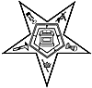 Hawthorne Farewell Meeting  OR Installation | 18 Stated Meeting  Refreshments: J.D. | 19  Sidney | 20  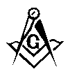 Grand Lodge  at Dayton | 21  Grand Lodge  at Dayton
22 | 23 | 24  Shawnee  Ivanhoe | 25  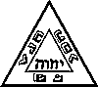 St. Marys Chapter & Council | 26 | 27 | 28
29 | 30 | 31

