November 2006
Sunday | Monday | Tuesday | Wednesday | Thursday | Friday | Saturday
 |  |  | 1  Annual Meeting  Election  Refreshments: W.M. | 2 | 3 | 4
5 | 6 | 7 | 8 | 9 | 10 | 11
12 | 13 | 14  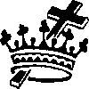 Shawnee | 15  Stated Meeting  Insallation  Refreshments: W.M. | 16 | 17 | 18
19 | 20  Sidney | 21  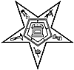 Hawthorne | 22 | 23 | 24 | 25
26 | 27 | 28  Shawnee  Ivanhoe | 29  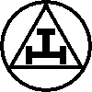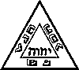 St. Marys Chapter & Council | 30

