May 2006
Sunday | Monday | Tuesday | Wednesday | Thursday | Friday | Saturday
 | 1 | 2 | 3 Stated Meeting  Refreshments: Tyler | 4 | 5  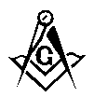 Education & Ritual Meeting  7:00 p.m. Latham | 6
7 | 8 | 9   Shawnee | 10 | 11 | 12 | 13
14 | 15 | 16  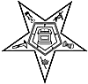 Hawthorne | 17 Stated Meeting  Refreshments: W.M. | 18  Sidney | 19 | 20
21 | 22 | 23  Shawnee  Ivanhoe | 24  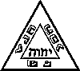 St. Marys Chapter & Council | 25 | 26 | 27
28 | 29 | 30 | 31

