March 2006
Sunday | Monday | Tuesday | Wednesday | Thursday | Friday | Saturday
 |  |  | 1 Stated Meeting  Refreshments: J.D. | 2  7:00 Ft. Amanda | 3 | 4  1:00 p.m. Senate
5 | 6  7:30 p.m. Lima | 7 | 8 | 9 | 10  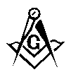 Secretary's Meet | 11  Secretary's Meet
12 | 13  7:00 p.m. Bluffton | 14   Shawnee | 15 Stated Meeting  Refreshments: S.S.  7:00 p.m. Ada | 16  7:00 p.m. Dunkirk  Sidney | 17 | 18
19 | 20 | 21  7:00 p.m. Hamer  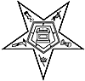 Hawthorne Annual Inspection | 22  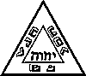 St. Marys Chapter & Council | 23  7:00 p.m. Wayne | 24  10th District  7:00 p.m. Ft. Amanda | 25 Mt. Cory  7:30 a.m. breakfast  9:00 a.m. EA Insp.  Ivanhoe  2:00 Inspection
26 | 27  7:00 p.m. Garrett-Wykoff | 28  Shawnee  Ivanhoe | 29 | 30 | 31

