June 2006
Sunday | Monday | Tuesday | Wednesday | Thursday | Friday | Saturday
 |  |  |  | 1 | 2 | 3
4   Ohio Masonic Home Day. | 5 | 6 | 7 Stated Meeting  Refreshments: S.W. | 8 | 9 | 10
11 | 12 | 13   Shawnee | 14 | 15  Sidney | 16 | 17
18 | 19 | 20  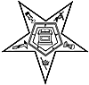 Hawthorne Election of Officers | 21 Stated Meeting  Refreshments: J.W. | 22 | 23  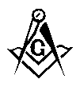 10th District  7:00 p.m. Mercer | 24  Feast of Saint John the Baptist
25 | 26 | 27  Shawnee  Ivanhoe | 28  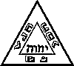 St. Marys Chapter & Council | 29 | 30

