December 2006
Sunday | Monday | Tuesday | Wednesday | Thursday | Friday | Saturday
 |  |  |  |  | 1 | 2  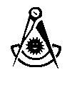 Past Master's Convocation  TBA -- Latham
3 | 4 | 5 | 6 Stated Meeting  Refreshments: S.W. | 7 | 8 | 9
10 | 11 | 12   Shawnee | 13 | 14 | 15 | 16
17 | 18  Sidney | 19  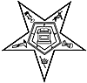 Hawthorne | 20 Stated Meeting  Refreshments: J.W. | 21 | 22 | 23
24 | 25 | 26  Shawnee  Ivanhoe | 27 Feast of Saint John the Evangelist  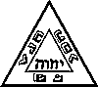 St. Marys Chapter & Council | 28 | 29 | 30
31

