

Installation of Officers
December 20, 2008
Past Masters of Shively Lodge

Shively Lodge 951 F & AM
Stanely W. Crawley Jr 1960
Edwin R. Acree 1961 & 1963
Howard C. Reeves 1962
Earl R. Merrick Jr 1963
Joseph A. Davis 1964
Sherman T. Sappington 1965
Lucien R. Rankin 1966
Sol E. Ashley 1967
Wilbur E. Rice 1968
John L. Sanders 1969
Charles E. Singleton 1970
Gervis R. Williams 1971
Larry R. Jones 1972
Roland T. Stayton 1972 & 1973

Herbert R. Ritchie 1974
Grover Crabtree 1975
William T. Ashby 1976
Henry Sturbaut 1977
James R. Schaub 1978
Roy L.. Gribbins 1979 & 1999
Everett L. Parish 1980
James A. Bennett Jr 1981
William H. Rader 1982 & 2008
James L. Roberts 1983
Charles A. Kirchner 1984
Bobby R. Woodruff 1985
Donald G. Fraley 1986
Raymond Carman Jr 1987
Michael G. Dohn 1988
Gerald W. Ashby 1989
Charles W. Embry 1990
James T. Scott 1991
Stanley Philip Ott Jr 1992
Clifford D. Tharp Jr 1993
James A. Price 1994
Frederick T. Lacy 1995
Ernest J. Royal 1996
Donald L. Dunlap 1997 & 2000

4221 Hillview Avenue

Shively, Kentucky 40216

502.448.3782

Silas A. Tomes 1998
James T. Ashby 2001
James T. Thompson 2002
James W. Coleman 2003
George M. McConnell 2004 & 2006
Duncan B. McConnell 2005
Richard W. Viglione 2007

Officers for 2009 

Welcome Message William H. Rader PM

Installation of 2009 Officers
Installing Officer Raymond Carman Jr. PM
Installing Marshall Gerald W. Ashby PM

Master’s Greeting Silas A. Tomes PM

Officer’s Introductions 2009 Officers

Pin Presentation

Closing Remarks Silas A. Tomes PM

Benediction

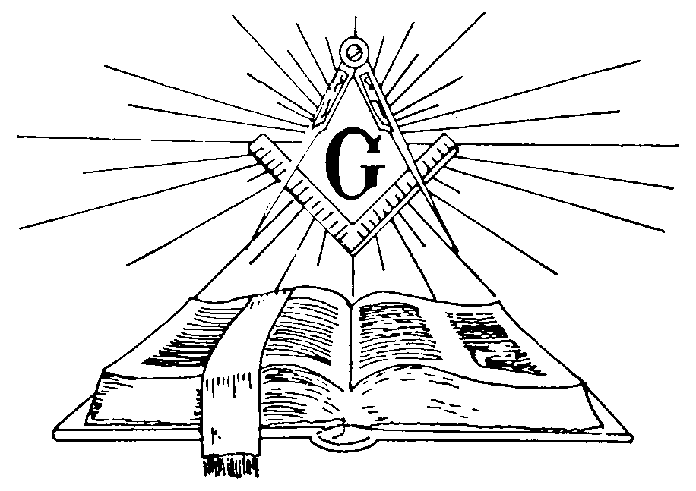

Master Silas A. Tomes, PM

Senior Warden Stanley W. Crawley Jr. PM

Junior Warden Roy Lay PM

Treasurer Gerald W. Ashby PM

Secretary Raymond Carman Jr. PM

Chaplain William D. Strader PM

Senior Deacon Edwin W. Compton

Junior Deacon Robert K. Felts

Senior Steward Randall A. Sipes

Junior Steward Carlton McMichael

Tyler Kenneth C. Dutschke

Building Committee William T. Ashby PM

Trustee William D. Strader PM

