
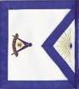
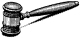

Shively Lodge 951 F & AM
Installation of Officers
December 20, 2008

Stanely W. Crawley Jr1960
Edwin R. Acree 1961 & 1963
Howard C. Reeves1962
Earl R. Merrick Jr1963
Joseph A. Davis1964
Sherman T. Sappington1965
Lucien R. Rankin1966
Sol E. Ashley1967
Wilbur E. Rice1968
John L. Sanders1969
Charles E. Singleton1970
Gervis R. Williams1971
Larry R. Jones1972
Roland T. Stayton 1972 & 1973
Herbert R. Ritchie1974
Grover Crabtree1975
William T. Ashby1976
Henry Sturbaut1977
James R. Schaub1978
Roy L.. Gribbins 1979 & 1999
Everett L. Parish1980
James A. Bennett Jr1981
William H. Rader 1982 & 2008

James L. Roberts1983
Charles A. Kirchner1984
Bobby R. Woodruff1985
Donald G. Fraley1986
Raymond Carman Jr1987
Michael G. Dohn1988
Gerald W. Ashby1989
Charles W. Embry1990
James T. Scott1991
Stanley Philip Ott Jr1992
Clifford D. Tharp Jr1993
James A. Price1994
Frederick T. Lacy1995
Ernest J. Royal1996
Donald L. Dunlap 1997 & 2000
Silas A. Tomes1998
James T. Ashby2001
James T. Thompson2002
James W. Coleman2003
George M. McConnell 2004 & 2006
Duncan B. McConnell2005
Richard W. Viglione2007

Past Masters of Shively Lodge 951 F & AM

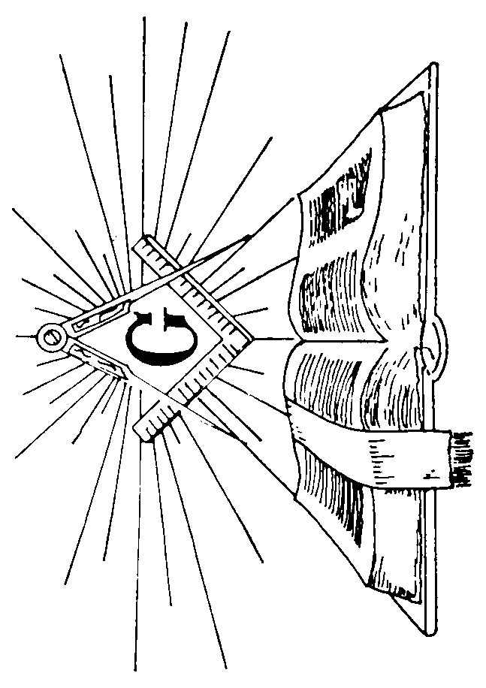
Master Silas A. Tomes, PM
Senior WardenStanley W. Crawley Jr., PM
Junior WardenRoy Lay, PM
TreasurerGerald W. Ashby, PM
SecretaryRaymond Carman Jr., PM
ChaplainEdward L. Norman
Senior DeaconEdwin W. Compton
Junior DeaconRobert K. Felts
Senior StewardRandall A. Sipes
Junior StewardCarlton McMichael
TylerKenneth C. Dutschke
Building CommitteePhilip Ott (3 years)
William H. Rader, PM (1 year)
TrusteeRoland T. Stayton, PM

Officers for 2009

Welcome MessageWilliam H. Rader, PM

Installation of 2009 Officers
Installing OfficerRaymond Carman Jr., PM
Installing Marshall Gerald W. Ashby, PM

Master’s GreetingSilas A. Tomes, PM

Officer’s Introductions2009 Officers

Pin Presentation

Closing RemarksSilas A. Tomes, PM

BenedictionEdward L. Norman

