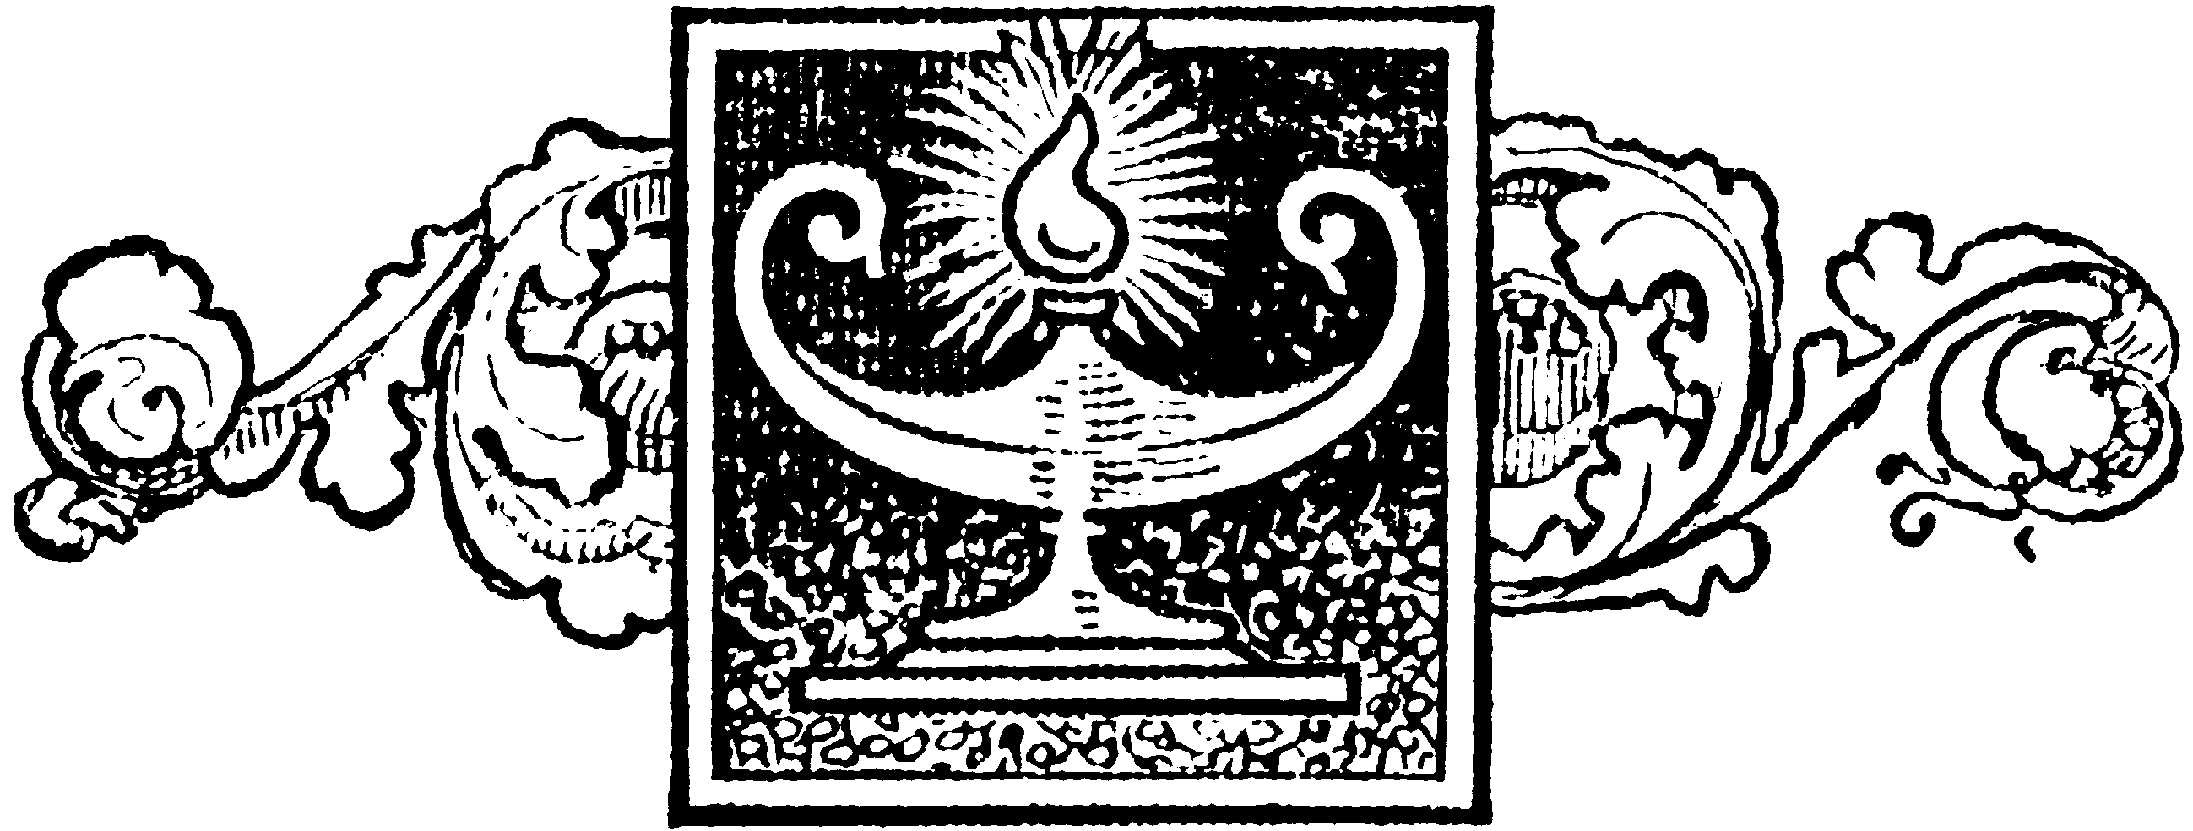
The New Jersey Lodge ofMasonic Research and Education Number 1786

Statement of Purpose
The purpose of the New Jersey Lodge of Masonic Research and Education is to foster the education of the Craft at large through prepared research and open discussion of topics concerning Masonic History, Symbolism, Philosophy, and Current Events.

MEMBERSHIP APPLICATION

The Initial Membership Fee is $ 25.00 and the Annual Dues are $25.00. A personal check, bank check or money order made out to “NJ Lodge No. 1786” in the amount of $50.00 must accompany this application.
Mail to our Secretary: WB Matthew Korang / 344 East Union St. / Burlington, NJ 08016

Please clearly print or type the following information

 Brother  Dist. Brother  WB RWB  MWB

Name_______________________________________________GL No.___________________

Address______________________________________________________________________

____________________________________________________________ Zip _____________

Telephone (home) __________________________ (business)__________________________

Fax _________________________ E-mail _________________________________________

Lodge Affiliation (Mother Lodge or Lodge currently attending)

Name _____________________________________________Number _____________

Address _________________________________________________________________

Grand Lodge of _________________________________________________
Lodge Seal
Signature of Lodge Secretary ______________________________________

“I respectfully represent that I am a Master Mason in good standing in a Lodge of Master Masons in the State of New Jersey or in a Grand Jurisdiction with which New Jersey maintains fraternal relations and do hereby make application for membership.”

Applicant Signature ______________________________________________

Upon acceptance of an application the member will be sent a copy of the By-laws of the Lodge and the “Procedure for Preparing and Presenting Papers”. Each year every member in good standing will receive the Proceedings of the Lodge for that year, which will include the minutes of the Stated and Emergent Communications of the Lodge and copies of all papers presented during the year.

NJ Lodge of Masonic Research & Education No. 1786 – http://www.njlore1786.org

