

Kinder Morgan Energy Partners, L.P.

Liquid Pipelines

SCADA Alarm Management

Principles and Philosophy

Table of Contents

Introduction 3
The Alarm Problem 4
What is an Alarm? 5
Alarm Priority 6
Priority levels: Critical, High, Low. 6
Alarm Priority Matrix 8
Logging & Historical Archive 9
Measurement & Reporting 9
List of Suppressed Alarms 10
Alarms Per Day 10
Top 20 Alarms 11
Alarms Per 10 Minute Period or Alarm Floods 11
Stale Alarms 12
Summary of Changes in Alarms Needing MOC 12
Continuous Improvement: 13
Identify Potential Improvements 13
Re-engineer Target Alarms 13
Implement Through MOC 13
Audit Compliance 14
Glossary: 15
Contact 17

Introduction
The alarm system is the primary tool for identifying abnormal situations and helping pipeline personnel take timely, appropriate corrective action. Effective alarm systems create effective operators; ineffective systems pose a serious risk to safety, the environment, and company profitability.
Too often, alarm system effectiveness is undermined by poorly configured alarms, static alarm settings that can't adapt to dynamic pipeline conditions, and a host of other nuisance alarms, resulting in alarm floods that overwhelm operators when they need to focus on potentially serious problems.
The first, most important step in alarm management is: to collect the data. Each of the SCADA systems in use by Kinder Morgan Liquid Pipelines collects and archives all alarm and event data in sufficient detail to allow reporting and analysis by control seat. It all begins with the data – you cannot control what you do not measure. Collection of real-time alarm data, and archiving that data for further analysis, is the necessary and underlying foundation of any alarm management system.
Alarm Management at KMEP is a continuous process as depicted in the following illustration. Each of the steps in this process will be discussed in detail in the remainder of this document.
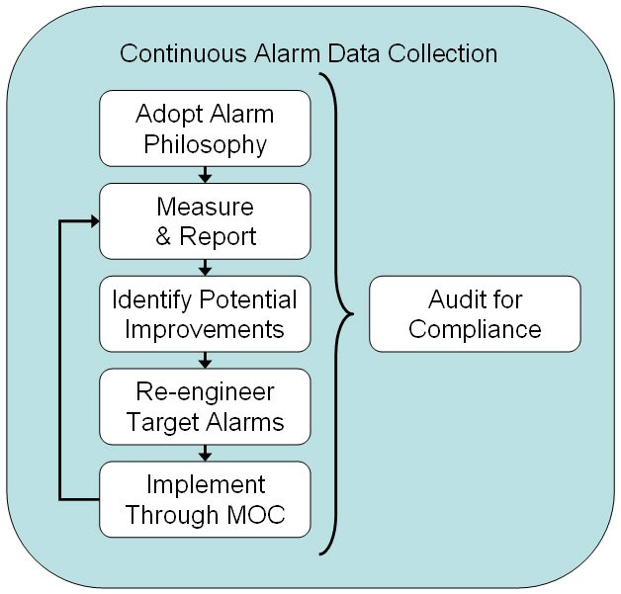
The key message is that it is never going to be acceptable to conduct one review and implement the conclusions. This is to be part of a continuous process of improvement, just as it is with most other business areas such as quality. Why manage safety any differently?

The Alarm Problem
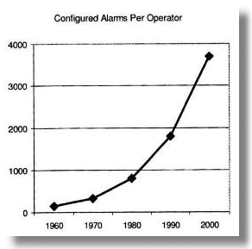
Two industry trends have converged to cause the current alarm problem. First, alarms have become inexpensive and therefore are more widely configured. Secondly, technology has allowed the span of control for a single operator to expand significantly, taking on ever increasing responsibility as a result of consolidation and down-sizing. Therefore, the number of alarms per control seat has expanded exponentially.
For many companies, the shear volume of alarms is now inhibiting operator performance, rather than enhancing it. KMEP recognizes this as a critical issue and is taking the steps outlined in this document to mitigate the negative impact of this convergence. These alarms must be managed. Troublesome alarms must be identified and corrected; and new alarms must be created in a disciplined, orderly process.
The most reported problem with alarms systems is nuisance alarms. These are alarms that trigger when no abnormal or atypical condition exists or when no operator action is required. Maintenance issues are a frequent cause of nuisance alarms. Because they require no response, these alarms desensitize the operator, and thus reduce the response to real alarms.
Another common problem is stale alarms – alarms that remain in the alarm state for more than 24 hours because no operator action is required or because they do not clear after operator action has been taken. These alarms build a baseline of clutter in the alarm system masking other alarms from the operator.
One of the most dangerous problems with alarm systems, and the most complex to solve, is the flood of alarms usually associated with an event. An alarm rate of 10 or more alarms in 10 minutes defines the beginning of an alarm flood. An alarm flood may last several minutes to several hours. It is determined to have ended when the alarm rate drops below 5 alarms in 10 minutes. These alarm floods overwhelm the operator making it difficult to process the alarms and determine the cause of the event.
One other common problem is a lack of clarity of real alarms. When the cause of the alarm or the response to the alarm is not clear to the operator, the desired action is delayed or not taken and the alarm is ineffective.
The principles and philosophy presented in this document specifically address these issues.

What is an Alarm?
This is a most basic, and most important, question.
An alarm is:
An audible and/or visible means of indicating to the operator an equipment malfunction, process deviation, atypical or abnormal condition requiring a response.

The purpose of an alarm is to prompt a unique operator action.
An alarm is an annunciated process condition to which the operator must and can take appropriate action. Some actions will return the process to normal and safe operation. Others are required to react to operational changes in hydraulics, volume measurements and/or product quality.
- Every alarm presented to the operator should be meaningful (clear) and relevant to the operator.
- Every alarm should have a defined response.
The alarm system must be reserved for events that require operator action. Only such events shall be configured as alarms. Events that are useful only “for operator information” or similar reasons, not involving action, can and should be presented in a variety of ways other than the use of the alarm system.
Alarms must exist solely as a tool for the benefit of the operator. They are not to be configured as a tool for the benefit of the control engineer or other staff.
Alarms should meet each of the following criteria:
- Does the event require operator action? Events that do not require operator action shall not be allowed to produce alarms.
- Is the alarm the best indicator of the situation’s root cause? Alarms should be placed, configured, and handled so that a single process event does not produce multiple alarms all signifying the same thing. Alarms should be configured on the best indicator of the root cause of a situation.
- Is the alarm truly resulting from an abnormal situation? Alarms should not activate during routine process variable changes, or from normal, expected cases of operation.

Alarm Priority
An alarm is an audible and/or visible means of indicating to the operator an equipment malfunction, process deviation, atypical or abnormal condition requiring a response. If a response is not required, it may be an event to be written to a log or journal, but it is not an alarm.
Not all alarms are of equal importance. The purpose of assigning a priority is to help ensure that those alarms with the greatest risk and urgency of response do not become obscured by alarms of lesser consequence. It is therefore important that a consistent evaluation of risk and urgency is applied when assigning the priority level to an alarm.
EEMUA studies have shown that to maximize operator effectiveness, no more than three different sets of alarm priorities should be configured in an entire system. This alarm priority attribute can be used to ensure that the highest priority unacknowledged alarm is displayed at all times. It also provides one means of filtering alarm display lists so that operators can home in on specific critical alarms.

Priority levels: Critical, High, Low.
A two-dimensional matrix is used to assign the priority to each alarm. Each alarm is evaluated using this same matrix and the same criteria. By applying these criteria consistently across all alarms, the resulting alarm priorities properly reflect the relative importance when multiple alarms occur simultaneously.
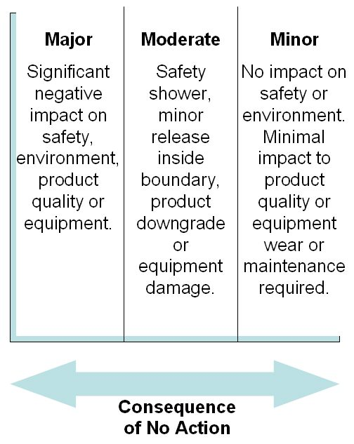
The horizontal axis of the matrix addresses the consequences if an alarm occurs and no operator action is taken in response. The categories are: Major, Moderate or Minor.
Each alarm is evaluated independently on its own merit. The cascading effect that might follow the alarm is excluded.
For example: Low tire pressure increases tire wear, which could cause a tire blow out, which at high speed could cause a loss of control of the vehicle, which could result in a crash, which could result in property damage and/or loss of life.
While all of this is true, an alarm for low tire pressure should only consider the increased wear on the tire, not the cascading effect. The low tire pressure alarm would have Minor consequence of no action.
Note: If there are no consequences from the failure to take operator action in response to the alarm, then it is not an alarm.
The vertical axis of the matrix addresses the urgency of response. The “maximum time to respond” is the time within which the operators can take action(s) to prevent or mitigate the undesired consequence(s) caused by the abnormal condition. This response time must include the action of outside personnel following direction from the console operator.
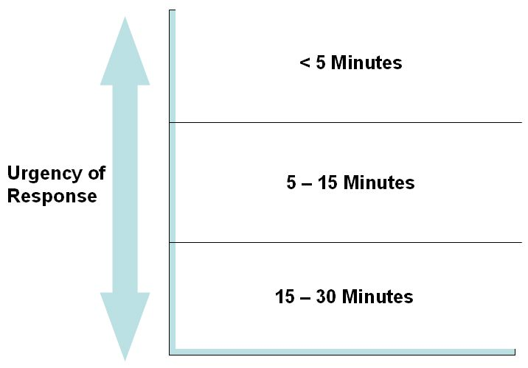
This is not how long it actually takes the operator to take the action, which might only be a few seconds in the best scenario. It is how much time is available, to take the effective action from when the alarm sounds to when the consequence becomes unavoidable, regardless of the action.
Note the upper time limit. If a condition does not require a response within 30 minutes, then the condition does not meet the criteria for the creation of an alarm.

Alarm Priority Matrix
The following matrix reflects these criteria. Those alarms that require the most urgent response – less than 5 minutes – and carry the more severe risk of no action, are classified as Critical. Those alarms with the least urgency of response and least significant consequences of no action are classified as Low priority; the others are High priority. The EEMUA guidelines suggest that the priority distribution of all defined alarms should be: no more than
- 10% Critical,
- 20% High and the remaining
- 70% Low priority.
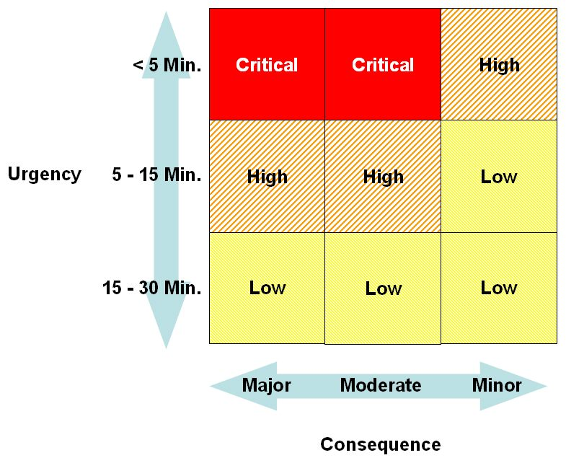
In tabular lists, the alarm priority should be obvious. This may be accomplished with the use of color, or segregation by priority class, or both.
Also, the audible annunciation should be different for Critical, High and Low alarms. Further, in a control room, each console should be able to choose its own “family” of sounds for priority.

Logging & Historical Archive
Alarm and event data is captured in real-time. It is real-time alarm information that allows operator’s to control the pipeline in a safe, effective manner. This alarm and event data is also archived, for it is the analysis of this historical information that allows refinements in the process to be identified.
Real-time alarm data is routed to the operator control seat responsible for taking action on the alarm. Archiving of the alarm data could occur at that location. (All analysis – all Measurement & Reporting – described in the next section is organized by control seat.) Alarm data could also be archived centrally, but if control is not centralized by control center.
Where to maintain the historical archive is a business decision with impacts in many areas. However, regardless where the archive is maintained, the following capabilities are essential.
- Real-time alarm & event data must be available at the control seat responsible for taking action.
- This alarm & event data must be encoded in a tabular format for fast storage and easy retrieval from a database.
- This data must be available to those responsible for Measurement & Reporting, continuous improvement, and accident investigation.

Measurement & Reporting
The following reports shall be available by control seat. If the pipeline is normally controlled centrally via a console in a Control Center, then these reports should be produced by console. If control is distributed to each facility or location, then these reports should be produced by location.
For each control seat:
- List of Suppressed Alarms
- Alarms Per Day
- Top 20 Alarms
- Alarms Per 10 Minute Period, or Alarm Floods
- Stale Alarms
- Summary of Changes in Alarms Needing MOC
Each of these reports will be discussed individually.

List of Suppressed Alarms
Each of the SCADA systems in use by KMEP Liquid Pipelines provides an ability to “suppress” an alarm which prevents the alarm from being presented to the operator. This is intended for use when a field sensor has a problem and begins creating a chattering alarm every few seconds. The operator needs and looks for a way to eliminate this nuisance. Alarm suppression is a temporary override.
The operator should be able to call up, or print, a report of Suppressed Alarms at the beginning of each shift. This report should identify each alarm being suppressed, when it was suppressed, and the reason that it was suppressed.
Reviewing this report should be a procedural requirement at shift change.

Alarms Per Day
The number of alarms per day is a good indicator of the overall health of the alarm system. This count of alarms per day should only include those alarms that are presented to the operator.
This report is available on demand and is reviewed weekly. Normally, the data presented should span the most recent 90 days, though this is a run-time variable.
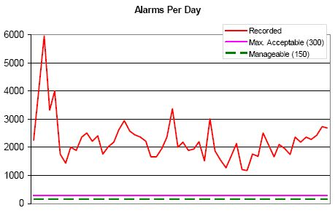
If alarms are suppressed and only written to a log file or journal, (not presented to the operator), then they should not be included in this count. A separate review into the quantity of these suppressed alarms should be made, since a large volume of such entries can negatively impact system throughput and performance.

Top 20 Alarms
This report is a simple ranking of the most frequent alarms during the analysis period. (The analysis period should be a runtime variable, but should default to the past 30 days.) This analysis can direct improvement efforts to where they will do the most good.
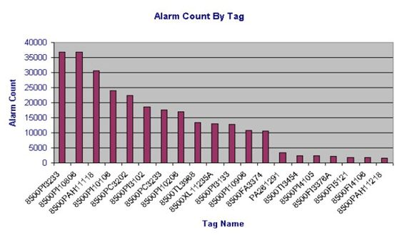

Alarms Per 10 Minute Period or Alarm Floods
“Burst Rates” of alarms are quite important. Looking at alarms in 10-minute time slices gives a better picture of this than the daily counts.
An alarm rate of 10 or more alarms in 10 minutes defines the beginning of an alarm flood. Such rates can continue for hours. During such periods, the likelihood of an operator missing an important alarm increases, as has been shown many times in the analysis of major accidents.
As with the Alarms Per Day, this report should be available on demand and should be reviewed weekly. Normally, the data presented should span the most recent 7 days, though this could be a run-time variable.
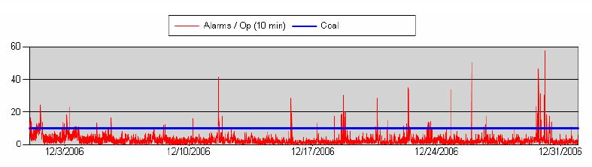
A refinement of the “Alarms Per 10 Minutes” analysis is the Alarm Flood analysis. An Alarm Flood can last for many hours and include hundreds, or thousands, of alarm events. Alarm floods can make a difficult process situation much worse. This analysis shows the Alarm Floods occurring during the time span, the average and maximum alarm events in each flood, and the average and maximum duration of each flood.

Stale Alarms
This is a simple listing of alarms that have been in the alarm state for more than 24 hours.
Following their initial appearance, stale alarms provide no valuable information to the operators. They clutter the alarm displays and interfere with the operator’s ability to detect and respond to new and meaningful alarms. Most stale alarms are not indicating a truly abnormal situation.

Summary of Changes in Alarms Needing MOC
Certain changes made in the system should be done under Management-of-Change (MOC) control, as system safety and integrity can be compromised. Such changes should be properly evaluated, authorized and communicated to all affected personnel.
The following table summarizes several such changes as recorded in the log files. These entries can be compared with the MOC records in an audit fashion to ensure that unauthorized, undocumented changes are not occurring.
Types of Changes Needing MOC:
- Alarm Suppression
- Alarm Trip Points
- Alarm Priority
- Point Range
- Point Execution Status
- Tuning Coefficients

A summary report should be available on demand that counts the number of each of these types of changes made during the analysis period. (The analysis period should be a runtime variable, but should default to the past 30 days.) A detailed listing of each recorded change should also be available.

Continuous Improvement:
Alarm Management is an ongoing activity, not a one-time event.
Using the collected alarm data, the Alarm Philosophy, and the measurement reports defined in the preceding section, continuous improvements in the Alarm System can be made.

Identify Potential Improvements
Often, the “Top 20” most frequent alarms comprise anywhere from 25% to 95% of the entire system load. Obviously, if those alarms are dealt with successfully, then major system improvement will occur, and with comparatively little effort.

Re-engineer Target Alarms
For many “bad actor” alarms, the correction can be achieved through one of the three following tools.
- Proper alarm deadband configuration. Similar to deadband for setpoints and process control, alarms on analog values should also have a deadband specified. As a process value passes through an alarm setpoint, any “noise” or slight variation of the signal will cause multiple alarms, if there is too small of an alarm deadband.
- Proper process filter configuration. It is more important that process value filters act correctly for control than for their resulting alarm characteristics. Therefore, signal filtering is generally not a desirable method to use to address a chattering alarm.
- Proper alarm delay time (On-delay of Off-delay) configuration. (Applies to both analog and digital alarms.) Use the On-delay time parameter to prevent a transient alarm from ever being presented to the operator. The Off-delay prevents the alarm from automatically clearing until it remains clear for this interval. Two types of frequency analysis can be performed on the historic alarm data to help determine the appropriate On-delay/Off-delay values. That is: time-in-alarm (duration); and time-between-alarms (interval).
Other techniques may be appropriate for correcting “Stale alarms”, duplicate alarms, and nuisance “bad measurement” alarms.

Implement Through MOC
Management of Change (MOC) is a well-understood and required manner of doing business in the pipeline industry. Any addition of piping, instruments, equipment, etc., is rigorously controlled with documentation, safety checklists, training requirements, and approvals. This methodology, however, often overlooks the alarm system.
Significant time and effort will have been expended implementing this Alarm Philosophy at KMEP. Without a proper MOC system, the alarm configuration will drift into a suboptimal set over a short period of time.

Audit Compliance
An annual or periodic audit of this process provides a number of benefits. It reinforces the fact that there are rules and guidelines in-place, and that these rules and guidelines are important. It confirms that these rules and guidelines are being followed.
It also provides the opportunity to re-examine the rules and guidelines – the Alarm Philosophy – to determine if it should be changed. Each year there are changes in available technology, as well as in learned “best practices” in alarm management. Besides auditing for compliance with the current Alarm Philosophy, the philosophy itself should be audited to ensure that it correctly reflects the current desired principles and practices.
This KMEP SCADA Alarm Management Principles and Philosophy document defines the framework to be followed for continuous improvement. This is a journey, not a destination.

Glossary:
Term | Definition
Abnormal Operating Condition | A condition identified by KM that may indicate a malfunction of a component or deviation from normal operations that may indicate an operating condition that could exceed design limits or could result in hazard(s) to persons, property or the environment.
Alarm | An audible and/or visible means of indicating to the operator an equipment malfunction, process deviation, atypical or abnormal condition requiring a response.
Alarm Flood | An alarm rate of 10 or more alarms in 10 minutes defines the beginning of an alarm flood. An alarm flood may last several minutes to several hours. It is determined to have ended when the alarm rate drops below 5 alarms in 10 minutes.
Alarm Management | The processes and practices for determining, documenting, designing, monitoring, and maintaining alarm systems.
Alarm System | The collection of hardware and software that detects an alarm state, transmits the indication of that state to the operator, and records the transmission.
ASM | The Abnormal Situation Management (ASM) Consortium, formed in 1994, is an active Honeywell-led research and development consortium of 14 companies and universities. (http://www.asmconsortium.com/)
Atypical Operating Condition | A deviation from normal operations where the conditions are within the parameters identified by KM.
Chattering Alarm | An alarm that comes in and clears at least 3 times in one minute.
DCS | Distributed Control System. Synonym for a modern SCADA system.
EEUMA | The Engineering Equipment & Materials Users’ Association. This organization published the EEMUA Publication 191 “Alarm Systems: A Guide to Design, Management and Procurement” in 1999. This has become a seminal reference document for Alarm Systems. (http://www.eemua.org/)
HSE | Health and Safety Executive. The Health and Safety Commission is responsible for health and safety regulation in Great Britain. The Health and Safety Executive and local government are the enforcing authorities who work in support of the Commission. (http://www.hse.gov.uk/)
HAZOP | HAZOP is an abbreviation for HAZard and Operability analysis. HAZOP Studies are performed by a team consisting of plant operators, engineers, managers and others, some of whom should be intimately familiar with the facility being studied.
ISA | ISA – The Instrumentation, Systems, and Automation Society. Founded in 1945, ISA develops standards; certifies industry professionals; provides education and training; publishes books and technical articles; and hosts an annual conference and exhibition for automation professionals.
ISA-SP18 | ISA-SP18, Instrument Signals and Alarms Committee. This committee develops standards, technical reports, and guidelines for alarm systems including annunciators and process automation systems.
LOPA | Layers of Protection Analysis
Nuisance Alarms | Alarms that trigger when no abnormal condition exists or when no operator action is required.
OSHA  CFR 29  Regulation 1910.119 | Occupational Safety & Health Administration standard titled: “Process safety management of highly hazardous chemicals”. (http://www.osha.gov/)
P&ID | Piping and Instrumentation Diagram - a schematic diagram showing piping, equipment and instrumentation connections within process units.
PHA | Process Hazard Analysis
SCADA | The acronym for Supervisory Control And Data Acquisition. A SCADA system includes input/output signal hardware, controllers, HMI, networks, communication, database and software. See also DCS.
SIL | Safety Interlock Level (SIL) alarms.
Stale Alarm | An alarm that remains in the alarm state continuously for more than 24 hours.

Contact
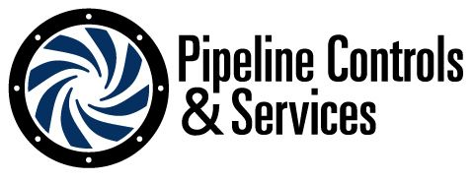 | Donald P. Gresh Email: dgresh@pipecs.com  Pipeline Controls & Services, Inc. Phone: (706) 636-1802  515 Staghorn Court  Alpharetta, Georgia 30004

