GLOSSARY

Adjourn, cannot adjourn and reconvene
Anno Lucis
Apron, lambskin - long lecture
Apron, properly clothed
Apron, lecture explained
Balloting is inviolate, un-Masonic to disclose vote
Brotherly Love, the principle of
Cabletow
Cardinal Virtues
Circumambulation, walking around the Altar
Demit vs. Renunciation
Ecclesiastes XII, Meaning of the allusions in the,
Esoteric Masonry
Freemasons, what’s free
Holy Sts. John
Landmarks, ancient
Mason at Sight
Oath vs. Obligation
Passing between Altar and East

Past Master
Point Within a Circle
Posting lectures
Quorum in a Lodge
Recruit, why we do not
Redundancy, repetitions
Religion
Religion or Politics, not allowed in lodge
Ring, Masonic, how to wear
Ritual
Secrecy equivalent to privacy
So Mote it Be
Speculative Masonry
St. John the Baptist
St. John the Evangelist
Test Oath
Trestleboard
Unworthy Members
Visitors, admitting into a lodge
Visitors, objecting to visit
Working tools. meet, act and part
Worshipful Master

Why are we called “Freemasons”?
There are many theories: a man was a Freemason because his ancestors were not slaves nor was he a slave; he was so called because he was free within his Guild, or free of the Guild’s laws and could thus “travel to foreign countries” and work where he would; he was a Freemason because he worked in freestone, which is any stone that can be cut, smoothed, carved in any directions; he was free when he had passed his apprenticeship and became a Fellow of the Craft; he was free when he had left the status of serf or villein* and legally became free.
Probably, at one time or another, masons were called Freemasons for any of these reasons or for all of them. The consensus leans to the theory that the Freemason was such because of his skill, knowledge and abilities which set him free of those conditions, laws, rules and customs which circumscribed masons of lesser abilities in the building of the Cathedral.

NB Notes/Definition
Villein - any of a class of feudal serfs who by the 13th cent. had become freemen in their legal relations to all except their lord, to whom they remained subject as slaves
Note that the craftsmen of the olden times (Renaissance in Europe before and after) traveled from workplace to workplace building cathedrals and other edifices. One must have KS passport to travel to Ethiopia, hence some were not “free” to travel until the completion of the Temple.
Back to the Glossary

What are Ancient Landmarks?
Various Grand Lodges have “adopted” various “list of Ancient Landmarks” and thus have given the tenets in the list the force of law in those Grand Lodges. But no Grand Lodge can make or unmake a landmark, any more than the Congress of the United States can make or unmake a law of nature. Congress might pass a law saying that the law of gravitation was hereafter to be inoperative, but presumably an apple rolling from a table would still fall to the floor.
Grand Lodges which leave landmarks undefined and unrestricted by listing seem to have a better practice, just as those churches which do not list “the moral law” clause by clause seem to have better grasp of what it is.
The late great Charles C. Hunt, Grand Secretary of the Grand Lodge of Iowa, put this point of view in a few words:
“The Masonic conception of a landmark is fundamental law of Masonry which no body of men or Masons can repeal. Anything that can be adopted can be repealed. If a Grand Lodge has power to adopt, it has the power to repeal. It is the very fact that they are unalterable which makes the landmarks similar to scientific laws which cannot be changed or altered by any man or body of men.”
It is probable that all English speaking Grand Lodges will agree that at least seven Masonic fundamentals are landmarks.
These are:
- Monotheism, the sole dogma of Freemasonry (one God).
- Belief in immortality, the ultimate lesson of Masonic philosophy
- The Volume of the Sacred Law, an indispensable part of the furniture of the lodge.
- The legend of the Third Degree
- Secrecy.
- The symbolism of the operative art.
- A Mason must be a freeborn male adult.
Back to the Glossary

What is meant by “Esoteric Masonry”?
The secret portion of Masonry, which is hidden emblems, symbols, allegories, legends, and other forms of mystery, and wholly apart from monitorial teachings

Examination of Candidate – What is the practice of Freemasonry in this matter?
Esoteric Masonry, the ritual and ceremonies of the different degrees of Symbolic Masonry, are conferred in emblems, symbols, allegories, legends, and must be committed to memory by the candidate following each degree and before advancing to the succeeding degree. Some brother gives the candidate instructions in private. From time immemorial it has been required that before accepting a candidate for the advancing degrees he must pass a creditable examination on the work of the previous degree in open lodge. The necessity for an adequate comprehension of the mysteries of each degree before passing to the succeeding degree, of proficiency in the work through which the candidate has already passed, is absolutely essential.
es•o•ter•ic adj.
1 a) intended for or understood by only a chosen few, as an inner group of disciples or initiates (said of ideas, literature, etc.) b) beyond the understanding or knowledge of most people; abstruse
2 confidential; private; withheld [an esoteric plan]
Opposed to exoteric
Back to the Glossary

Why is the Masonry of today called "speculative"?
The word is used in the sense that the Masonry of today is theoretical, not practical, building; that it is a pursuit of knowledge, not of the construction of edifices (or buildings). Speculative masonry began with the practice of admitting to membership in operative lodges men who were not practical builders, stonecutters, architects, etc. but who were interested in the moral, ethical and philosophical teaching of the Fraternity.

NB's Notes:
Operative Masons - they build temples of stone, mortar and cement
Speculative Masons - we build temples not made with hands eternal in the heavens, those temples built in the hearts and minds of men
Back to the Glossary
What distinction is attached to this principle of “brotherly love” among Masons?
The principle of brotherhood and the obligation of a distinct affection for fellow-members are characteristics of any organized society of men. Too often, however, brotherly love is a mere abstraction, an indefinable something that is not practiced, or if any effort is made to practice it, the individual is governed by selfish interest. In the Masonic Fraternity, the candidate for the mysteries of Freemasonry is impressed with the fact that the great principles of the Order are Brotherly Love, Relief and Truth in the initiatory Rites, and throughout his advancement. The mode and manner for the practice of these principles are detailed in words and illustrated in symbols, so there can be no cause for error in understanding or failure in practice.
Certainly no Mason can fail to be fully acquainted with the Five Points of Fellowship; he should understand their symbolic meaning; the interesting incidents that accompanied their explanation can never be forgotten; and so long as he is controlled by this knowledge and retains this remembrance, he can not fail in his duties in the Practice of Brotherly Love.
prin•ci•ple n.
1 the ultimate source, origin, or cause of something
2 a natural or original tendency, faculty, or endowment
3 a fundamental truth, law, doctrine, or motivating force, upon which others are based [moral principles]
4 a) a rule of conduct, esp. of right conduct b) such rules collectively c) adherence to them; integrity; uprightness [a man of principle]

Why does Freemasonry forbid the brethren to ask their friends to become Masons?

One of the fundamental concepts of Freemasonry is that application for membership must be wholly a voluntary act. A man must seek for himself and join “of my own free will and accord.” Under no other formula can men unite brethren of a thousand religious and political beliefs. Under no more constricting act could Freemasonry accomplish her only end, the building of character among men. Men who become members of a Masonic Lodge for any other reason that their own desires can neither receive nor give to others the advantages of a wholly voluntary association. Freemasonry is bigger than any man; the man must seek its blessings; it never seeks man.

NB Notes; Draw your attention to the last phrase.
fun•da•men•tal adj.
1 of or forming a foundation or basis; basic; essential [the fundamental rules of art];
2 on which others are based; primary; original [a fundamental type]
char•ac•ter n.
1 a distinctive mark; a distinctive trait, quality, or attribute; characteristic; essential quality; nature; kind or sort; the pattern of behavior or personality found in an individual or group; moral constitution; moral strength; self-discipline, fortitude, etc.; a) reputation b) good reputation [left without a shred of character]
Back to the Glossary

Mason is a secret society. What can be told and what cannot?

Masonry is not a “secret society” but a society with secrets. A secret society is one of which the membership, aims and ideals are unknown. There is no secret about who is, and who is not, a Freemason. Lodges publish their rosters. Many Grand Lodges publish the names of their members in Annual Proceedings. The world at large knows that the aims and ideals of Freemasonry are religious, charitable, friendly, fraternal.
What is secret in Freemasonry is well phrased in the Ninth Landmark as adopted by the Grand Lodge of New Jersey. “The legend of the third degree; the means of recognition; the methods of conferring degrees; the obligation of those degrees and the ballot of every brother are, and must continue to be, inviolably secret.”

NB Notes: In one of my readings, I came across this well-phrased explanation as to the issue of secrecy or secretiveness, etc. “In this regard, all human groups and institutions have “secrets”, or better still, PRIVATE affairs which for good reasons they do not wish to be made public. Families have discussion on subjects which do not, and should not, concern their neighbors. Governmental bodies meet behind closed doors to resolve problems affecting the state without publicity. Church councils convene apart from the general congregation, permitting a more direct approach to situations demanding prompt action. … While all these are done privately – “secretly”, if you will – this is hardly evidence that the subjects under discussions, or resolutions made, are in any way unwholesome. Thus, if families, governmental bodies, church councils, civic organizations, and directors of industries have private matters which they wish to discuss away from the public, it is only reasonable that a lodge of Freemasons should want to meet behind tiled doors while peacefully engaged in the lawful pursuits of Freemasonry.
Back to the Glossary

Why do we use "So Mote it be" instead of "Amen"?
"So Mote It Be" are final words in the Regius Poem. "Mote" is old English for "may." Masons have used the phrase since the beginning of the written history of the Craft. Freemasonry includes many other words, now obsolete, which bring the sanctity of age and the continuity of ritual from ancient days to modern times.
Back to the Glossary


Masonic dates are written “A.L.” before figures which never correspond with the number of the year in which we live; why?
Freemasonry’ practice has followed the ancient belief that the world was created four thousand (4000) years before Christ; that when God said “Let there be light” the world began. Therefore Masons date their doings four thousand years plus the current year, “Anno Lucis,” or “In the year of Light”.
Back to the Glossary
Is there a distinction between Masonic oath and Masonic obligation?
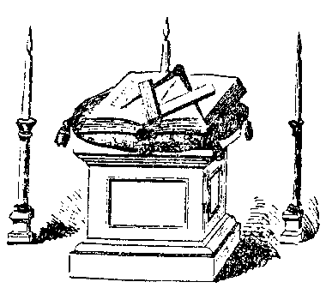
The “oath” is the “So help me, God” at the end of any solemn promise made with hand upon the Book of the Law. The “obligation" is the substance of the preceding promises: “oath” is thus symbolical of man’s fear of God; “obligation” signifies the promises and agreements made preceding the oath.
Back to the Glossary

Test Oath and excerpts from the WMC
I, (name), do hereby and hereon most solemnly and sincerely swear that I have been regularly initiated as an EAM, passed to the degree of a FCM and raised to the sublime degree of MM in a regularly constituted Lodge of such; that I am not suspended or expelled, and know of no reason why I should not converse Masonically with my Brethren. So help me God.

In the absence of personal avouchment, the applicant for admittance as a visitor to a Lodge shall take the test oath and submit to strict trial and due examination. Neither a diploma, nor a dimit, nor a certificate of membership, nor a receipt showing payment of dues, shall be conclusive as to the identity of the holder, nor as to his good standing in the Fraternity. See WMC Secs. 92, 924, 925, 926, 2608.
WMC Sec. 13.09 B.L. - Admitting Visitors.
- Every Master Mason, on applying for admittance as a visitor to a Lodge, shall exhibit either a receipt for dues or a document showing him to be in good standing, or a dimit that was issued within the previous three years. Such documents shall not be conclusive as to the identity of the holder, who must provide additional evidence of his identity,
- A Lodge must be satisfied as to the good Masonic standing of an applicant for admission and as to the regularity of the Lodge from which he hails. A Lodge becoming satisfied as to the identity of a visitor and the genuineness and regularity of his documentation shall require additionally, either:
  - The personal avouchment by a Brother knowing him to be in good Masonic standing and having met him in open Lodge (examination by a Brother outside of Lodge is not sufficient), or
  - That he shall take the Test Oath and submit to a strict trial and due examination by a committee appointed by the Master.
A Mason who has been unaffiliated for more than three years shall not be permitted to visit a Lodge in this Jurisdiction, unless, in an exceptional case, he shall have received written permission from the Master of the Lodge to attend the Lodge for a period not to exceed six months.
Back to the Glossary

WMC Sec.13.10 B.L. - Objection to Visitor.
The privilege of a Mason to visit a Lodge other than his own is subject to the right of any member thereof to object to his admittance. Such member shall not be required to state his reason for the objection. The objection shall hold good only during the communication at which it is made and while the objector is present.
Back to the Glossary

Why does the ritual use so many repetitions, as in “duly and truly,” “worthy and well-qualified,” etc.?
Several word pairs in Masonic rituals make interesting studies: “duly and truly,” “worthy and well-qualified,” “free will and accord,” “parts and points,” “hele and conceal.” At first glance it may seem that these are so arranged only for emphasis. In the Middle English writing, especially in the 13th and 14th centuries, when Freemasonry was in the process of formation, England had two languages. One was Norman-French, the other Anglo-Saxon. To make sure of understanding, word pairs were much in use, a word of similar meaning being taken from each language.
The apparent redundancy of expression in a number of places in Masonic ritual may be traced back to these Middle Ages. The perpetuation of such usage now, when clarity of thought and understanding might be served as well with one word, is one of many proofs that Freemasonry delights to cling to the ancient and venerated because it is venerated and ancient.
re•dun•dant adj. - more than enough; overabundant; excess; superfluous; 2using more words than are needed; wordy
ac•cord vt.
1 vt. to make agree or harmonize; reconcile
2. vi. to be in agreement or harmony (with)
Back to the Glossary

Why do Masons wear aprons? What does “properly clothed” mean?
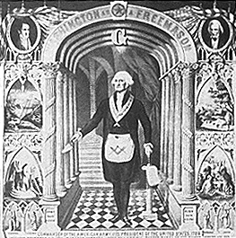
The use of the apron is extremely old, not, as with the operative Masons, as a protector of clothing and body against tools and stone, but as a badge of honor. It was so used by the priest of Israel, by the candidates of the mysteries of Mithras in Persia, by the ancient Japanese in religious worship. Ethiopia knew aprons, as did Egypt. In all times and climes, it has been a badge of distinction. It is as such that a Mason wears it.
The material of the Masonic apron-lambskin-is a symbol of innocence, as the lamb has always been. Color and material are important in its symbolism but Masonry admits the “symbol of the symbol” – as, for instance, an electric light in place of a candle. Hence, a Mason has more than once been “properly clothed” when the lambskin aprons of the lodge were all in use and he came through the tiled door clad in a white handkerchief!

Note: I was unable to find in the WMC a section specific to the regular white apron we use in our tyled meetings. Unless a brother knows, please let me know. Section. 15.10 hereunder is the closest I can find..

WMC Sec. 15.10 B.L. Jewels and Aprons.,
The officers’ aprons shall be white and should be of lambskin, fourteen inches wide and twelve inches deep, and may have sky-blue lining and edging, with the respective emblems thereon. Rev. 1992

WMC Sec. 13.07 B.L. Public Appearance as Masons.
A Lodge or Mason may appear in public in Masonic clothing to attend a Masonic funeral service, when escorting the Masonic Float in parades, at meetings of the International Order of Job's Daughters, the International Order of Rainbow for Girls, or the Order of DeMolay. A Lodge or Mason may not otherwise appear publicly in Masonic clothing without the consent of the Grand Master.

The occasions for which the Grand Master may consider granting a dispensation for Masons or Lodges to appear publicly in Masonic clothing are:
- A strictly Masonic occasion,
- To attend divine services,
- The performance of Masonic duty, ceremony, or custom,
- To take part in a community patriotic, historical, or educational event; and
- To take part in a community parade. Rev.1998
Back to the Glossary

THE LAMBSKIN APRON
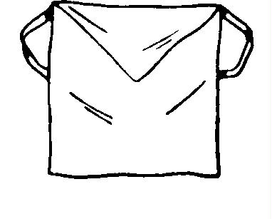
It is am emblem of innocence and the badge of a Mason. More ancient than the Golden Fleece or the Roman Eagle, more honorable than the Star and Garter, or any distinction that can be conferred upon you, at this or any future period, by King, Prince, Potentate or any other person.
It may be that in the coming years, upon your head shall rest the laurel wreath of victory, upon your breast may hang jewels fit to grace the diadem of an eastern potentate; nay more than these, with light added to coming light, your ambitious feet may tread round after round the ladder that leads to fame in our mystic circle and even the purple of our Fraternity may rest upon your honored shoulder.
But never again from mortal hands, never again until your enfranchised spirit shall have passed upward and inward through the pearly gates shall any honor so distinguished, so emblematical of purity and all perfections, be bestowed upon you as this which I now confer.
It is yours - your name is written upon it - yours to wear throughout an honorable life and at your death be placed upon the coffin which shall contain your earthly remains and with them laid beneath the silent clods of the valley.
Let its pure and spotless surface be to you an ever-present reminder of an emblematical or unblemished purity of life and rectitude of conduct, a never-ending argument for nobler deeds, for higher thoughts, for purer actions, and for greater achievements. And when at last your weary feet shall have come to the end of their toilsome journey, and from your nerveless grasp shall drop forever the working tools of life, may the record of your life and actions be as pure and spotless as this fair emblem which I now place in your hands (hand its).
And when your trembling soul shall stand naked and alone before the Great White Throne, there to receive judgment for the deeds done while in the body, may it be your portion to hear from Him who sitteth as the Judge Supreme, the welcome words “Well done thou good and faithful servant enter thou into the joy of thy Lord.”
It is hoped, my Brother, that you will wear that apron with pleasure to your self and honor to the Fraternity.
Back to the Glossary

Apron Lecture Interpretation Part 1
The apron is said to more ancient and honorable than certain orders and decorations. The Order of the Golden Fleece was founded by Philip, Duke of Burgundy in 1429.
The Roman Eagle was Rome’s symbol and ensign of power and might a hundred years before Christ. The Order of the Star was created by John II of France in the middle of the 14thCentury. The Order of the Garter was founded by Edward III of England in 1349 for himself and 25 Knights of the Garter. The Masonic Apron is more ancient than these is a provable fact. In avering that it is more honorable, the premise “when worthily worn” is understood. The apron is “more honorable than the Start and Garter” when all that it teaches is exemplified in the life of the wearer.
Aver - to declare to be true; state positively; affirm
Back to the Glossary

Apron Lecture Interpretation Part 2
Symbol of honorable labor. The material of the Masonic apron – lambskin – is the symbol of innocence, as the lamb has always been. But for “innocence” do read “ignorant”. The word describes those who do no injury to others, not those to whom injury maybe done because they know little.
There is special symbolism in the different ways in which the EA are taught to wear their aprons, emblematic of a progress from darkness to light, from ignorance to knowledge.
The use of the apron is extremely old, not, as with operative Masons, as a protector of clothing and body against tools and stone, but as a badge of honor. It was so used by the priest of Israel, by the candidates for the mysteries of Mithras in Persia, by the ancient Japanese in religious worship. Ethiopia knew aprons as did Egypt. In all times and climes, it has been a badge of distinction. It is such that a Mason wears it.
Color and material are important in its symbolism but Masonry admits the “symbol of the symbol” – as for instance, and electric light in place of a candle. Hence a Mason has ore than once been “properly clothed” when the lambskin aprons of the lodge were all in use and he came through the tiled door clad in a white handkerchief!
Back to the Glossary

How is a man made a Mason at sight?
The Grand Master calls into existence an emergent lodge under temporary dispensation, which lodge then confers the three degrees, usually in short form, and usually all three degrees in one consecutive period, upon the man selected for the honor by the Grand Master. Most Grand Lodges admit the right of a Grand Master to do this; a few specifically forbid his doing so; one recognizes the right and frowns upon its use. The objection to the act are two: first, he who seeks Masonry of his own free will and accord honors himself and not the Order by his application; masonry need seek no candidate; second, the general belief that every Mason should pass the ballot of his fellows and not be picked by authority as beyond and above the requirement.
The ceremonies of “making a Mason at sight” are less and less often performed as the years bring a better perspective upon the practice.
Back to the Glossary

What is a demit in Masonry?
A Mason is said to demit from his lodge when he withdraws his membership; the demit (also spelled dimit in some jurisdictions) is a document granted by the Lodge which certifies that dismission has been accepted by the Lodge, and that the demitting brother is clear of the books and is in good standing as a Mason. The usual object in applying for a demit is to enable the brother to join some other Lodge, into which he can not be admitted without some evidence that he was in good standing in his former lodge.
Permission given a member to terminate his membership; the paper representing that permission. In nearly all Grand Jurisdictions obtaining a dimit is a formality; a lodge is obliged to grant a dimit to him who asks it, provided he is in good standing and no charges have been or are about to be preferred against him, The theory is that the joined his lodge of his own free will and accord he should have the right to leave it in the same way. In some Grand Jurisdictions a member may receive a dimity only to join another lodge, or to remove from his Grand Jurisdiction to another.

Can a man renounce Masonry?
For reasons which may or may not be justifiable a man may sever his connection with a Masonic Lodge; but it is utterly impossible for any Mason who has been honest and understanding in accepting the Rites of Freemasonry to repudiate his Masonic Obligations. Nor can any man, in all good conscience with himself, toward man, and toward God, denounce the principles, tenets, symbolic instructions, inner workings, and uplifting benedictions of Freemasonry, once he fully understood Freemasonry and fully assimilated its teachings.
re•pu•di•ate vt.
1 to refuse to have anything to do with; disown or cast off publicly
2 a) to refuse to accept or support; deny the validity or authority of (a belief, a treaty, etc.) b) to deny the truth of (a charge, etc.)
re•nounce vt.
3 to cast off or disown; refuse further association with;
de•nounce vt.
1 to accuse publicly; inform against
2 to condemn strongly as evil
Back to the Glossary
Unworthy Members – What is to be said of them?
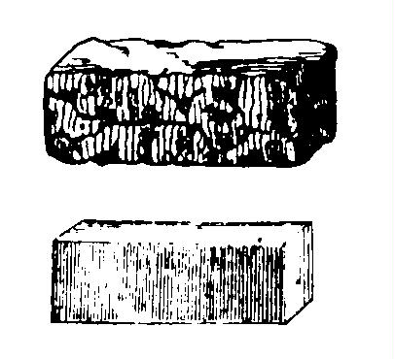
We are forced to admit that there are men in the Masonic Order whose characters and lives reflect no credit upon the Institution, whose hearts are untouched by its sublime moral and religious teaching, and to whom Masonry means nothing in its higher and nobler aims and purpose. They are in the Temple, but not of the Temple; members of our household, but not of us; they are of Israel, but have not the faith of Israel. Some Lodge may have been remiss in conferring on them the Degrees. Masons persist in the hope of making them better. But the institution is not responsible for what they are, and should not be unduly criticized. The merciful thing is to bear with them and hope and pray for their regeneration of their hearts by God, who alone can perform such miracles.
Back to the Glossary

Is Freemasonry a religion or has it a religion?
No to both questions. "A" religion connotes some particular religion. Freemasonry is nonsectarian. Before its altar Christian, Jew, Mohammedan, Buddhist, Gentile, Confucian may kneel together. If the question be phrased "is Freemasonry religious" then the obvious answer is that an institution "erected to God" which begins its ceremonies and ends its meeting with prayer; which has a Holy Book upon its Altar; which preaches the fatherhood of God and the brotherhood of man, of course has a religious character, although. let it be emphasized again, wholly nonsectarian. All Grand Lodges require their initiates to express a belief and trust in God. No atheist can be made a Mason. (From the MSA Handbook "101 Questions About Freemasonry").

NB's Opinion: The focal point of a tyled (tiled) lodge is the Masonic Altar with the "Volume of the Sacred Law". This is the more appropriate term to use when explaining this issue to the uninitiated. Be conscious and sensitive to the non-Christian brethren (or to a future brother). We refer to one Great Light as the Holy Bible. Yes... for predominantly Christian countries. Remember though, that we have brothers from the Islam, Judaic and other faiths.
Back to the Glossary

Why are discussions of politics and religion forbidden in lodge?
The prohibition goes back to the early history of the Fraternity. It is written in the second paragraph of the sixth “Old Charge” (Behavior after the Lodge is over and the Brethren not gone); “No private Piques or Quarrels must be brought within the Door of the Lodge, far less any Quarrels about Religion or Nations, or State policy, we being only, as Masons, of the Catholick Religion above-mentioned; we are also of all Nations, Toungues, Kindreds, and Languages, and are resolved against all Politicks as what never yet conduc’d to the Welfare of the Lodge, nor ever will. This Charge has been always strictly enjoin’d and observ’d, but especially since the Reformation in Britain, or the Dissent and Secession of these Nations from the Communion of Rome.”
Freemasons today hold that the Old Charge prohibits lodge discussions of politics in the sense of partisan politics and religion in the sense of sectarian religion.

NB Notes: In between lines, the writers of this Old Charges are of the Roman Catholic faith. On a time frame: Britain has seceded from Rome and established the Anglican Church, and perhaps even during the time Martin Luther (a former Catholic priest) established his own church (Lutheran).
Back to the Glossary

The Trestleboard - Symbol of moral law.
As one of the “movable jewels” of a lodge it is considered with the rough and perfect ashlars. The trestleboard is that on which the Master draws his design, from which the perfect ashlar is made from the rough, and later, built into walls to construct the temple. By analogy, the trestleboard of the Speculative Masons is that on which he draws the designs for his character and spiritual growth; in other words, lays down his moral law. (From the “Pocket Encyclopedia of Masonic Symbols).
Back to the Glossary

Why Rituals?
“Ritual is important! Our ceremonial rituals teach us of the history, heritage, and the principle and tenets of our Masonic Brotherhood. They inform us of our duties and obligations as men and as Masons. To strive to execute the rituals correctly, to cross the “Ts” and dot the “Is” in every case also teaches discipline, the discipline we need in every aspect of our lives to be God-fearing, God-serving men and Masons. No doubt, correctly executed ritual is impressive and absolutely necessary to impart the lessons it is to teach, especially to our candidates for membership.
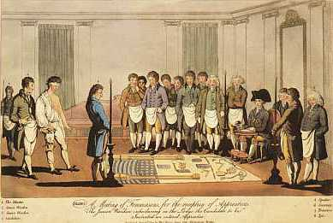
The learning of the rituals of the degrees and orders require study and experience. Sessions and/or meetings to study and practice the rituals afford, in my opinion, an excellent time for the fellowship that strengthens our brotherhood, and it is an excellent time to grow our understanding and knowledge of who we are as a fraternity, where we came from, and what our purposes are. Also, and of prime importance, the ability to correctly confer ritual rightfully adds to the pride we have as members of our Masonic organizations.
The preparation for a monthly meeting to study and practice the ritual of a Commandery Order or any degree or order requires relatively little work. The operative word here is “relatively.” Schedule the meeting, arrange for inspectors and instructors, announce it, spread the word (talk it up), arrange for light refreshments, and then DO IT, and do it regularly. Participate. You and your fratres will like it.”…
Back to the Glossary

What is a cabletow?
It is an emblem that acts as an outward visible pledge of submission and fidelity. It is the symbol of a vow to assist another, particularly a Brother, even at the judicious risk of one’s life. Upon what does the strength and length of the cabletow depend?
The strength and length of the cabletow depends upon one’s ability to fulfill his obligations. The cabletow, in effect, is a test of one’s character and his capacity to love.
How long is the cabletow? The cabletow is as long as one wants to be. It will reach as far as one’s moral principles go, or one’s material conditions allow. Each Freemason must judge the length of his cabletow. But if the cord of every Freemason’s cabletow were tied around the world, no earthly power could break the bond of brotherhood.
The cabletow, the symbolizes the Mystic Tie that binds Craftsmen together – the tie that keeps Freemasonry a house undivided.

NB Notes: This was contributed by Bro. Sam J, borrowed from “The Cabletow” publication of the MWGLP. Also note the word structure. Though one word in our usage, the main point here is the “tow” and the “cable” then becomes the adjective. To understand this, a “dog house” is different from a” house dog”. The use of the cabletow in our degree work is explained therein.
Back to the Glossary

What is the required quorum in a Lodge Meeting?
This question is answered in the question, “How many compose a Lodge?” in the formal opening of each Degree; the number composing a Lodge is a quorum for any Degree work, or for transaction of any business. In opening a Lodge, five is the minimum; for the work of the Entered Apprentice Degree, seven, although the ritual places the number for opening the Master Lodge at three.
Back to the Glossary

St. John the Baptist: why is he one of the patrons of Freemasonry?
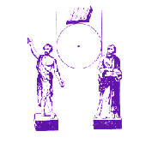
The firm integrity of Saint John the Baptist, which induced him to forego every minor consideration in discharging the obligations he owed God; the unselfish firmness with which he met martrydom rather than betray his duty to his Master; his steady reproval of vice, and continued preaching of repentance and virtue, make him a firm patron of the Masonic Institution. His festival is celebrated on the 24th of June.
Back to the Glossary

St. John the Evangelist: why is he one of the patrons of Freemasonry?
The constant admonition of this Apostle, in his epistles, to the cultivation of brotherly love, and the mystic nature of his Apocalyptic visions, sometimes similar to the mystic communications of Freemasonry, are reasons for his veneration among Masons and for adopting him as a worthy patron. His festival is on the 27th of December.
Back to the Glossary

Worshipful Master
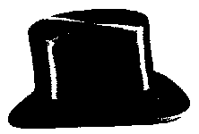
Few Masonic matters are less understood by the non-Masonic public than this. The word “worchyppe” or “worchyp” is Old English and means “greatly respected.” In the Wyclliffe Bible “Honor thy father and thy mother “ appears as “Worschyp thy fadir and thy modir.” English and Canadian mayors are still addressed “Your Worship.” In some of the Old Constitutions of Masonry is the phrase “Every Mason shall prefer his elder and put him to worship.”
“Worshipful” therefore in modern Masonry continues an ancient word meaning “greatly respected.” A Grand Master is “Most Worshipful”, that is “Most greatly respected” (Except in Pennsylvania where the GM is RW, as are Pennsylvania’s and Texas PGM).
Back to the Glossary

Why are Past Master’s compasses, in his jewel, open at 60 degrees on a quadrant instead of on a square?
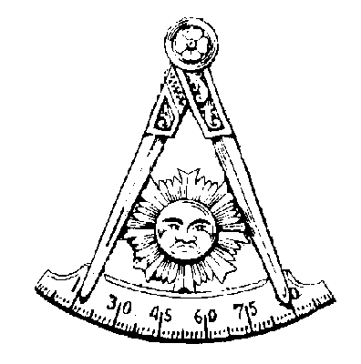
The compasses open sixty degrees are in easy position to construct a square. The Master has worn the square while he presided; now, as Past Master, he is supposed to being possession of the knowledge necessary to make a square, hence the position of the compasses and the quadrant.
There are many geometric methods of erecting a square; the Past Master’s jewel hints at one of the simplest and most used methods as best to the Past Master to employ in instructing his successor.
The jewel is the compasses, opened to sixty degrees, the points on graduated arch. Masonic compasses are opened to sixty degrees because this is the number of degrees in each of the three angles of an equilateral triangle, always the symbol of Deity.

WMC Sec. 15.10 BL
Jewels and Aprons. The jewels of Lodge Officers shall be of silver or of white metal, to be worn either suspended from a blue velvet collar or as a badge on the left breast.
The jewels of a Past Master and of the officers of a Lodge are:
Past Master – the Blazing Sun within the compasses extended on a Quadrant.
Back to the Glossary

Working Tools: How do meet, act and part?
Further information can be obtained of the working tools of a Fellowcraft Mason. It is half revealed and half concealed in the association of the level with the Senior Warden, the plumb with the Junior Warden and the square with the Master, particularly in the ceremonies of closing the lodge.
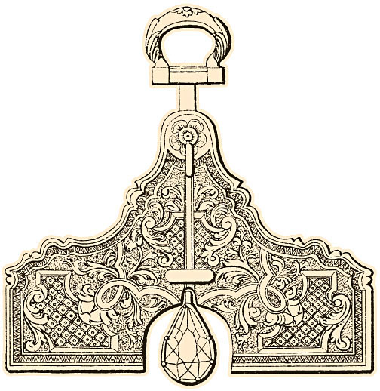
In a lodge, all brethren meet on the level of exact equality which is not concerned with brains, or education, or wealth or position, men are equal in a lodge in manhood and in Masonic right and Masonic character. We meet on the level means just what it says; Masons trust each other because they are, Masonically on the level with each other.
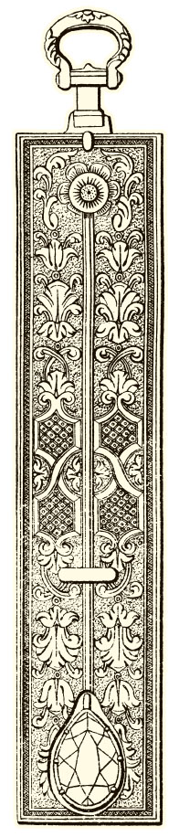
We “act by the plumb” in accord with Amos VII – the plumb line God said He would place “in the midst of my people Israel.” In other words, they were to be judged by their own plumb line, not another’s. Masons are to judge their fellows, if at all, by their fellow’s plumb line, not their own. One brother must not condemn another by personal standards; only when a brother is false to his own standards can he judge him.
To “part upon the square” signifies that while a square points in different directions, and men “part” to go each his own way, it is a known way, not a devious way, a wrong way, a bad way, but a “square” way. The Mason who goes his own way, so it is the square way, is never alone, even if out of sight oh his lodge and his brethren.
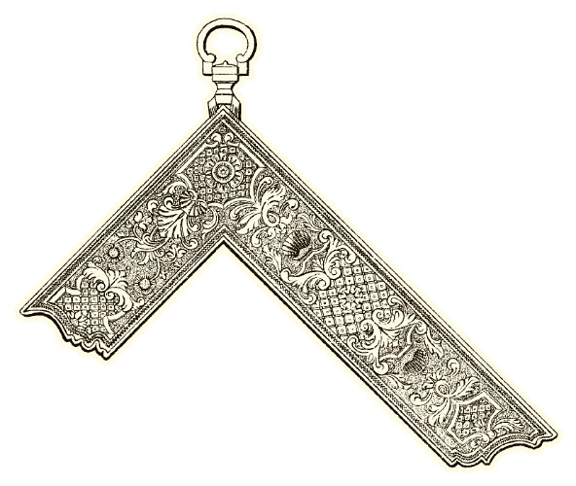
The square is the fundamental tool of the operative Mason; without its use no building would stand. It is the fundamental tool of the Speculative Mason; without square thoughts and actions, no spiritual building can stand.

Note: Some readings state that the square is an angle of 90 degrees or a right angle. Using this tool, Masons therefore must act righteously or according to what is right. This is the only angle for stones which are to build a perpendicular and stable wall.
Back to the Glossary

Point Within a Circle (What will you be tried?)
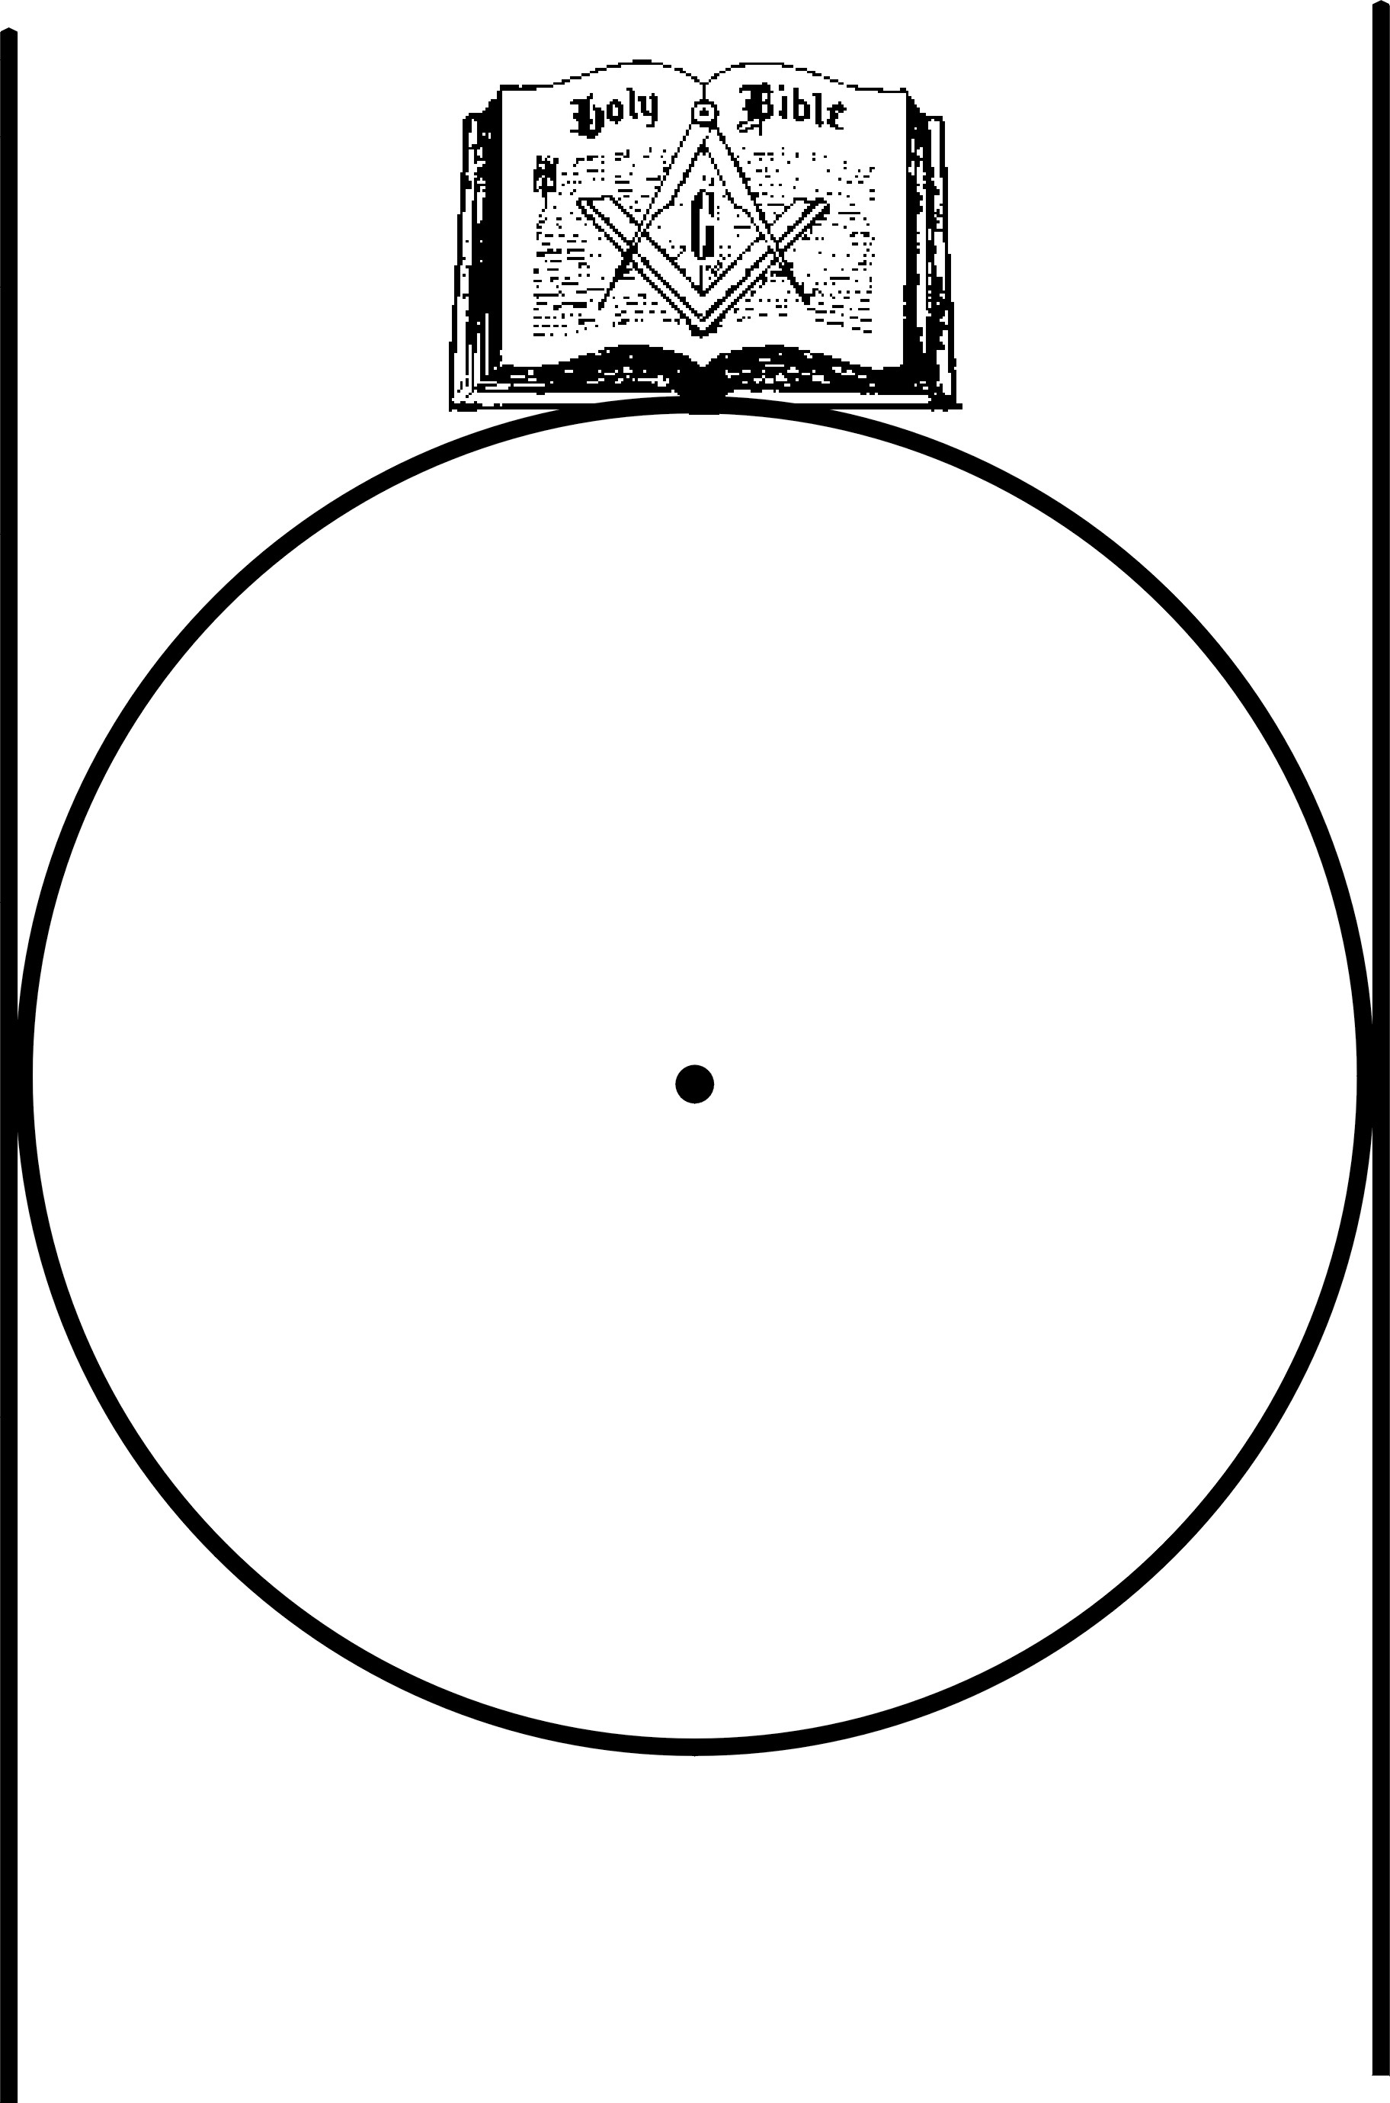
Ritualistically, a symbol of control of conduct; a standard of right living. The symbol has an extreme antiquity. Early Egyptian monuments are carved with Alpha and Omega or the symbol of God in the center of a circle embroidered by two upright parallel perpendicular serpents, representing power and wisdom of the Creator. The symbol apparently came into Masonry from an operative practice, known to but a few Master Workmen on cathedrals and great buildings.
Any schools boys knows it now: put a dot in a circle anywhere; draw a straight line across the circle through its center; connect the dot with the points at which the line through the center cuts the circle; the result is a perfect square..
This was the Operative Masters great secret – knowing how to “try a square.” It was by this that he tested the working tools of the Fellows of the Craft; did he do so often enough, it was impossible either for their tools or their work “to materially err.” From this, also comes the ritual used in the lodges of our English brethren, where they “open on the center.” American lodges know the “center” only as the point within a circle. The original line across the center has been shifted to the side and become the “two perpendicular parallel lines” of Egypt and India and our admonitions are no longer what they must once have been; …”while a Mason circumscribes his square within the these points, it is impossible that it should materially err.”
Ascribing the lines to the Holy Saints John and putting the Great Light on top are modernisms, carrying out the ritualistic symbolism while neglecting that of the original meaning of the point within the circle; that of a means of making working tools correct in angle, to the end that stones and building might be square, level and plumb.
Back to the Glossary

How does one wear the ring?
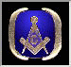
No Grand Lodge has legislated upon the subject except North Carolina whose law states that a Mason should wear a ring so the tips of the compasses are pointed towards him. But this is suggestive, not mandatory. The consensus is that if a Masonic ring is worn to advise those see it that the wearer is a Master Mason, the tips of the compasses should be pointed towards the tips of the fingers. If the ring is worn to remind the wearer that he is a Master Mason, the ring should be worn with the tips of the compasses pointed towards the wrist. This, to remind him that wears, of where those vitals tenets of Masonry are contained.
Back to the Glossary

Cardinal Virtues
Some authorities think of temperance, fortitude, prudence and justice only as moral principles, the use of which is Masonically taught. The consensus, however, is that they are symbolic in that their meanings can be extended beyond mere definitions. Thus temperance, usually taken to mean care in use of stimulants, Masonically means more, just as it did to Socrates, hundreds of years before it was woven into Freemasonry. Temperance means caution in action, speech, thought, feeling, judgment, life and living. Fortitude implies physical bravery, but Masonically, moral courage far more than physical. Prudence is not only selfish determination of “what is good for me” but use of common sense, reason, logic, in meeting a problem. Justice, a civic concept, is
Masonically allied with that with which it cannot really exist-mercy. Justice is a strict interpretation of the law which is an expression of the greatest good to the greatest number. Mercy is actually a tampering with, as well as a tempering of justice and implies that in special cases justice is insufficient. This moral dilemma of philosophy is not indicated ritualistically, but is implied by the fact that the first three cardinal virtues do have symbolic as well as a moral meaning
Back to the Glossary

Why do brethren not pass between the Altar and the East when lodge is at labor?
Brethren do not pass between the Altar and the East in a Masonic lodge at labor (except in a degree) because the Master is supposed to have the Great Lights constantly in view. In theory, at least, he draws inspiration from the Altar to preside over the lodge and must not, therefore, be prevented from seeing it at any time.
The custom is but a pretty courtesy, but it is rooted in a fundamental conception of the Craft - that the Altar is the center of Masonry, and that from it and from the Great Lights it bears, flow all that there is of Masonic inspiration and truth and light. English lodges do not have this problem, since in them a pedestal near the Master is the Altar on which lies the Holy Book.
Back to the Glossary

Why do we walk around the Altar so much in the degrees?
Circumambulation is walking around a central point. In Masonic initiations it is always clockwise from East to West by way of South; like so many symbols, the ritualistic explanation does not explain; except with the most elementary reasons. During this part of a degree, members of a lodge observe that a candidate is properly prepared, but circumambulation is far older than initiations. To primitive man, the sun was God. The sun traveled from East to West by way of the South. Hence, early man circled his stone altar on which was his imitation of the sun-fire-from East .to West by way of the South, in humble imitation of the god in the sky.
Circumambulation is one of many concealed symbols of a Great Architect. In those rituals in which in a certain part of the Master’s degree the circumambulation is in the reverse direction, Freemasonry imitates the ancient ceremony signifying death.
Back to the Glossary

Why is it un-Masonic to disclose how one has balloted?
In all jurisdictions the ballot on candidates is secret and inviolable. It is considered un-Masonic, and in most Grand Jurisdictions is against Masonic law, for any brother to divulge how he has balloted or will ballot on any candidate. Masters are instructed strictly to adhere to this requirement. Peace and harmony are the foundations of all Masonic meetings. For Brother A to learn that Brother B has balloted or will ballot against his friend would, disrupt that peace and harmony. The rejection of a candidate is a blow to him who has applied. If everyone knew who had cast the black cube, the rejected man might speedily learn, and cause of friction in the profane world would then have come out of a Masonic lodge.
A ballot is sometimes immediately retaken, because the appearance of a single black cube may be an error; the cube may have been cast by mistake. If the single black cube appears the second time, presumably it was intentionally cast.
Ballots differ in different Jurisdictions. In some, a "collective ballot" may be taken on several candidates at once; if a black cube appears, each name is then balloted on separately. In others, a "multiple ballot box" is used, with, a compartment for each name, which is printed above it. In still others, each name is balloted on separately from the beginning. In most Grand Jurisdictions, one ballot elects to all three degrees. In some, a separate ballot is taken for each degree, and in one, at least, still another ballot on "moral qualifications." But in all Grand Jurisdictions, ballots are secret, inviolable and regarded as a cornerstone on which the fraternity is erected.
Back to the Glossary

Why cannot a lodge adjourn and then reconvene?
The adjournment of any meeting is an act following a motion by some member of the group. No Master can give the power of termination of a meeting to any member, or to the lodge as a whole, without sacrifice of his power to control the lodge. Any Masonic lodge must be in one of three states: closed, open and at work, or at refreshment. It is universally law that an open lodge must be closed before the brethren depart, otherwise a "reconvening of an open lodge" at some future date might work an injustice to some brother interested in lodge legislation, who could not be present at the "reconvened adjourned" meeting. The fundamental reason for "no adjournment" is found in the fact that the Master's power to control, which means opening and closing his lodge at his pleasure (but always within the opening time set by the by-laws), cannot be abrogated by a member or by the lodge as a whole
Back to the Glossary
Explain the meaning of the allusions in the 12th Chapter of Ecclesiastes.
Of the two favorite interpretations of Biblical commentators one makes this dramatic passage a description of, old age and senile decay; the other, reference to the seldom experienced and much feared thunderstorm in Palestine.
Verses 1, 2: The darkening of light and luminaries refers to coming blindness or extreme near-sightedness and the clouds which return after the rain to a continuation of poor sight after much weeping.
Verse 3: The keepers of the house are the hands which tremble with palsy in old age. The strong men are the legs which become, bowed with the years. The grinders which cease when they are few are the teeth, and those that look out of the windows are, poetically, the eyes.
Verse 4: The doors are the ears which grow deaf in age and can no longer hear the sound of grinding of grain in the little stone mills which the women use. To rise up at the voice of a bird may signify either the light sleep of age easily interrupted by any slight sound, or the nervousness which is so extreme in some old men that they start at any little noise. The daughters of music are the vocal cords which lose their timbre in age; hence, the cracked voice of senility.
Verse 5: The old man fears any height, knowing his brittle bones will stand no fall. He is timid, as he has no strength with which to defend himself. The almond tree blossoms white, like an old man's hair. Any little weight, even a grasshopper, is too much a burden for extreme age to carry. The old have no desires. The long home is the grave, in anticipation of which the mourners go about the streets.
Verse 6: The silver cord is the spinal cord; the golden bowl is the brain, the pitcher broken at the fountain a failing heart, and the wheel broken at .the cistern the kidneys, bladder and prostate gland, 'all of which give trouble to old men. Whether or not the writer possessed a sufficient knowledge of anatomy to symbolize parts of the body as the "silver cord," the "golden bowl;'" the pitcher, the wheel broken at the cistern" is so problematical that much skepticism of this interpretation has been expressed.
The storm interpretation is not open to this objection and certainly it is far more in keeping 'with the magnificent poetry of the words.
Think of a windy day, with clouds and rain; towards evening it begins to clear, but the heavens turn .black again as the “clouds return after the rain". This was a signal for caution if not for terror in Palestine. Men and women and children feared the thunderstorm, probably because it came so seldom. Doors were shut in the streets. The strong guards who stood before the houses of, the wealthy were afraid, and trembled, for they might not leave their places. The little mills with which the women ground grain at eventide ceased; few would remain at their tasks in the face of the storm. Women in upper rooms drew back into the dark. Those outdoors became nervous; no one sang; the black thunderheads flourished their white tops like- the almond tree; everyone feared the lightning and the thunder on high; even a little weight which kept a man from running to shelter was a burden.
Here the admonition is to remember the Creator before the terror of death, which is worse than the terror of the storm. The rich man with his golden water bowl hung from a silver chain must fear it. The poor man with his earthen pitcher who must send his women to the well for water was in terror. Even the man strong and rough as the crude wooden wheel which drew the-skin bucket to the top of the well shook with fear. Death is the same for all and it is feared alike by all.
Back to the Glossary

End of Document Masonic Education Series

