Inuvik Masonic Club
Newsletter
Special “BBQ” Edition
Vol 1, No. 5 ~ 27 July 2002
How We’re Doing | How to Contact Us
Things are progressing well towards our goal of becoming a Lodge.  With all the blank forms received, we anticipate sending all the paperwork to the Grand Lodge of Alberta no later than August 2nd.  It will then take about a month for the Grand Master to approve the dispensation, and get the appropriate documents back to us.  With this timeline, we expect to be able to hold our first official lodge meeting in September or October of this year.  Although delayed by a few months, we are right on track and look forward to officially opening our new lodge under dispensation.  Thanks to all the brethren who have helped get us this far – we know it has been a long, slow process, but there is light at the end of the tunnel. | The Inuvik Masonic Club can be reached in a variety of ways.  You can email the Secretary (garven@nt.sympatico.ca)  Postal Mail can be sent to: The Inuvik Masonic Club, Box 2536, Inuvik, NT, Canada X0E 0T0  Our website is at: (http://www.mastermson.com/FarNorthMasons ) Enter comments by clicking on the book logo located throughout the site.  Use any of the above to submit articles, apply for membership, or just to say hi!.  If you've ever lived in or visited Inuvik, we'd like to hear your stories  If you have trouble getting to the website from the above address, go to http://www.onblueice.ca and click on the square and compasses logo.  Even easier than this is to find one of the Masons living in Inuvik and just say hi. We’re more than happy to answer your questions.
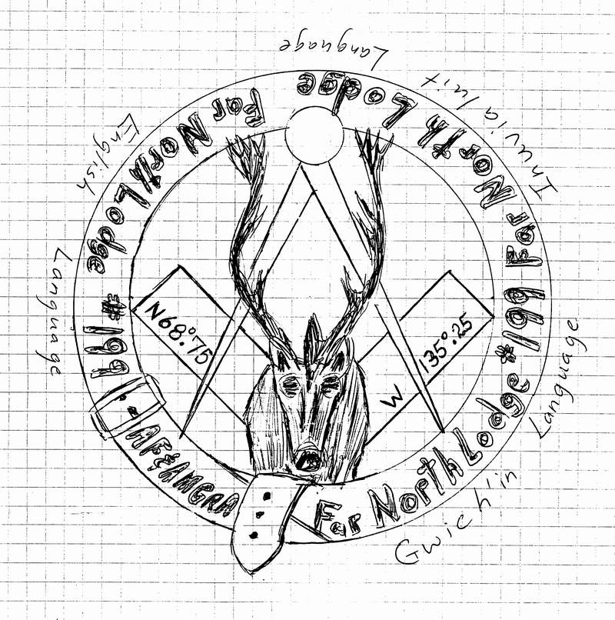
After much discussion at recent meetings and practices, the members of the Inuvik Masonic Club have made a few decisions about the proposed Club and Lodge Logo.
First – we would like to have the design come from a member of the Club.
Second – The logo should be a regular shape. Odd shapes are difficult to be made into pins, and can be prohibitively expensive.
Third – The amount of text should be reduced from the original proposed design. There should be provision in the design to have either “U.D.” or a Lodge Number. By having less text, it will be more readable.
Fourth (and finally) – It was felt the Caribou and similar elements adequately represented the “North”, making the multilingual wording on the design redundant. This wording should be removed.
The initial proposed design is reproduced above.
All members are encouraged to submit logo designs to the Club for consideration as the official Seal and Logo of the Club and eventually the Far North Lodge.
Again, please note that the Lat and Long listed are samples only. Precise figures will be provided on request for inclusion in any design.
- The process of forming a new lodge is a long and involved process, but we are making progress.
- The club members who live in the Inuvik Area have been meeting to practice on a regular basis and have had the pleasure of visits from Brethren currently living in Inuvik, Fort McPherson and Yellowknife, NWT
- We have received donations from Lodges in Hope, BC, Edmonton, AB, and Simcoe, Ontario.
- The Club currently has members from Ontario, Alberta, Northwest Territories, Yukon Territory, New Brunswick, Nova Scotia, Manitoba and elsewhere.
- The Application for Dispensation to form a lodge is on its’ way from the Grand Lodge of Alberta.
- Plans are underway for a Pig / Muskox BBQ in June.
- A number of candidates in the Inuvik Area have contacted members to enquire about becoming Masons.
- A trip to the Dawson City, Yukon Lodge is being planned for later in the summer.
- Regular meetings and practices continue on Thursday nights, at either Rocky’s Plumbing or Wally’s home.
"Thanks"
Thanks are due to many lodges and individuals for their support of the Inuvik Masonic Club and the Far North Lodge.
In particular, the brethren of the Lodge in Hope, British Columbia receive exceptional thanks, for their donation of a truckload of Lodge paraphernalia, including pillars, furniture, furnishings and assorted items too numerous to mention.
The brethren of Patricia Lodge # 92 in Edmonton, Alberta, also receive our special thanks for their donation of a canvas.
For helping guide the Secretary through the process of applying for dispensation, the Grand Lodge Secretary for the Grand Lodge of Alberta is also a deserving recipient of accolades.
Most of all, for all the brethren who have called, emailed or otherwise contacted members of the Inuvik Masonic Club and offered to help out “however I can”, THANK YOU.
It is your help and support that is making this a truly wonderful experience.

Inuvik Masonic Club
Membership Application
Applicant Information
Name:
Current Address:
City: | Prov/Terr: |  | Postal Code:
Email: |  | Website:
Phone (H): | Phone (W): |  |  | Other:
Lodge Membership Information
Mother Lodge: |  |  |  | How long?
Lodge Jurisdiction: |  |  |  | Current Rank:
City: | Prov./Terr: |  | Postal Code:
Phone: | E-mail: |  | Fax:
Date Initiated: | Passed: |  | Raised:
Position Currently Held:
Positions Previously Held:
Other Information
If you have ever visited or lived in Inuvik, please provide details here:
I authorize the verification of the information provided on this form as to my current standing in the above lodge, and make application to join The Inuvik Masonic Club. I have attached a copy of a current Lodge Dues card and a Certificate of Good Standing (or equivalent). I have also included payment of Club Dues for the current year ($50.00 CDN) and understand that such dues will be credited to the payment of Lodge Dues once a lodge is formed in Inuvik, NWT.
Signature of Applicant: |  |  |  |  | Date:

Rays of Masonry

MY SACRED OBLIGATIONS

It is the quiet of night, a time when Day's Door closes to the tumult of the world, and darkness opens the portals of our spiritual nature. Here in comfort I rest in a clean bed. The good health of my loved ones brings a feeling of satisfaction and gratitude. I cannot feel that I deserve the good fortune that is mine, the joy of home, privilege of health, the love of wife, the blessing of children, the confidence of friends. But in that
reverential peace and quiet calm I resolve to do more for others, to think more of giving and less of getting, to put all those good thoughts of mine into action, to translate those intentions into deeds, to be in unity with my brother by dwelling with him, to know him better.
Let me see. Did I go by and see Brother John yesterday? Brother John is old and feeble. He is no longer able to attend lodge. He has always loved Masonry. I could have brought a bit of Masonic cheer to him; I could have made him happier by letting him know the Masons remember. I reflect now that it would have cost only a small inconvenience, only a little time.
What single thing I accomplished yesterday was worth more than would have
been a visit to Brother John?
Recently a brother passed away. Did I attend his funeral? I failed to go. I
saw the notice of the Masonic meeting in the paper.
Yes, as I rest comfortably and enjoy the good things of life, I remember too well. I remember the things I should have done and failed to do- "My Unfulfilled Obligations”
Dewey Wollstein -1953

