FAR NORTH LODGE #199

In Inuvik, NWT, in 1995, two masons would get together on an irregular basis for lunch, etc. When checking the community they found 3 or 4 other Masons in their midst but incompatible schedules precluded regular get-togethers.

In 1999, A NUMBER OF MASONS got together for an evening Barbeque on the shared deck of Terry Rafferty, Wally Wolfe and Robin McConville who lived beside each other. Present were: Chris Garven, Terry Rafferty, Eli Bryant (visiting from Newfoundland) Bro. Vivian (whose first name is forgotten), Stanley Grimes Sr., Wally Wolfe and Robin McConville. The steaks were supplied by Robin McConville and cooked by Mark Bleakney (who was to become the first candidate initiated in Far North Lodge, Inuvik). During the course of the evening The Inuvik Masonic Club was born.

The arrival of RWB Howard Townsend in 2000 brought all the brethren together on a more regular basis. Meeting whenever and wherever they could, this stalwart band of brothers ploughed through “The Work”, with little furnishings, furniture or regalia. Talk about a “Rusty Nail” night – The Inuvik Masonic Club had at least 6 months of rusty nails as brethren from New Brunswick, Ontario, Alberta, BC, Yukon Territory and of course the NWT all tried to remember ritual from the Ancient York, BC and Canadian Rites.

One memorable “practice” was held in Brother Townsend’s house, where Tabasco bottles were used as columns, and an overturned cardboard box served as the altar. Meetings and practices were held in houses, warehouses, restaurants and lounges. Sometimes the brethren had to shout to be heard over the heating fans. On at least one occasion, a front-end loader was moved out of the way to make room for the milk crates that served as altar, pedestals and desk for the secretary.

A kind donation of furnishings and furniture from Hope and Chilliwack Lodges in BC gave the club a shot in the arm, as did a similar donation arranged through the Grand Lodge of Alberta. Those donations included the Volume of the Sacred Law that is currently used in the Lodge, which orighinally was used by Rising Sun Lodge and Polaris Lodge in Fort Smith, NWT, and includes the names of many renowned Northerners, Bro. “Wop” May amongst them.

Far North Lodge would not exist without the efforts of many Brethren, but among the foremost of these has been VWB Ken Bibby of Yellowknife Lodge #162. His untiring efforts, support and guidance through the years have proven invaluable, and he has the distinction of being a Past Master of the Lodge without having sat in the East of that Lodge.
The ceremony of institution of “FAR NORTH LODGE, U.D.” was performed on January 8, 2003 by RWB Rod Ponech, Senior Grand Warden, assisted by the Brethren present.

First Officers of Far North Lodge U.D.

Worshipful Master……………………………………………….Howard R. Townsend
Immediate Past Master……………………………………………………….Ken Bibby
Senior Warden………………………………………………………..Robin McConville
Junior Warden………………………………………………..…………….Wally Wolfe
Senior Deacon…………………………………………….…………….Mark B. Garven
Junior Deacon………………………………………………………...…..Terry Rafferty
Senior Steward………………………………………………………………....Al Allison
Junior Steward…………………………………………………………..Mario Lemieux
Inner Guard………………………………………………………..…..Michel Bourassa
Tyler………………………………………………………………...…Colum McCready
Chaplain…………………………………………………………...…….Thomas Mickey
Secretary/Treasurer…………………………………………………...Chris M. Garven
Director of Ceremonies………………………………………………….…….Jay Wolfe
Registrar……………………………………………………………….……..Allen Smith
Piper………………………………………………………………..…….Don Finnamore

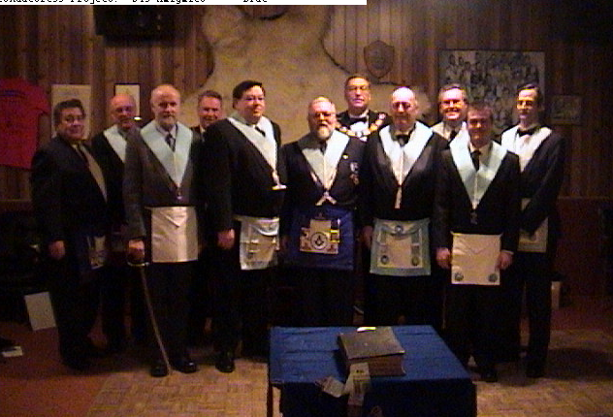

Left to Right: R.W.Bro. Don Frizell, V.W.Bro. Ken Bibby, Bro. Colum McCready, M.W.Bro. Tom Mickey, Bro. Robin McConville, R.W.Bro. Howard Townsend, R.W.Bro. Rod Ponnech, Bro. Wally Wolfe, Bro. Al Alison, Bro. Mario Lemieux, Bro. Chris Garven
The first order of business of the Lodge was to send greetings and vows of due obedience to Her Majesty, Queen Elizabeth the Second.
Second order of business – ballot on Mr. Mark Bleakney and Mr. Derek Lindsay who were initiated the following day – January 9, 2003. The pyjamas and regalia for the degree almost went to Tuktoyaktuk when they were picked up at the airport by mistake by a Tuktoyaktuk bound passenger. Upon learning whose suitcase V.W.Bro. Bibby had, a quick exchange was made before any problems arose. One can only imagine what the community would have thought of Freemasonry if the suitcase has been opened….

Petitions were received from Mr. David Patrick and Mr. Truman Kingsler. A donation of books was received from Norfolk Lodge #10 G.R.C. to start a Masonic Library. All in all a very excellent beginning for the Lodge.

March 13, 2003
Initiations were held for Bro’s David Patrick and Truman Kingsler
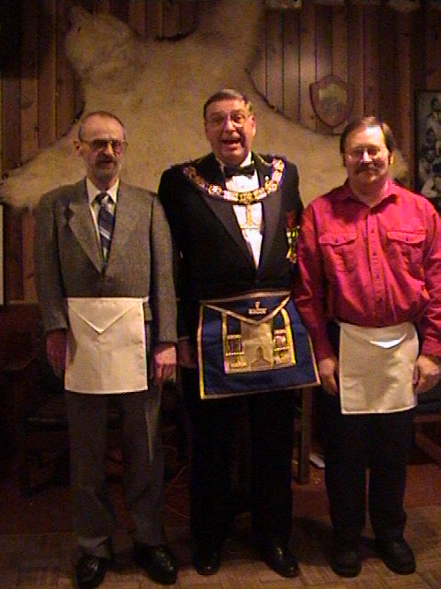

Left to Right: Bro. Derek Lindsay, R.W.Bro. Rod Ponech (Deputy Grand Master), Bro. Mark Bleakney
April 10, 2003
A shipment of regalia was received from Grand Lodge of Alberta.

June 6, 2003
Initiation of Bro. Lyle Neis

June 7, 2003
Passing to the Fellowcraft degree of Bros. Bleakney, McCready, Patrick and Kinglser.

June 10, 2003
Provided a whole pig barbeque for R.C.M.P.

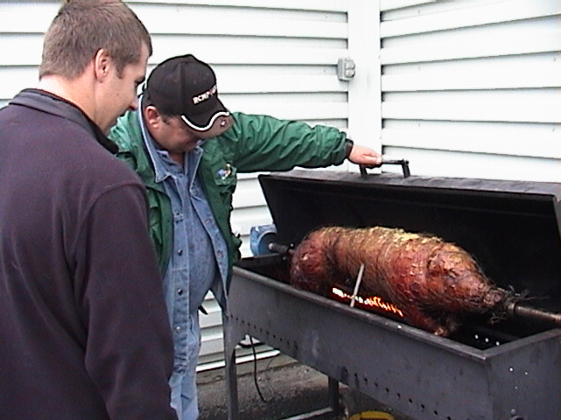

June 21, 2003
Provided a whole pig barbeque for the Ladies Auxiliary.

July 1, 2003
Lodge manned a float in the Canada Day Parade and barbequed a whole pig.

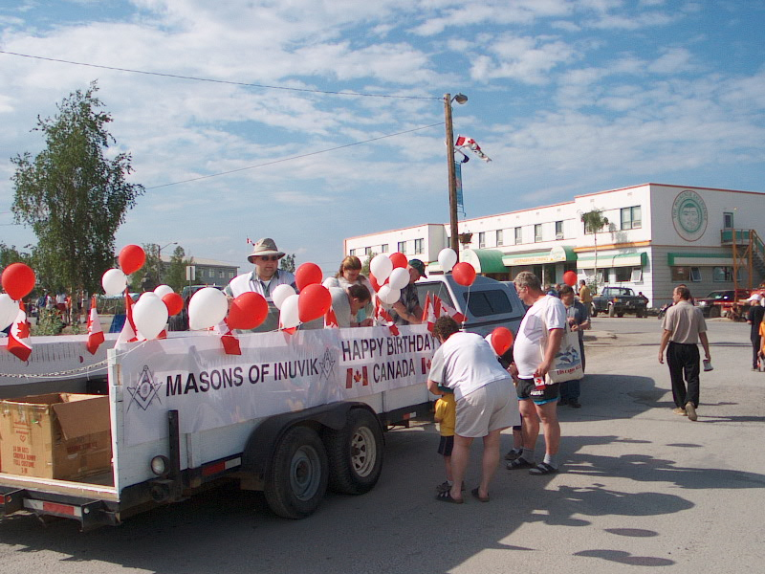
August 7, 2003
Bro. Wolfe was appointed to investigate the possibility of acquiring a building to be used as our Lodge Hall.
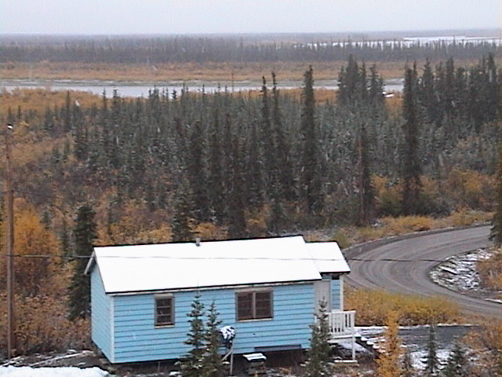

The future Masonic Hall, Inuvik, NT – Future Home of Far North Lodge #199
September 11, 2003
Ceremony of Passing to the Fellowcraft Degree Bro. David Patrick

September 20, 2003
Initiation of Bro. Christopher Always

November 29, 2003
Raising of Bro. Patrick to the Sublime Degree of a Master Mason

December 11, 2003
The first draft of our by-laws was distributed to the brethren

January 15, 2004
Raising of Bro. McCready to the Sublime Degree of a Master Mason

February 12, 2004
The By-Laws of Far North Lodge were approved by the Lodge.

February 14, 2004
Provided a whole pig barbeque for the Lions Club. Becoming well known for this sort of thing, perhaps it’s time to vary the menu.

March 27, 2004
Raising of Bros. Lindsay and Kinglser to the Sublime Degree of a Master Mason.

April 8, 2004
Initiation of Bro. Levente (Levy) Kiss

April 16, 2004
Raising of Bro. Mark Bleakney to the sublime Degree of a Master Mason.

May 13, 2004
First meeting held in the “512” at Jimmy Adams Peace Park.

June 5, 2004
Initiation of Bro. John Bulmer (First candidate initiated in new Lodge building)

