The 4th District Artificer
(Artificer: one who contrives, devises or constructs)

September 2011 ---- Volume 2, Number 9
A source of information for the active Free and Accepted Mason seeking to travel, participate and
earn master’s wages … or, just have some fun! New issue for each monthly DLI meeting.
under the direction of
R.W. George Mackanin, District Deputy, Grand Master
Editor: Richard C. Powell
7 White Oak Lane, Wayne, NJ 07470 - (862) 221-9537
ricksworld@optonline.net
THE ARTIFICER online www.mastermason.com/euclidlodge136
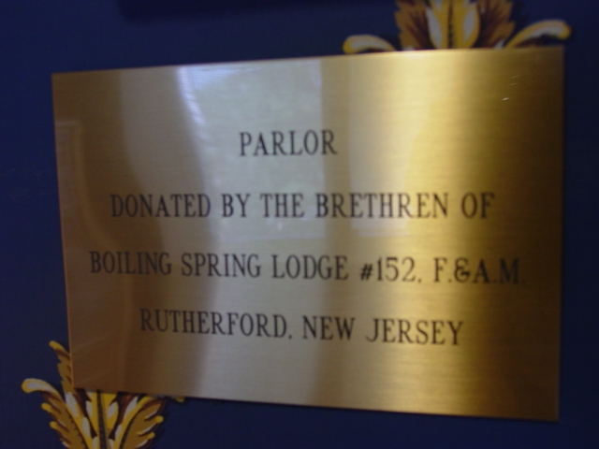
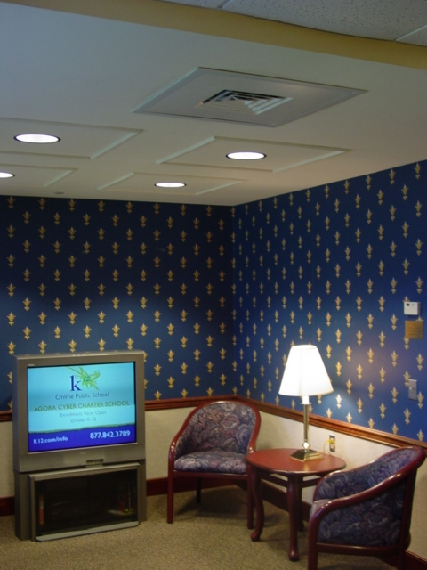
Many Thanks to the Brethren of Boiling Spring Lodge #152 for their generous donation of the West-1 Parlor to the NJ Masonic Home, Burlington, NJ.

DISTRICT LODGE OF INSTRUCTION –second Monday of every labor month. Next DLI is September 12th, 7:30 at Adoniram Lodge #80, Lyndhurst. Attendance is mandatory for all Lodge Officers! All Master Masons welcome. Jacket & tie. Under the direction of R.W. Kenneth Wasiewicz, District Ritual Instructor (973) 764-3037.

Lodges - Regular & Special Event Meetings
(Regular business meetings are not listed, only special events and degree nights)
Adoniram #80, 1st and 3rd Wednesdays
-9-7 RETURN TO LABOR (Hawaiian Shirt Night)
-Sunday 9-11 Veterans Home Visit
-December 21st – OFFICER INSTALLATION
Boiling Spring #152 , 2nd and 4th Tuesdays
-9-13 RETURN TO LABOR
-Sunday 9-18 Veterans Home Visit
-December 13th – OFFICER INSTALLATION
Clifton #203, 1st and 3rd Thursdays
-Lodge Picnic, Sept.10th.
-9-15 RETURN TO LABOR
-9-22 Emergent EA Degree 7:30pm (7pm opening)
-Sunday 9-25 Veterans Home Visit
-10-20 FC Degree
-11-17 MM Degree (Past Masters Night)
-December 15th – OFFICER INSTALLATION
Eclipse #259, 2nd and 4th Wednesdays
-9-14 RETURN TO LABOR
-December 14th – OFFICER INSTALLATION
Euclid #136, 1st and 3rd Fridays
-9-16 RETURN TO LABOR (Flag Dedication)
-Oct. 28 MM Degree
-December 17th – OFFICER INSTALLATION
Lessing Passaic #67, 1st and 3rd Tuesdays
-9-20 RETURN TO LABOR
-December 20th – OFFICER INSTALLATION
Little Falls #263, 2nd and 4th Wednesdays
-9-14 RETURN TO LABOR
-9-28 EA Degree (7:10 opening)
-December 22nd – OFFICER INSTALLATION

!!!!!! Special Events !!!!!!

-BLOOD DRIVE - Clifton Masonic Temple, 3rd Friday of every month, 2:00 to 8:00pm. Walk-in for whole blood donations; make a reservation to donate platelets. For additional information contact: District Chairman Thomas Wood, 201-729-0023.

-Sept. 10th, CLIFTON LODGE ANNUAL PICNIC – held at the Lodge grounds. Noon to 4pm. A family event! RSVP to WM Eric Gonzalez; 732-970-7361 egonza7@gmail.com .

-Sept. 17th, Saturday, 6-9pm. MASONIC CLUB OF LYNDHURST CRAB NIGHT! This very popular event is here again with all you can eat crabs, chicken fingers, and cole slaw for $15 per person. Open to the Public! Clams available at extra cost. Reservations are strongly recommended and appreciated to help with planning. Call the club at 201-933-1330. Masonic Club, 316 Riverside Ave, Lyndhurst, NJ. Cash bar (with the cheapest prices in NJ!). If you have never visited the historic Masonic Club, here is a great excuse to do so!

-Sept. 20th, Tuesday, 7:30pm, KANE COUNCIL #2 of ROYAL AND SELECT MASTERS celebrates its 150th anniversary. This historic event will include: Official Visit of Most Illustrious John D. Barnes, GM of the R&SM of NJ; An open table council, catered buffet dinner, presentation of “Mozart and Freemasonry”; and a souvenir medal for all in attendance. This is open to all Master Masons and Royal Arch Companions. Cost is $25/Mason. Checks should be payable to “Kane Council No. 2 R.&S.M.” and mailed to Hansil F. Asmar, 724 Highland Avenue, Paramus, NJ 07652. Please RSVP, ASAP! This date is fast approaching! Event will be held at Masonic Temple, 225 Kearny Ave., Kearny, NJ. http://www.kanecouncil.org for additional information.

Sept.23rd OASIS NIGHT at Salaam Shrine. Visit their website for details www.salaamshrine.com

-Sept. 23rd , Friday, 7-11pm CHILDRENS DYSLEXIA CENTERS OF NJ HARVEST MOON CHARITY BALL at NORTH JERSEY COUNTRY CLUB, Wayne, NJ. $120 per person. Black tie optonal. Guest of Honor is Rose Heck, former Assemblywoman and current Mayor of Hasbrouck Heights. Dance to THE BRASS TACKS ORCHESTRA. Hors D’oeuvres, Champagne, Antipasto & Cheeses, open bar, premium liquors, signature martinis, Four Course Meal (choice), Pastries and Desserts. RESERVATIONS REQUIRED. RSVP and Details, contact: Barbara and Kyle Nurge (201) 440-9425 or email banurge@aol.com . Please RSVP by September 9th.

-Sept.24th, Saturday, 1 to 6pm, at the CLIFTON MASONIC TEMPLE … FAT MIKE’S FAMOUS FISH FRY & COURT CAST PARTY. $25 per adult; $12.50 children under 12. RSVP A MUST by September 10th. Checks to Mike Porter, 26 Walsh Court, Clifton, NJ 07013, payable to “NEWARK COURT #37 ROJ”.
This event is being held to raise funds for a new sound system at the Temple so please come out and support your Brethren! It will be a great afternoon … menu includes: ½ pound of fish of your choice including flounder, cod, red hake, sea bass, ling, stripped bass, porgy, scrod, (others as available); red or green slaw, corn, fries, hamburgers, dogs (for those who don’t like fish!), watermelon, beer, soda, and (for an extra charge) you can add: cooked crabs, lobster tails, clam chowder, fish chowder and clams. Get your checks in the mail to Mike today!!! Don’t miss this one!!! Held at Clifton Masonic Temple, 1476 Van Houten Ave, Clifton.

-SEPT. 24th, Sat., 9:30am, M.B.Taylor Lodge #141, Hammonton, NJ MEETING OF NJ LODGE OF RESEARCH AND EDUCATION. Visit the website www.njlore1786.org . COME, SHARE MASONIC LIGHT !!!
(WMs: Would you like to host a LORE meeting? LORE is seeking Lodges to host a quarterly meeting and provide wider exposure throughout the state. Programs are always interesting. Membership application available on website.)

-October 1, 2011, 6:00 PM Saturday, Boiling Spring Lodge annual Oktoberfest Dinner /Dance $20.00 per ticket. Tickets available through Bro. Douglas Sinopoli and WB Wayne Heber.

-Oct. 1st, 2011, Saturday, Clifton Craftsmens Club Trip to West Point for picnic and ARMY VS. TULANE Game. Limited seating. $70 per person includes game, bus, tailgate and homecoming activities! Contact Jim Wright for information and tickets (973)661-2155. jejwright@aol.com . Game time is 12 noon. Bus will leave from Clifton Lodge at 7:30am. A tour is also planned. FIRST COME FIRST SERVED! Call Jim to reserve your seat. Hosted by the Clifton Craftsman Club.

-Oct. 8th LITTLE FALLS LODGE GOLF OUTING AND BEEFSTEAK. Black Bear Golf Resort, Franklin, NJ. 6:30am continental breakfast. 7:30am shotgun start. 6pm beefsteak dinner (catered by Hap Nightingale) at LITTLE FALLS LODGE til 11pm. Proceeds benefit The Cystic Fibrosis Foundation. $150 golf and beefsteak; $130 golf only; $35 beefsteak at Lodge only. There is a flyer in circulation with full details or contact RW Tom Roskop grandpoobah04@optonline.net Many sponsorship opportunities are still available! Beefsteak is catered by Hap Nightingale. Please RSVP or send payment ASAP as this date is fast approaching! Checks payable to “Little Falls Lodge No. 263”, mailed to: Tom Roskop, Little Falls Lodge No. 263, 108 Boyle Avenue, Totowa, NJ 07512. Tom’s # is (862)686-0623.

Oct. 9th, Sunday, 2pm – ADONIRAM LODGE COCKTAIL PARTY OPEN TO ALL, Lodge members, family and friends. Socialize and see the renovations to Adoniram Lodge (Lyndhurst). Jacket and tie.

-Oct. 15th 2011, Saturday, 10am to 2pm - 2011 SQUARE & COMPASS DAY – ALL LODGES IN NJ open their doors to the public to share Masonic awareness, accept petitions for membership, and answer questions about our Fraternity. It is NOT too early to begin planning and promoting. I will get promotional materials in the hands of current WMs before our summer break. Our District Masonic Awareness Committee Representative is Greg Tierno of Clifton Lodge (201)323-2403.

-Oct. 15th, Saturday, HAUNTED HALLOWEEN OPEN TABLE LODGE hosted by Clifton Lodge Blue Apron Club. What a great way to wrap up Square & Compass Day with a Masonic Party! Open to ladies and friends. Please RSVP by Oct. 8th to Greg Tierno, 48 Fairview Avenue, West Orange, NJ 07052. 201-323-2403. $25 per person. Checks payable to: Clifton Lodge Blue Apron Club. Costumes STRONGLY ENCOURAGED. Good food, fun and friends! Starts at 6:30 at the Clifton Temple, 1476 Van Houten Ave.

-Oct. 27th, RECEPTION FOR DISTRICTS 2, 3, 4, 5 & 8 at FIESTA, Route 17S, Wood Ridge, NJ. 4pm social. GL opens at 7pm. Honorees include the 4th District’s RW Joseph Kubik, RW Alex Dakak, and RW Charles Hashagen. Tickets are $40. Choice of beef, chicken or fish. This is an open reception.

-Nov.15th , Tuesday, Master Mason Night – Stella Chapter OES. Please forward details to me.

-February 29, 2012 … HILLBILLY MURDER MYSTERY to be hosted by Boiling Spring Lodge at the Rutherford Masonic Temple. This will be an extremely fun event and beefsteak dinner open to ladies and friends of Masonry. Save that date! Snow date will be one week later.

SPAGHETTI DINNER – First Friday of every month, Masonic Club, Lyndhurst, $8.00 (children under 10 FREE), all you can eat. GREAT FOOD AND FELLOWSHIP! Open to the public.

FRIDAY NIGHT GANG at the Masonic Club, 316 Riverside Avenue, Lyndhurst, NJ. Open to all Masons (of any degree) and friends. An informal gathering of friends every Friday night at the historic Masonic Club at roughly 8pm (come early, come late). A $3 donation helps cover the cost of tasty snacks and treats. If you are interested in membership in the Masonic Club, you must be a full MM. Ask any member for full details or stop by the club to pick up an application. You won’t regret it. Club meetings are held on the 2nd and 4th Wednesdays of each month (including Summer), 7:30pm, at the Club.

Veterans Home, Paramus, NJ - Sunday Visitation

Adoniram: 9/11, 12/4; Boiling Spring: 9/18, 12/11; Clifton: 9/25, 12/18; Eclipse: 10/2, 12/25; Euclid: 10/9; Lessing Passaic: 10/16; Little Falls: 10/23.

All Masons are welcome on any Sunday! We need your support!
Meet at 12:45 in Front Lobby of Home to assist with Christian Worship Service Transport.
Anyone interested in becoming a certified volunteer at the home can talk to Brother Rick Powell, MSA, Deputy Representative, for details. RW Robert Evans, (973)779-4296, MSA Representative. Rick Powell (862)221-9537, MSA Deputy Representative. Mike Holt, State MSA Rep. (908)418-2177

* * * GRAND LODGE EVENTS * * *

-Oct. 1st 2011, Sat. – JUNIOR GRAND WARDEN’S RECEPTION & DINNER at Burlington Fellowship Center. In honor of RW Gerald J. Sharpe. Social hour 5:00, dinner 6pm. Reservations a MUST! $65/person. This is an OPEN event, so invite the ladies. Tables of 10 can be reserved. Be sure to include names of all attendees and meal choice (prime rib, chicken francaise, fish). Checks payable to KEYSTONE LODGE NO. 153. Payment to: Sheldon Bank, 309 Cornwall Avenue, Ventnor, NJ 08406. Contact info: sheldonbank@comcast.net (Home) 609-882-8947 (Work) 609-289-2498. Deadline for reservations is SEPTEMBER 1st, 2011 !!!!!!!!!!!!!! Act NOW !!! A great Lodge event !!!

-Oct.7th (Fri., 4 to 7pm) & Oct. 8th (Sat., 9am to 12noon) – MASONIC HOME RESIDENTS’ HOLIDAY BAZAAR – Handcrafted Halloween, Thanksgiving, and Christmas items. Toys, Hooked Rugs, Jewelry, Afghans and MUCH MORE! Please support the residents of the Home and do some holiday shopping at the Home! Bazaar at the Grow Memorial Hall, Masonic Home of NJ, 902 Jacksonville Road, Burlington, NJ (enter at rear of Home from Oxmead Road). Maybe visit this, and then arrange a tour? …
Guided Tours of the Masonic Home, Burlington, NJ are available and can be arranged through Tonya Costley-Stilts, Director of Volunteers, 609-239-3866. Remember that all Master Masons are required to visit Burlington! Why not make the tour a part of a Lodge event? Travel with your brothers, arrive early for a Grand Lodge event and tour the impressive facilities; or combine this tour with a visit to the USS New Jersey battleship or other historic sites.

-Oct.15th, 2011 TRICKY TRAY BENEFIT for the residents of the Masonic Home, Burlington. Always popular and successful, but us Lodge officers will be busy with Square & Compass Day duties!

-Dec. 10th ,Saturday, ANNUAL FEAST OF ST. JOHN, Burlington Fellowship Center. A great event open to ladies and friends. This year’s program will be a reenactment of the Grand Lodge of NJ’s founding fathers conducting the very first Lodge meeting in the state. Cost is $50/per person. RSVP deadline is Friday, Nov. 25th. Times: 5:30pm Social Hour, 6:30 welcome and opening, 6:45 dinner, 8:00pm program. NO TICKETS AT DOOR. Order NOW by sending payment and a SASE to: Grand Secretary’s Office, 100 Barrack Street, Trenton, NJ 08608. Checks payable to: Grand Lodge of NJ, F.&A.M. Group reservations for tables of 8 or 10 may be made. Include names of all attendees. Address of Fellowship Center is 1114 Oxmead Road, Burlington, NJ. If you have not been … do not miss out! Just a thought … use this for your Lodge’s Christmas Party?? You can’t beat the price … or the quality!

-Feb 25th, 2012 ANNUAL POLAR BEAR PLUNGE … Need a chilling thought in this record heat? Registration is now open for the 2012 Polar Bear Plunge in Seaside Heights. Our Team Name: Hiram On Ice
www.njpolarplunge.org All proceeds benefit the NJ Special Olympics.
If you came before, you know how much fun it is. If you never attended, please join us. You do not have to plunge. Questions: RW Dieter Hees DDGM
20th Masonic District dhees@mac.com c: 732-300-4860
RAISE $$ for the CHILDREN’S DYSLEXIA CENTER of Hasbrouck Heights and SAVE $$ on your electric bill. Brother Dragan Blanusa is promoting a deal with Viridian that will reduce your electric bill AND donate money to this worthy cause. Details about the program are available at www.viridian.com/hhcdc or by contacting Dragan at 908-296-2908.

VISITING THE TRENTON TEMPLE:Visit www.trentonmasonictemple.com for lots of information and parking sites around the area.

EDITOR’S NOTE: First I apologize for a few wrong return-to-labor dates in the previous issue. It is my understanding that all 4th District Installations are OPEN this year. Also we need the opening times for the Installations. For visiting brothers, please RSVP to the WM for any installation you plan on attending as this helps tremendously with planning. LAST CALL FOR THE JR.GW RECEPTION! If you have not made your reservations do so IMMEDIATELY! The event is being catered by a top-end restaurant(Sea Oaks) and will certainly be a memorable evening for all. See info in this issue. There are LOTS of great events coming up and I am looking forward to seeing everyone as we get back to our regular schedule. I hope your Summer was great … and our thoughts and prayers go out to all who suffered material and emotional damage with the recent floods. Your brothers stand with you! Fraternally, Rick Powell

