August 4, 2001, Annual Outdoor Communication  This year's Communication will again be held on the ranch of our late Brother, RWB Stan Nykanen. For the past several years, the Communication has been held on Stan's ranch. His wife, Elin has graciously invited the Lodge back again this year.  The fellowship will begin mid-afternoon, and a barbecue will be served around 4:00 p.m. The Lodge will be opened on the Entered Apprentice Degree around 5:00 p.m. The Lodge will open on the Entered Apprentice Degree to allow the newest members of our Fraternity to attend. Please encourage any EAs and FCs to attend with a Master Mason or someone who can vouch for them.  If you plan to attend, it is recommended that you bring some sort of headgear. Cowboy hats seem to be the most popular. It also provides some protection from the "occasional" afternoon thunderstorm and the afternoon sun can take its toll.  On August 16,1944 the first dispensation was granted to Estancia Lodge No. 33 to hold an outdoor communication in the Manzano Mountains. About 6 years ago it was moved to the above location.  It is our hope that you will be able to attend this long standing Estancia Lodge tradition. |  |   Six members are still delinquent with their dues and will be suspended as of June 30. They have until December 31 to be reinstated without a vote of the Lodge. After that they will have to go through the reinstatement process, with a petition.  Also, members, who are interested, can send me their email addresses, (if I haven't already asked for them) it wouild facilitate notification of noteworhty events, funerals, degrees, ect. Send your email address to: fbf123@aol.com Subject: Lodge email (or something so I know that it isn't just junk)  I promise no forwarded jokes or the like.  F, Fred Frye  Secretary
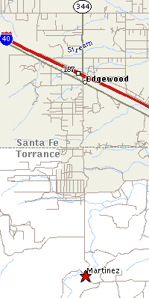 | Take the Edgewood exit south off of I-40 to the frontage road (old 66), through the 4 way STOP then 5.3 mile south (about "2 miles or so" south of the 4 way STOP turn left at the T and up the hill) and follow the signs. | BOAZ: New Mexico Ghost Town  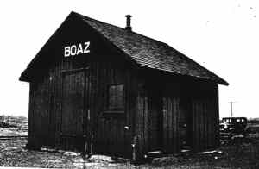  No residents for the past 65 years. Only ghosts remain, along with some foundations for buildings erected by the AT&SF RR Co for their section gang who maintained that long lonesomestretch of track back then. It is reached by traveling north and east from Roswell NM on State Highway # 70 for about 40 miles.

