From The South    Hot enough for ya?  Summer is here and the date of our annual outdoor communication is rapidly approaching. Last year the turnout was great and I have full confidence that this year’s will be also. Hope to see a lot of brothers there dwelling in unity.  Fraternally,  Daryl Abraham  Junior Warden |   Brethren;  Estancia Lodge has always been known for it's good work and fellowship, as well as a good feeder. The members of the Lodge are pretty well scattered and the attendance at meetings shows that. This makes it difficult to stay up to speed when all the officers cannot be at the meetings.  The Ritual Work of the Lodge is not up to standard. I firmly believe that more effort must be put forth by the Officers of the Lodge to improve the Ritual. We should not have difficulty in Opening and Closing. This reflects badly on the Lodge. Ritual practices have been called and few show up.  I am available to assist in any way necessary to improve the Ritual Work of the Lodge.  Fraternally;  Charles D. A. McCoy  Senior Deacon/ DDGL  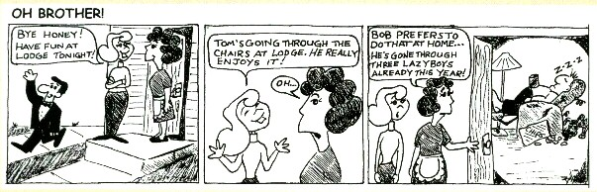
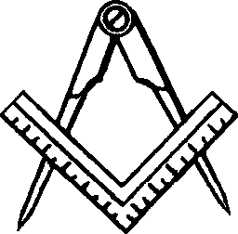

Congratulations and Welcome
to our three new Entered Apprentices!! Remember to work with your coaches to learn the proficiencies. Also, know that any brother in the lodge would be willing to answer your questions if he can and if he can't he will either find the answer or someone with the answer.



