DeKalb Masonic News
Publications of DeKalb, Illinois, Masonic Bodies, January 2002
DeKalb Lodge #144 A.F & A.M. P.O. Box 644, DeKalb, Illinois 60115

DeKalb Lodge Earns Grand Masters Award of Excellence –Again!
The Members of DeKalb Lodge can be justifiably proud of receiving the Grand Masters Award of Excellence for a third year! In addition, we were awarded the Golden Trowel Award for having the highest score in the 8th Northern. This is the result of many brothers working together to accomplish the goals set forth in the requirements. In addition, we were presented an award of merit for the newsletter, thanks to the efforts of the editor, WB Jay Elliott. The awards were received at Grand Lodge in October, and presented to DeKalb Lodge at the stated meeting of Oct. 9 by WB Al Johnson, District Deputy Grand Master. The requirements for this year have been changed, with less time to complete them.
Worshipful Master Bill Schmitt receives the Grand Masters Award of Excellence from Al Johnson, DDGM. This marks the third time DeKalb Lodge #144 has received the award.
WB Jay Elliott has again agreed to handle the paperwork needed to keep us on track to accomplish the goals. Not all Lodges participate in this program. Some may think it is too much work. Others, for whatever reason, just do not choose to participate. All members of DeKalb Lodge can be proud of their brethren who put forth the time and effort to compete for this honor.

Special Meeting
Ken Gregory, a law student at Rutgers University, returned to DeKalb for the Thanksgiving school break. The DeKalb Lodge #144 held a special meeting Friday morning at 9a.m. when Ken was initiated into the Lodge. He will continue the degree work later this year during the summer school break.

Note from Ken and Beryl
A note was received from Ken and Beryl Richardson regarding the DeKalb Lodge Christmas Party and the work being done by the lodge members. Nice hearing from the Richardsons. The editor had the privilege of visiting the Richardsons in their Florida home last winter. It’s obvious they do enjoy their winter home.
Worshipful Master Bill Schmitt and Brother Jay Elliott, editor, receive the Award of Merit from Al Johnson, DDGM. The award was first presented at the Grand Lodge in October.

State Lodge Flag
Brother Robert Boyd reported that the Most Worshipful Grand Master has asked him to make a state lodge flag. Robert said that he would like help with the project, and will bring some examples to the next meeting.

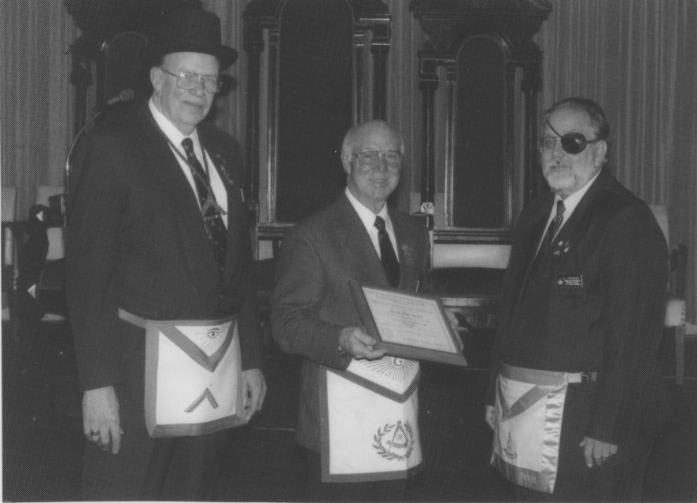
Web Site Is Up
The DeKalb Lodge Web site is up and running and can be reached at mastermason.com/dekalblodge144. This is much appreciated, especially after several previous attempts have faltered.

Sickness
Louis Meinert’s wife Shirley has been in the hospital for hip surgery.
Slim Kittleson was briefly in the hospital. He is home now.
Bill Minnihan’s wife Shirley is in the Swedish American Hospital for heart surgery. She will temporarily enter a nursing home when released from the hospital.
Gladys Prestegaard is recovering from knee replacement surgery. We wish a speedy recovery to one and all!

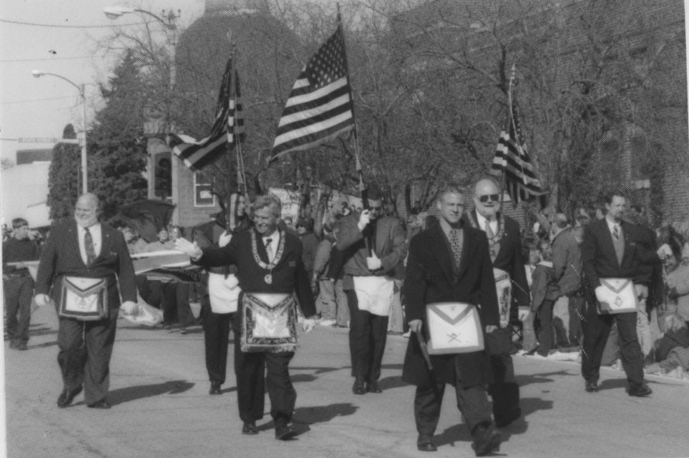
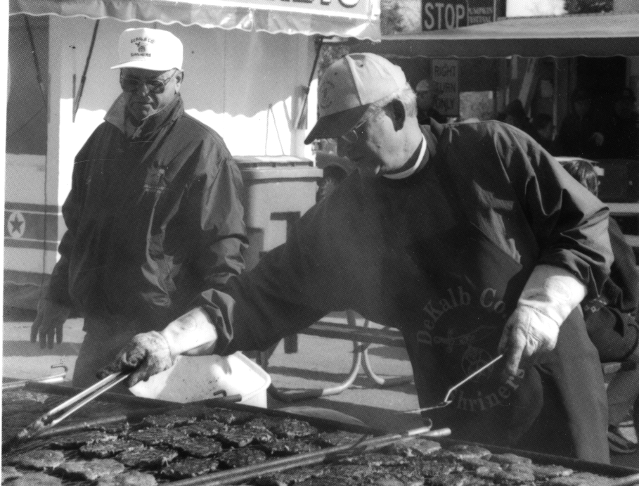
Marching in the Sycamore Pumpkin Parade were (with flags from left to right, all of DeKalb Lodge #144) Nick Barth, Jerry Finnigan, Todd Metsker; (middle row from left) Dale Carresse, DDGM 5th Northern District, James Durbin, Illinois Grand Master, J. Garrie Burr, Past Grand Master, Brother Robert Boyd, DeKalb Lodge #144; (front center) Brother Ray Binkowski.

Obituaries
Brother George Thomas Burch, DeKalb, passed away Sept. 28, 2001. Tom was raised to Master Mason at DeKalb Lodge Sept. 29, 1955. Burial was in Fairview Park Cemetery.
Brother Walter Raymond Hammett, DeKalb, passed away Sept. 30, 2001. He was raised to Master Mason on May 28, 1963. His burial was also in Fairview Park Cemetery.
The brothers of DeKalb Lodge participated in Masonic Funeral service for both brothers.
The Masonic bodies of DeKalb extend their sympathy to the families of these long time Masons.

Masonic Bowl
Ken White is working with Scott Williams at DeKalb High School to coordinate the Masonic Bowl activities.

Orator for Illinois Demolay Addressed the Lodge
At the Dec. 11th meeting of DeKalb Lodge #144, Senior Deacon Greg Finnigan introduced John Haney of Rock Island Lodge #658, and the State Orator for Illinois Demolay. John brought an update regarding the status of Demolay activity in this area.
Kalin Majors of Rochelle Horicon Lodge was also introduced at that time. Kalin also attended the January 8th meeting of DeKalb Lodge #144.

DeKalb County Shriners Presented 7th Degree at Scottish Rite Temple
Members of DeKalb Lodge #144 participated in presentation of the 7th degree at Scottish Rite Temple in Freeport recently. They were John Birkett, Dean Quarnstrom, Don Hudson, Chuck Kross, Roger Palmer, Ken White, Todd Metsker, and Curt Behrens. Other Masons taking part from Genoa Lodge were: Gary Tewksbury, Bob Larson, Dave Burrows, Henry Lanan, and Jay Johnston. From Sycamore Lodge were Tom Whitaker and Director Ross Niebergal.

New Affiliate
DeKalb Lodge #144 welcomes Loren Wilson from Malta. Loren affiliated with the DeKalb Lodge in October.

Donations
A donation to the Masonic Service Association Green Envelope Appeal, the Masonic Children’s Home, and the Masonic Service Association of Chicago were approved recently at regularly stated meetings.
A “Thank You” note from the New York Grand Lodge for DeKalb Masonic Lodge’s contribution was read.

Christmas Party
Junior Warden Todd Metsker chaired the Christmas Party Committee. The party was a huge success, with 65 individuals attending. Those assisting Todd were Ray Binkowski, Rich Spahn, Greg Finnigan, and Robert Boyd. Ham and Turkey were served, and Santa made an appearance. All enjoyed the good food, fun, and fellowship.
DeKalb Masonic Brothers Don Hudson grills pork chops at the Sycamore Pumkin Festival as Brother Dean Quarnstrom observes the activity.

Dues Invoice Charge
The printed invoice indicates our dues to be $28. Last year we had a by-laws change, which sets our local dues at $25 over whatever the Grand Lodge per capita charge may be. While this is a $10 jump in dues this year, the Lodge has absorbed two past raises in Grand Lodge per capita without raising dues. The lodge felt that in order to maintain a constant dues income level, we would establish our dues at the $25 level, plus the per capita Grand Lodge fee. I’m not sure this explains it succinctly, but if anyone want to talk to me (Chuck Kross, Secretary) about it, they can call me at 815-758-1772, and I will be happy to discuss it. If there are brethren who cannot pay their dues due to any circumstances, they should also call me and we can work something out.
Ralph Seats Suffered Stroke
Brother Ralph Seats was hospitalized in November with a stroke. He has not returned to work at this writing, but is home doing well.

Mike Salva Attended Meeting
Lt. Mike Salva attended the first Lodge meeting in January. He has been in Marine Corps Training since leaving DeKalb last summer. He is enjoying his time in the East, learning lots of history in the Washington-Virginia area, and is anxiously anticipating continued training at Camp Pendleton, California, later this year.

DeKalb Officers to Assist in Rochelle
Plans are in progress for officers of DeKalb Lodge #144 to assist Horicon Lodge in Rochelle on Tuesday, March 5 with 3rd degree work. The Worshipful Master will determine at which stations they need assistance. Other lodge members are welcome to attend and enjoy the evening with fellow Masons.

The DeKalb White Shrine
At our November meeting everyone brought non-perishable food items, which were donated to the food pantry at Sycamore Methodist Church.
At the December meeting Sojourner Ruth Johnson was honored for her 50 years in the order. She was presented a corsage and her 50 year pin and card. A brief history of her many years of service was read. Ruth is our Worthy Treasurer.
We met in January. Everyone seemed rested after the holidays. We were saddened by the death of Sojourner Helen Ebright.
Our next meeting will be Feb 14. Hope to see everyone there.
Betty Richardson
Worthy High Priest

Eastern Star Officers
for 2002 Installed
The Officers of Normal Chapter #357, Order of the Eastern Star for 2002 are: Kathie Schmitt Worthy Matron; Bill Schmitt Worthy Patron; Anna Bryson Assoc. Matron; Lou Meinert Assoc. Patron; Dorothy Bierman Secretary; Connie Klopp, Treasurer; Bev Evensen, Conductress; Bill Bryson, Chaplain; Dave Klopp, Marshall; Lois Seitzinger, Ruth; Kandis Emmert, Esther; Julie Emberson, Martha; Michelle Zibrun, Electa; Rick Emmert, Warder; and Jim Lofftus Sentinel.
Installation of Officers was held on December 1st.
The 2002 calendar and directory will be mailed to all members in January.

Sycamore Commandery Hosts Annual Inspection
Participating on November 24th were eight current and past Grand Officers of the Knights Templar. This year saw several changes, including the opening at 10:30am, and a luncheon meal in place of a dinner. The Ladies Auxiliary did an excellent job of preparing and serving the food.
Thanks to Arlene Johnson, Connie Klopp and Kathie Schmitt for their dedication and hard work.
Next year’s inspection is tentatively set for Sept. 21.
Our thanks to Bill Ferris, EC of Crusader #17 for his work as acting Commander, and all Sir Knights and their Ladies who attended.

Santa pays a visit to DeKalb Lodge
After an absence of almost 10 years, a Christmas party was held at the DeKalb Masonic Temple on Dec.9th. Todd and Sherri Metsker, Robert and Pam Boyd, Greg and Karon Finnigan, Rich Spahn and Ray Binkowski did an outstanding job of preparing turkey, ham and all the trimmings. More than 65 men, women and children enjoyed the meal.
After desert, Santa Claus distributed toys and goodies to the children. All adjourned to the lodge room for some Christmas music provided by Frank Biletzky at the organ.
Todd and his great crew deserve much credit for a delightful evening of food, fellowship and fun.

Potpourri, etc.

DeKalb Lodge #144 will host a school of instruction on January 24, with the emphasis on rod work.

A schedule will be out shortly with information on practice sessions leading up to the Lodge Officers competition for 2002. This includes opening 1-2-3, receiving the DD, and closing 3 short.

Sycamore Lodge #134 had their Installation of Officers Nov. 28th with Dale McBride as Worshipful Master. Dual members Todd Metsker is Sr. Warden, Rick Emmert is Sr. Steward and Bill Schmitt is Secretary.

A reminder from the Temple Board: After your meeting, please see that the kitchen is cleaned and ready for the next use. This includes putting dishes and utensils where they belong, and taking the towels for laundering. Lowering the thermostat to 65 degrees will help save on the gas bill. Your cooperation is appreciated.

Lost at Masonic Temple funeral reception: candlewick candy dish, two section, clear glass. If anyone has seen it, contact: Bernice Hammett, 756-6049.

Educational Meetings

The Standard Club met at DeKalb Lodge on Thursday, Nov. 15th, and Officers School met on Thursday, Nov. 29th.

Coming Events

Feb. 26th
There will be a Presidents’ Day dinner at the DeKalb Masonic Temple at 6:30 p.m.

Mar. 12th
There will be an official visit of the District Deputy Grand Master at the regular meeting.

Mar. 26th
DeKalb Lodge #144 will hold a St. Patrick’s Day dinner at 6:30 p.m. at the DeKalb Masonic Temple.

Apr. 9th
There will be a 2nd degree for DeKalb Lodge #144 during the scheduled meeting.

June 24th
St. Mary’s Catholic Church will hold services at 7:00 a.m. Mon. morning in memory of Saint John the Baptist. The church is located at the corner of Fisk and 4th streets.

WHO ARE THE MASONS?

The purpose of these quarterly essays is to share with our readers a discussion of the purpose, concepts, and philosophy of Freemasonry and thereby refresh the teachings of our degree work. My recent research has identified a newly published pamphlet entitled WHO ARE THE MASONS? It is available from the Masonic Information Center, 8120 Fenton Street, Silver Springs, MD, 20910-4785. What follows has been extracted from this pamphlet.

Freemasonry is dedicated to the Brotherhood of Man under the Fatherhood of God. It uses the tools and implements of ancient architectural craftsmen symbolically in a system of instruction designed to build character and moral values in its members. Its singular purpose is to make good men better. Its bonds of friendship, compassion, and brotherly love have survived even the most divisive political, military, and religious conflicts through the centuries. Masonry is a fraternity which encourages its members to practice the faith of their personal acceptance. Masonry teaches that each person, through self-improvement and helping others, has an obligation to make a difference for good in the world.

No one knows just how old Freemasonry is because the actual origins have been lost in time. Most scholars believe Masonry arose from the guild of stonemasons who built the majestic castles and cathedrals in the Middle Ages.

What Do Freemasons Do? The Masonic experience encourages members to become better men, better husbands, better fathers, and better citizens. The fraternal bonds formed in the Lodge help build lifelong friendships among men with similar goals and values.

Beyond its focus on individual development and growth, Masonry is deeply involved in helping people. The Freemasons of North America contribute over two million dollars a day to charitable causes. This philanthropy represents an unparalleled example of the humanitarian commitment of this great and honorable Fraternity. Much of that assistance goes to people who are not Masons. Some of these charities are vast projects. The Shrine Masons (Shriners) operate the largest network of hospitals for burned and orthopedically impaired children in the country, and there is never a fee for treatment. The Scottish Rite Masons in the Southern Jurisdiction maintain a network as of 2001, of 150 Childhood Language Disorder Clinics, Centers, and Programs. Other Masonic organizations sponsor a variety of philanthropies, including scholarship programs, and perform public service activities in their communities. Masons are men of good character who strive to improve themselves and make the world a better place.

And so my brothers may we ever meet, act, and part with a sense of brotherhood.

Fraternally yours,
Haakon L. Andreasen
Past Master

