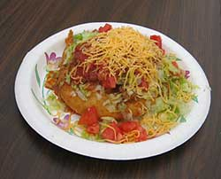
INDIAN
TACOS
$5.00 All you can eat (Dine-In Only)
$3.00 Children under 12
Take out / Pre-orders: 364-3248 or 387-3912
Saturday, Mar. 19th only: 485-3351

Proceeds benefit our Charity Projects.
Blanchard Eastern Star
10th and N. Main
Blanchard, Oklahoma

Saturday Mar. 19th
11:00 A.M to 2:00 P.M.

