GRAND LODGE FREE AND ACCEPTED MASONS
OF TENNESSEE

DISPENSATION

To the Worshipful Master, Wardens and Brethren of

White Station - OK Houck Lodge No. 95

BY THE VIRTUE OF THE POWER IN ME VESTED AS GRAND MASTER OF MASONS IN THE STATE OF TENNESSEE

I do hereby grant this, my dispensation

Authorizing said Lodge to change its stated meeting night from January 1st to the January 8th to avoid conflict with the New Years Day Holiday .

You are hereby instructed to see that all resident members are notified of this dispensation and the purpose thereof. This dispensation must be read in open Lodge and entered upon the minutes.

THE GRAND SECRETARY MUST BE NOTIFIED WHEN THE ACTION AUTHORIZED HAS BEEN COMPLETED.

Given under my hand and seal at Nashville, Tennessee this the 29th day of November, A. D. 2006, A. L 6006.

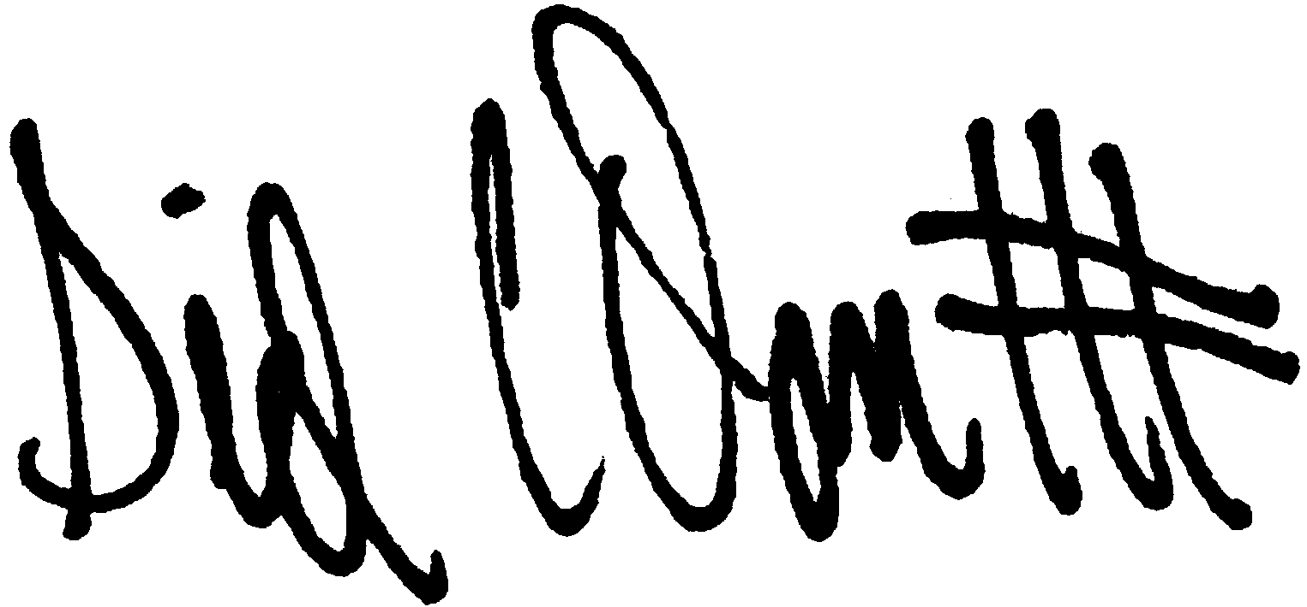

_______________________________________

Grand Master

