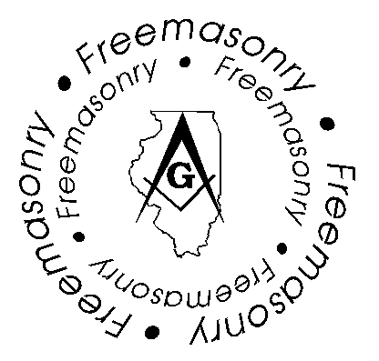

The Most Worshipful Grand Lodge of

Ancient Free and Accepted Masons
Of the State of Illinois

3307 Broadway Lawrence D. Petty, (H) 815-229-3005
Rockford, Illinois 61108 District Deputy Grand Master (P) 1-800-823-1632
3rd Northern District (C) 815-218-3378
Email: pabman@aol.com

3rd Northern District, District Deputy Grand Master Official Visits

January 15, 2004 Thursday Rockford Lodge #102, Loves Park, IL.

January 27, 2004 Tuesday E.F.W. Ellis Lodge, #633, Rockford, IL.

January 28, 2004 Wednesday Loves Park Lodge #1145, Loves Park, IL.

February 2, 2004 Monday Belvidere Lodge #60, Belvidere, IL.

February 10, 2004 Tuesday Roscoe Lodge #75, Roscoe, IL.

February 17, 2004 Tuesday Star in the East Lodge #166, Rockford, IL.

February 19, 2004 Thursday Winnebago Lodge # 745, Winnebago, IL., 8PM

March 4, 2004 Thursday Durand Lodge #302, Durand IL. 7:30 PM

March 9, 2004 Tuesday Winslow Lodge #564, Rockford, IL., 11:30AM

March 16, 2004 Tuesday Cherry Valley Lodge # 173, Ch. Valley, IL., 8PM

April 1, 2004 Thursday Byron Lodge # 274, Bryon, IL., 8PM

